**Practical Assinment:2**

**Aim:** To creat a map of your surrounding area using Raster layer (DIVA-GIS Administrative areas (boundaries))

* Add data (labels) on map in qgis
* Creat a raster layers.
* Add data using text annotation functionality
* Export the image with map and data

**Theory:**

**Introduction to study area mapping:**

A study area map is a visual representation of a geographic region or area that is under investigation. It shows the boundaries, key features, and relevant data associated with the area of interest. These maps allow researchers, planners, and decision-makers to better understand the spatial characteristics of the area and can clearly and concisely present stakeholders with the findings.

**DIVA-GIS** :-

DIVA-GIS is a free Geographical information system software program used for the analysis of geographic data, especially species occurrence data. The software was first designed for application to the study of the distribution of plants, especially crop wild relatives such as wild potatoes.

**Result**

|  |  |
| --- | --- |
| **Step 1:- Open qgis** | Step 2:- Add vector layer |
| Step 3:- select file .shp file | Step 4:- Add the shp file |
| Step 5:- open the map in QGIS | Step 6:- click on text icon to add the text |
| Step 7:- select the state to add name of state | Step 8:- click the write an select the edit optin |
| step 9:- give name to the state | Step 10:- give the name |
| Step 11:- after give name to all states | Step 12:- selsect projection map and select export image |
| Step 13:- export map to image and save it | Step 14:- save it |
| Step 15:- finally export map to the image |  |

**Assigment 3**

**Aim:** To Create a study area map layout using DIVA-GIS Administrative area (boundaries)

* Import and display administrative boundaries (shapefile) in DIVA-GIS.
* Add a north arrow to the map layout.
* Add legend in the map layout.

## Theory:

DIVA-GIS is a free geographic information system (GIS) software that allows users to visualize and analyze spatial data. It is particularly useful for ecological and environmental studies, as well as for mapping administrative boundaries.

# Map layout component:

1. **Administrative Boundaries:** These are the lines that define the limits of different administrative regions (e.g., countries, states, municipalities). They are typically represented as shape files (.shp) in GIS.
2. **North arrow:** A north arrow is a graphical element that indicates the orientation of the map. It helps the viewer understand the direction of north relative to the map.
3. **Legend:** A legend explains the symbols and colors used on the map. It is essential for interpreting the map correctly, especially when multiple features or categories are represented.

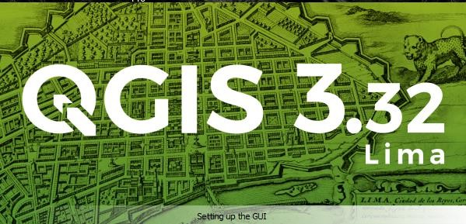**Step 1:** Open **QGIS** application.

**Step 2:** Click on **New Empty Project**

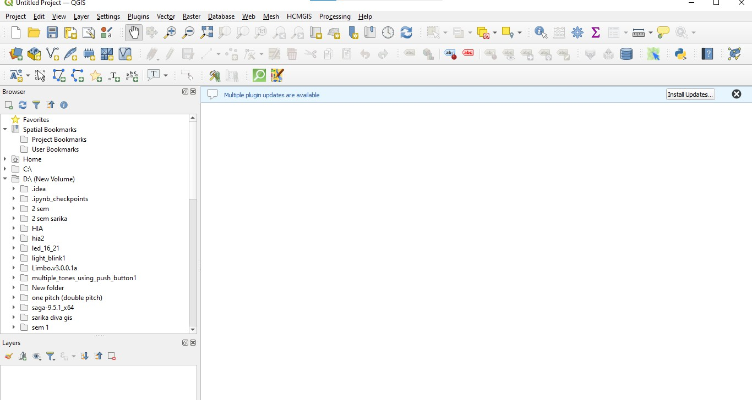

**Step 3:** Then click on **Layers** then **Add Layers** and **Add Vector Layer**.

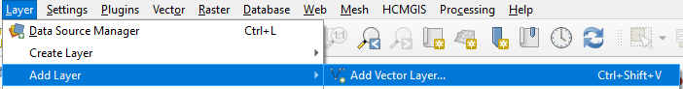

**Step:4** Click on **Browse** and select required file which is **Shapefiles** and click on **Ok** and **Add.**

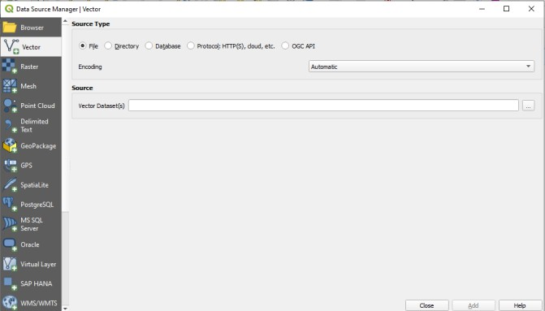

**Step:5** Three layer is added on Layers panel.

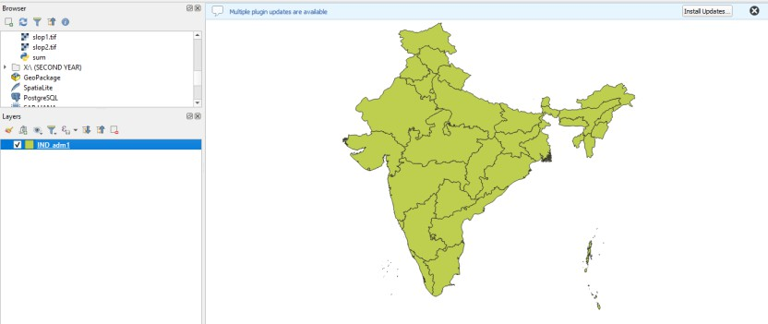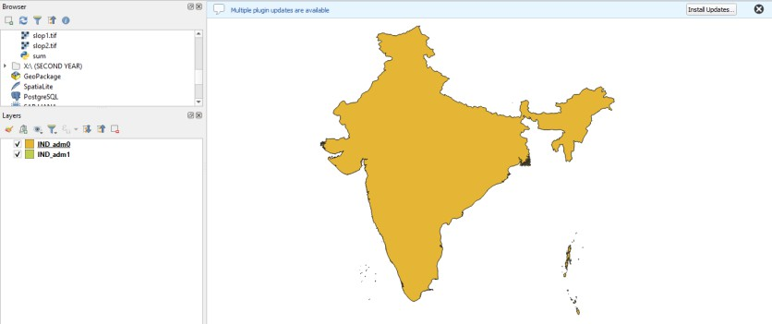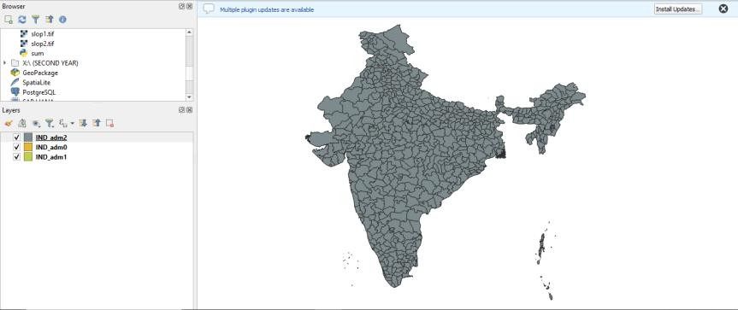

**Step:6** In the layer which contains state borders, use **OSMInfo** plugin to separate out Maharashtra and apply symbology.

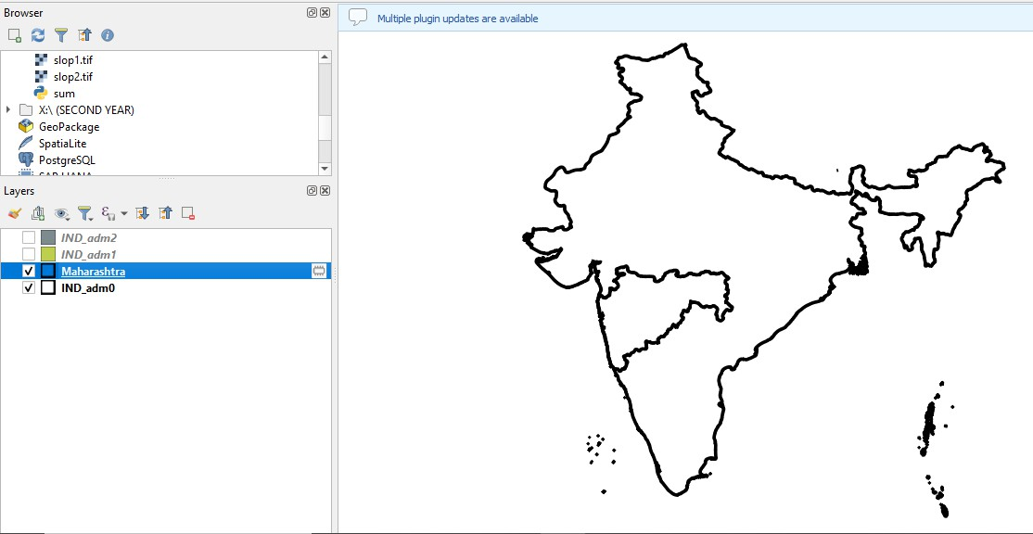

**Step:7** Then Click on **HCMGIS** then **Basemaps** then **Esri Physical.**

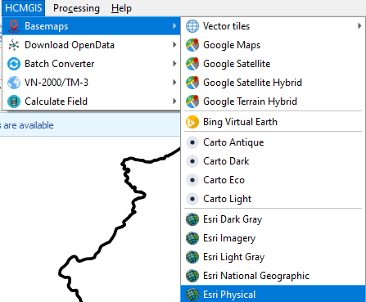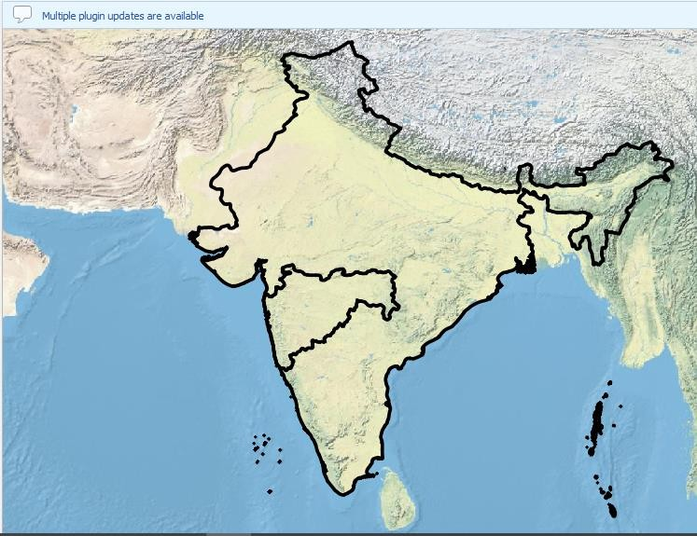

**Step:8** Add the map and Go to **Item properties** then go to **Grid** and Check the **Draw Coordinates**

option and **Scale Bar** and **North Arrow.**

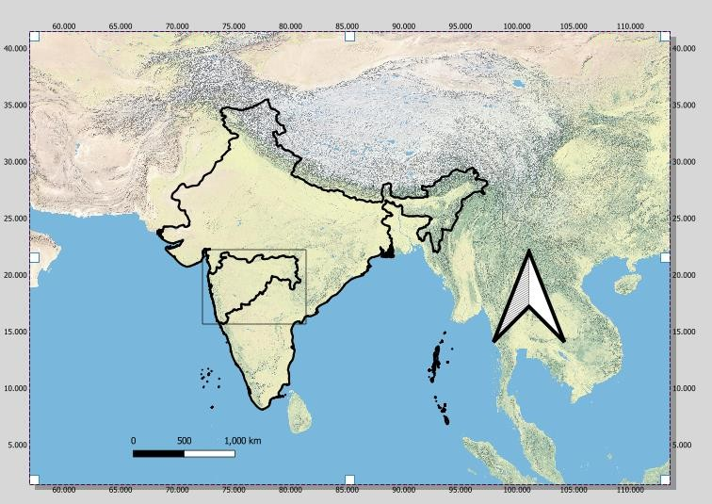

**Step:9** Then Click on **HCMGIS** then **Basemaps** then **Esri Topographic**

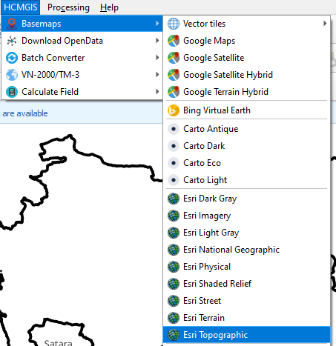

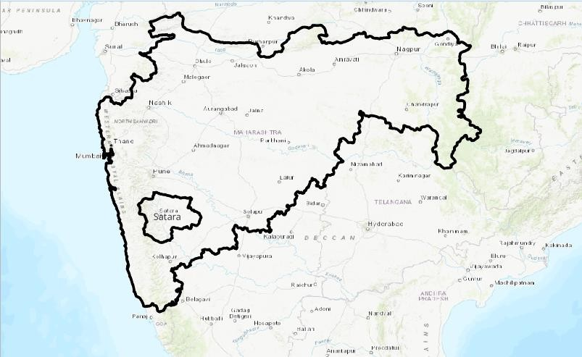

**Step:10 :** Add the map and Go to **Item properties** then go to **Grid** and Check the **Draw Coordinates**option and **Scale Bar** and **North Arrow**

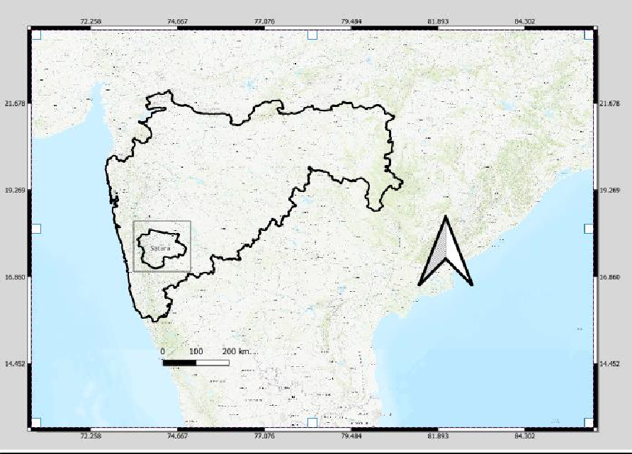

**Step:11** Then Click on **HCMGIS** then **Basemaps** then **Google Terrain Hybrid.**

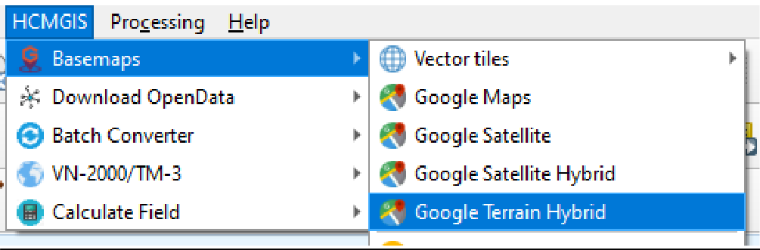

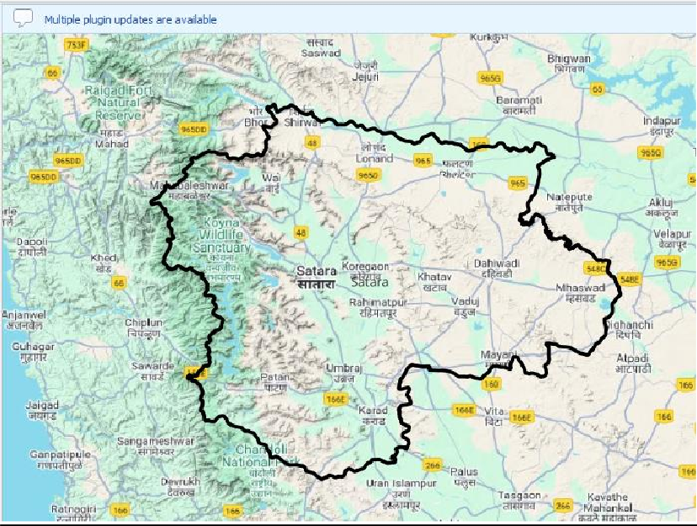

**Step:12** Add the map and Go to **Item properties** then go to **Grid** and Check the **Draw Coordinates**

option and **Scale Bar** and **North Arrow.**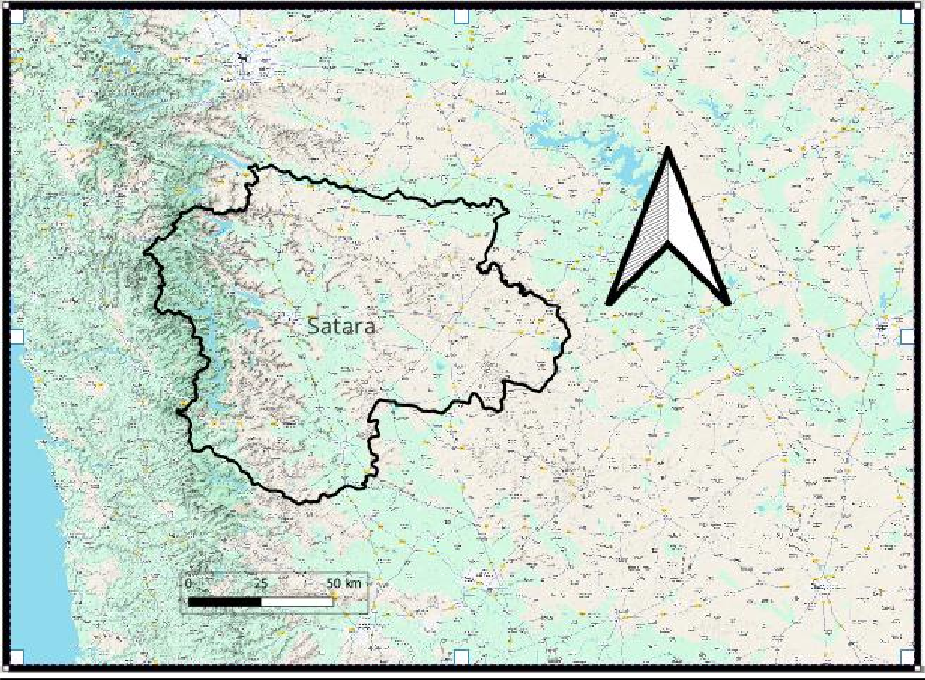

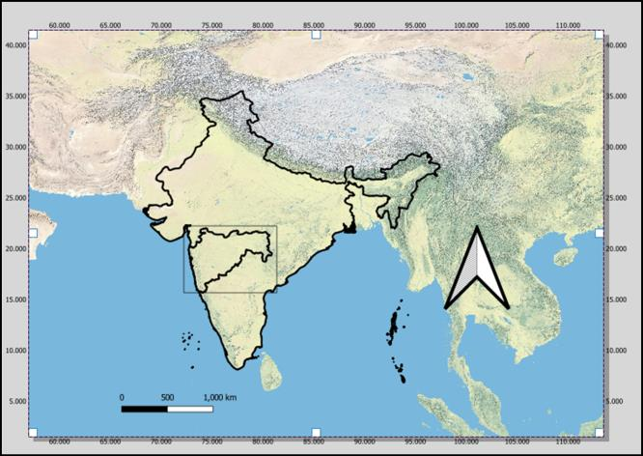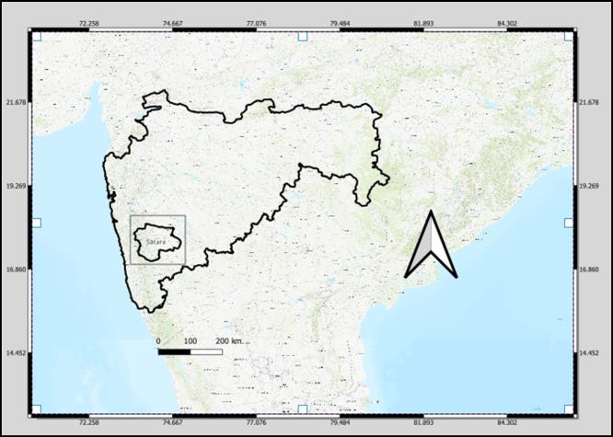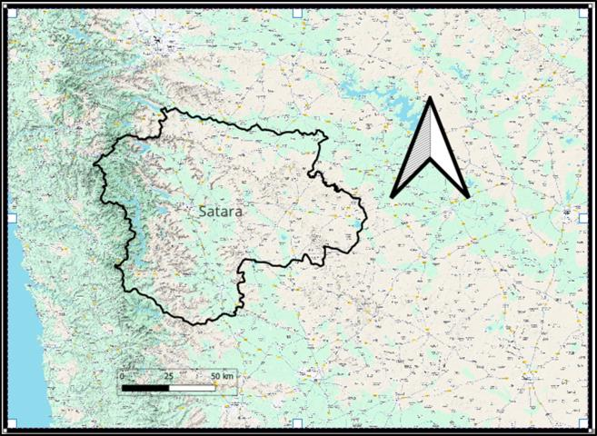

**Assignment 8**

**Aim :** To digitize ( Vectorization ) a Map / Toposheet using.

**Theory :**

Digitize a map or toposheet involves converting a physical or scanned map into a digital vector format using GIS software. The process includes tracing feature (like roads, rivers and Boundaries ) from the map as points, lines, and polygon . After importing the raster image of the map into the software, you create a new vector layer and manually trace over the feature to generate digital data. This data can then be analyzed , edited and integrated with other spatial information. The result is a digital version of the map that can be easily used for future analysis and mapping .

Step 1: Open QGIS.

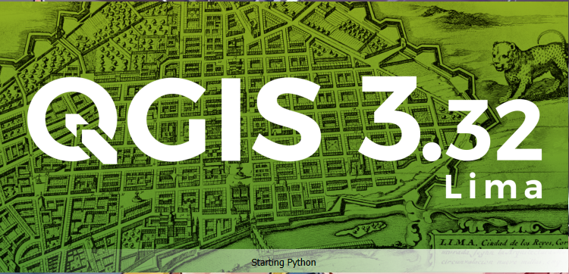

Step 2: Click on new Empty project.

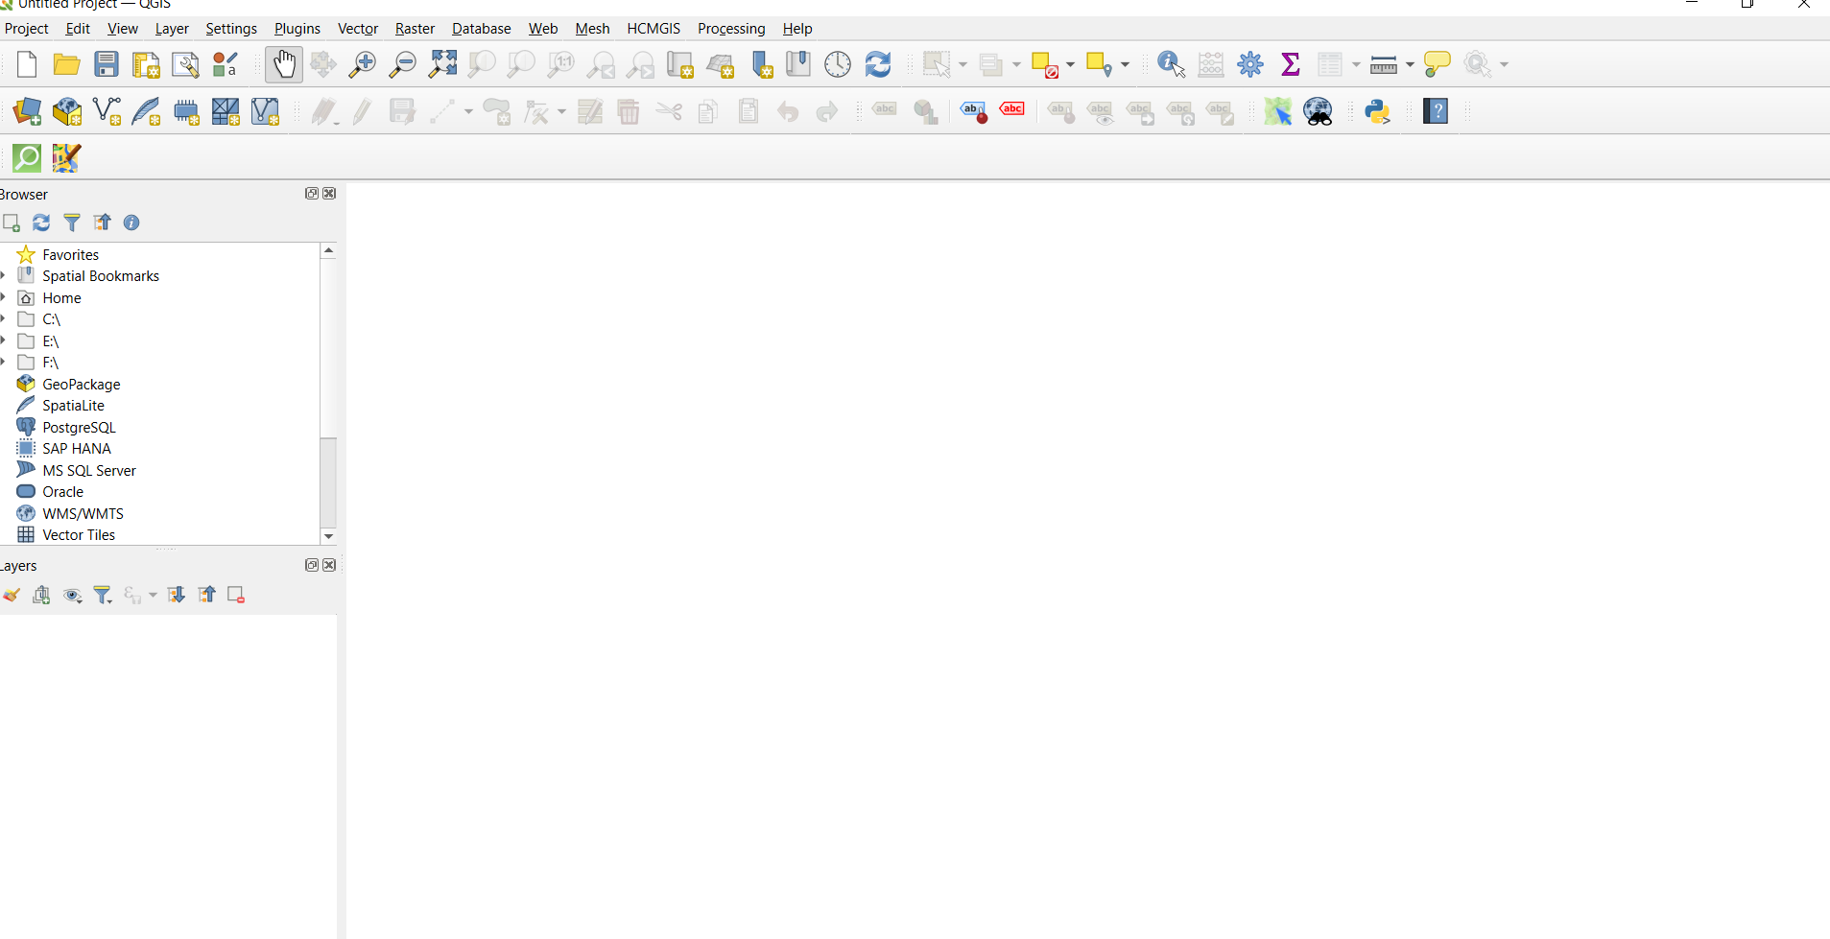

Step 3: Go to layers the Add Layer then Add Raster layer.

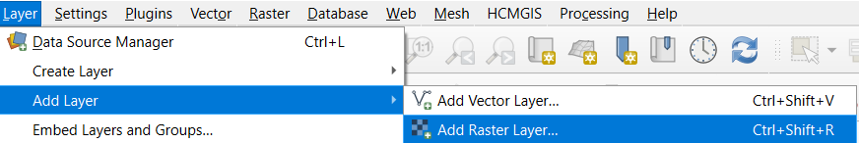

Step 4: This window will appear click on Browser option.

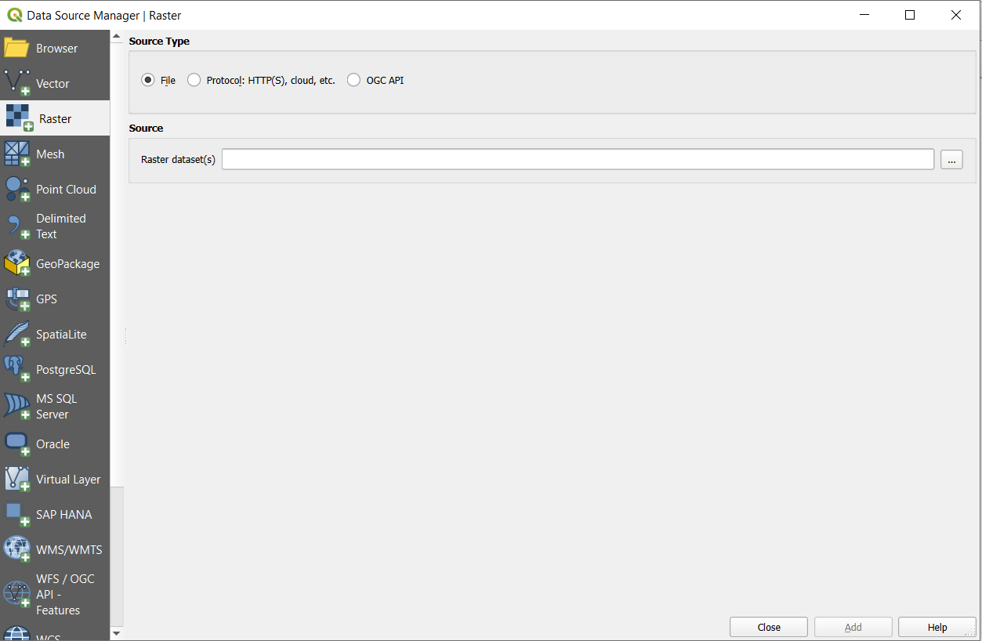

Step 5: select the require file then click on OK button.

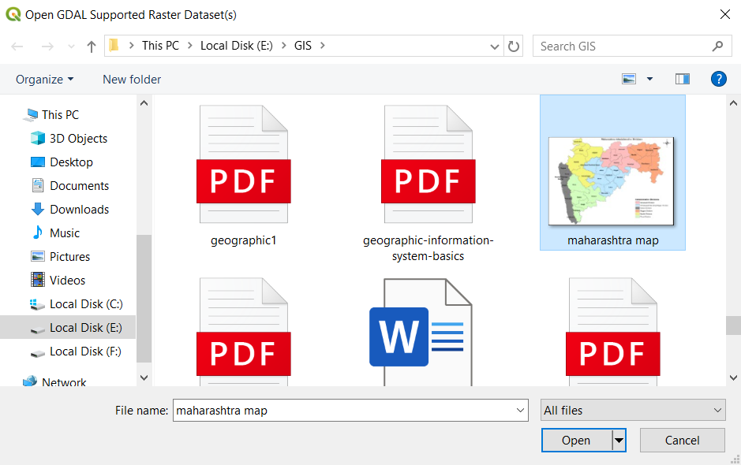

Step 6: Then click on Add button.

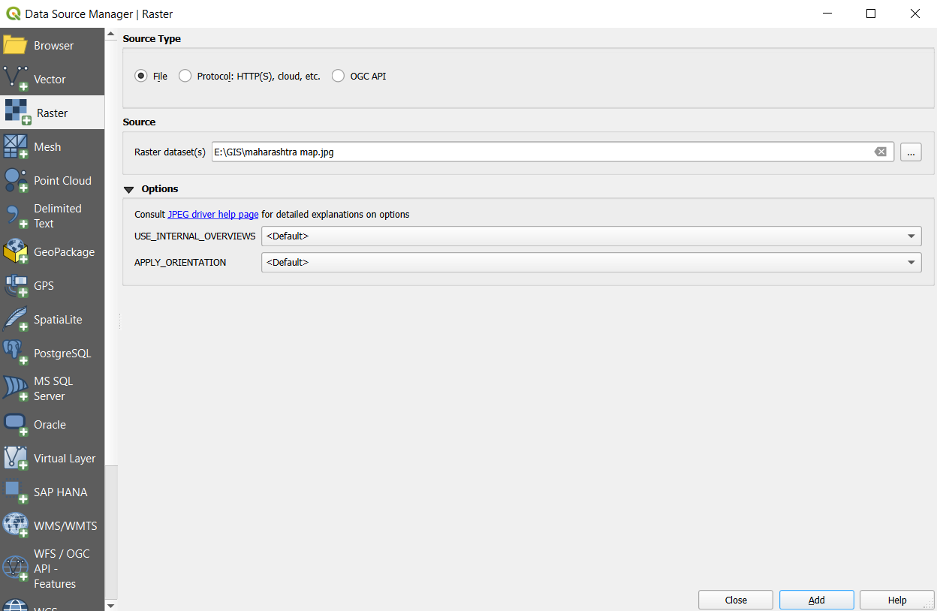

Step 7: Layer is added.

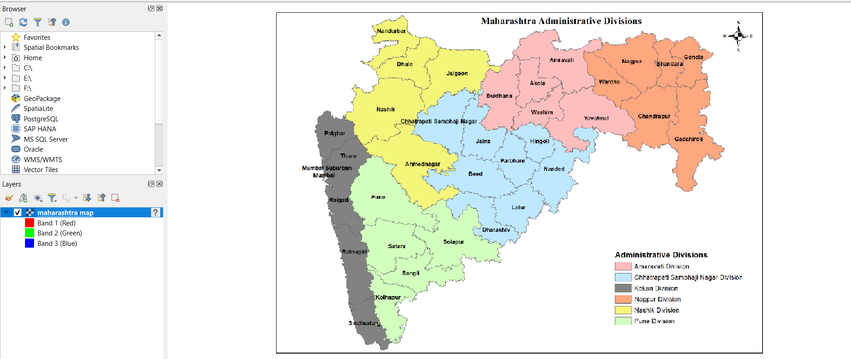

Step 8: Go to Layer then Create Layer then New Shapefile Layer

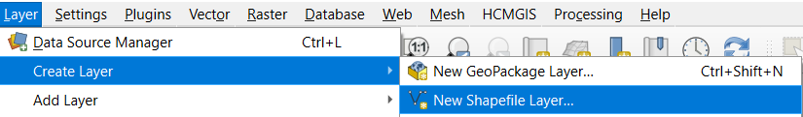

Step 9 :This window will appear then give file name , Geometry type then click on ok button.

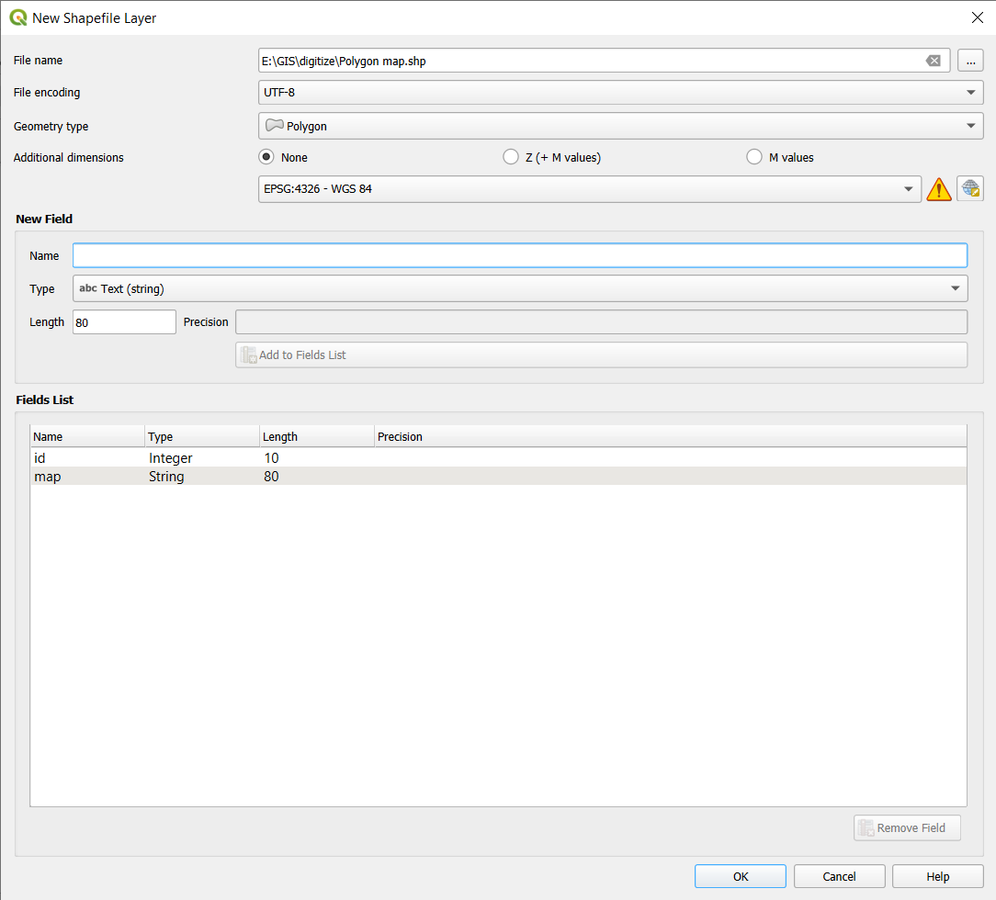

Step 10: Click on Toggle Editing .

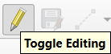

Step 11: Click on Add Polygon Feature .

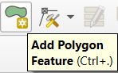

Step 12: Create chh.sambhaji nagar Polygon then right click give id and map then click on ok button.

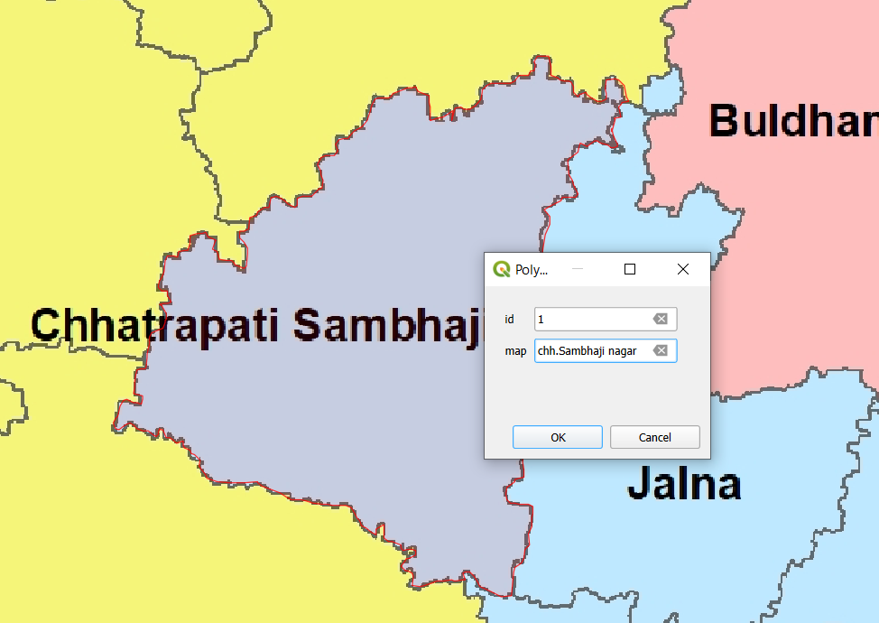

Step 9 :Create Hingoli Polygon then right click give id and map then click on ok button.

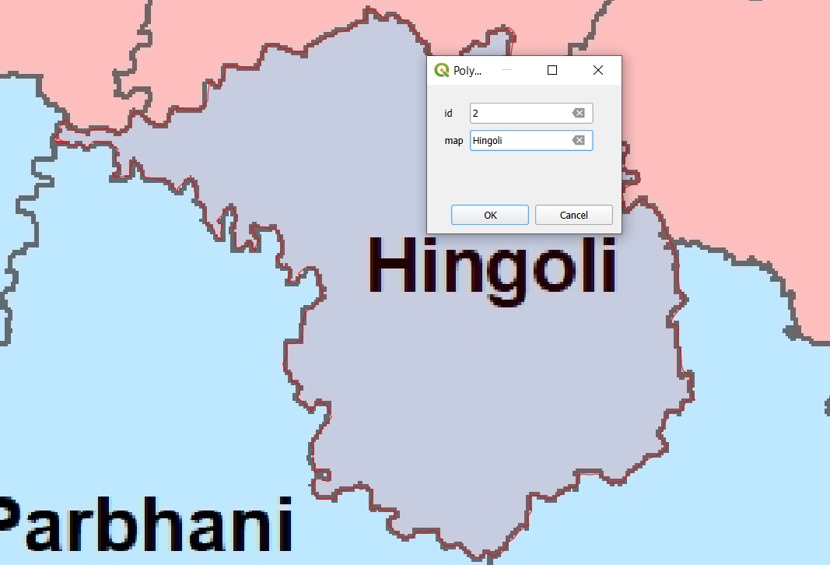

Step 10: Create Jalna Polygon then right click give id and map then click on ok button.

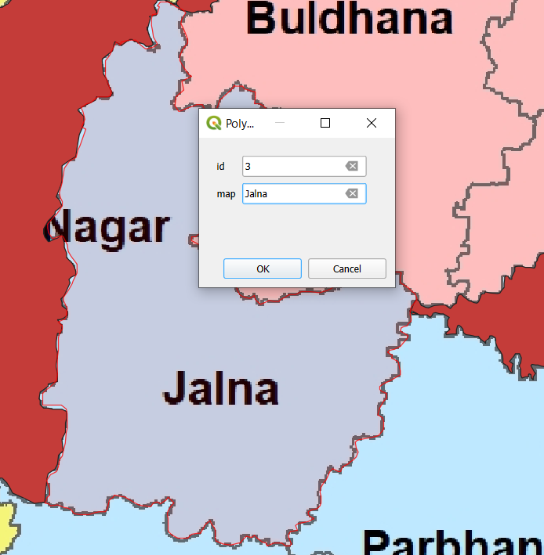

Step 11:Create Nashik Polygon then right click give id and map then click on ok button.

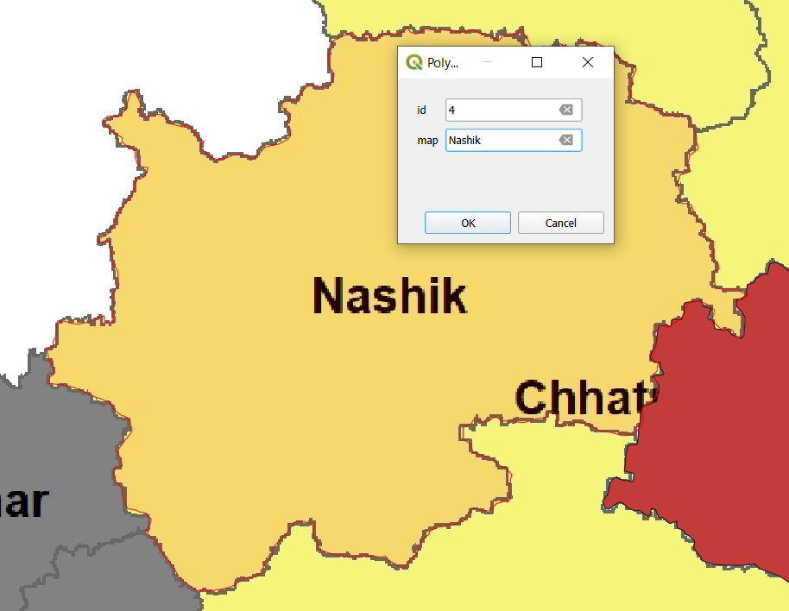

Step 12:Create Palghar Polygon then right click give id and map then click on ok button.

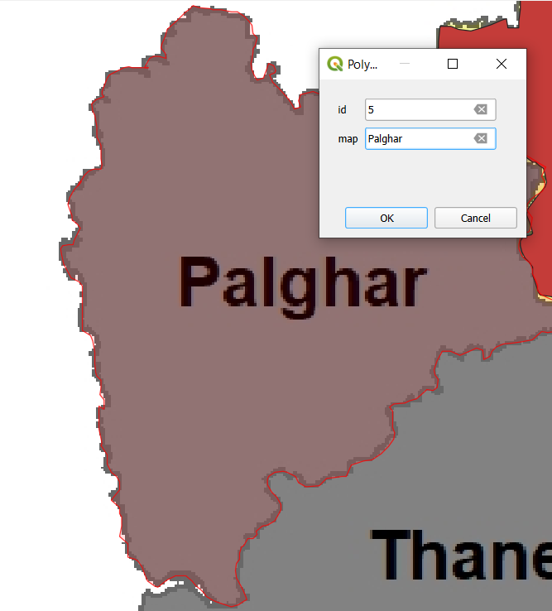

Step 13:Create Pune Polygon then right click give id and map then click on ok button.

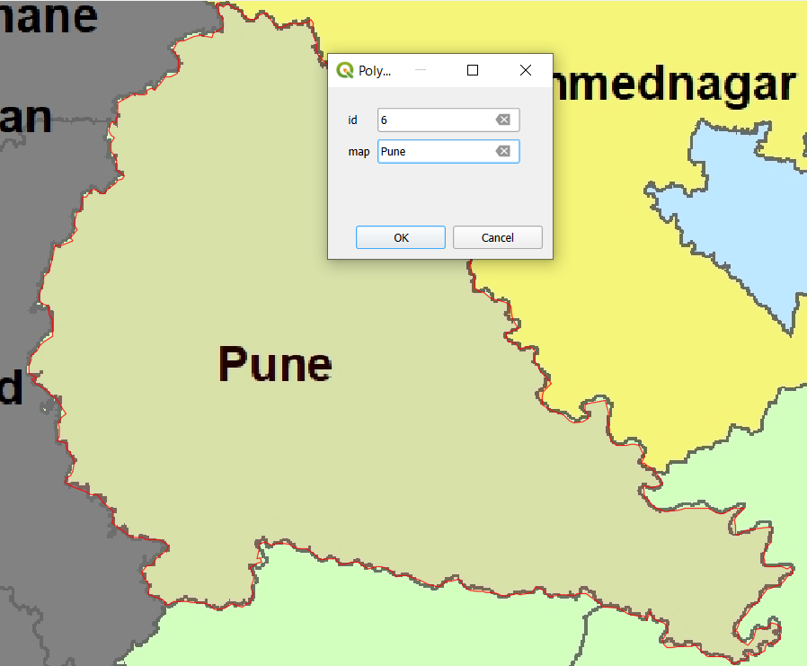

Step 14:Create Dharashiv Polygon then right click give id and map then click on ok button.

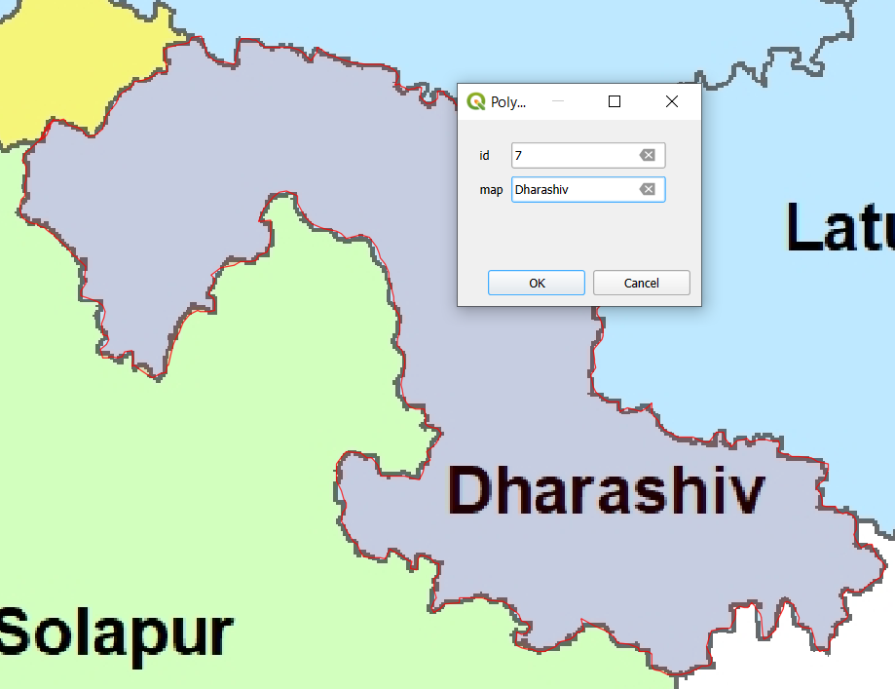

Step 15: Polygon is create .

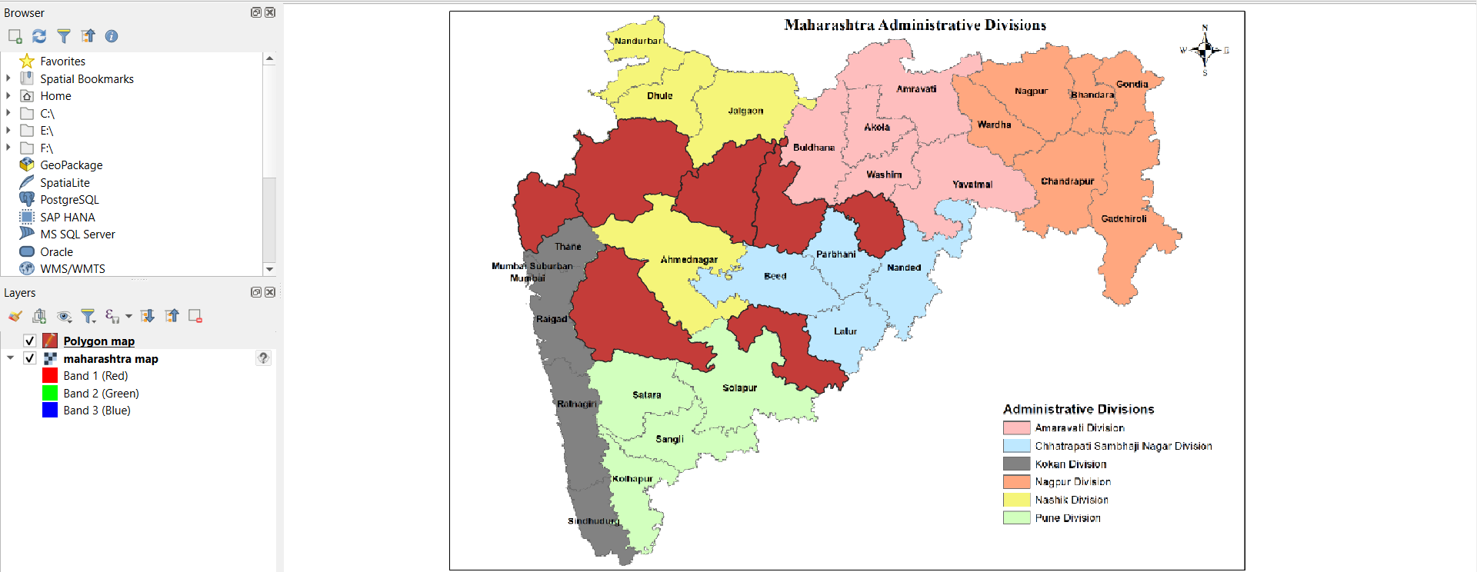

Step 16 : Map Polygon.

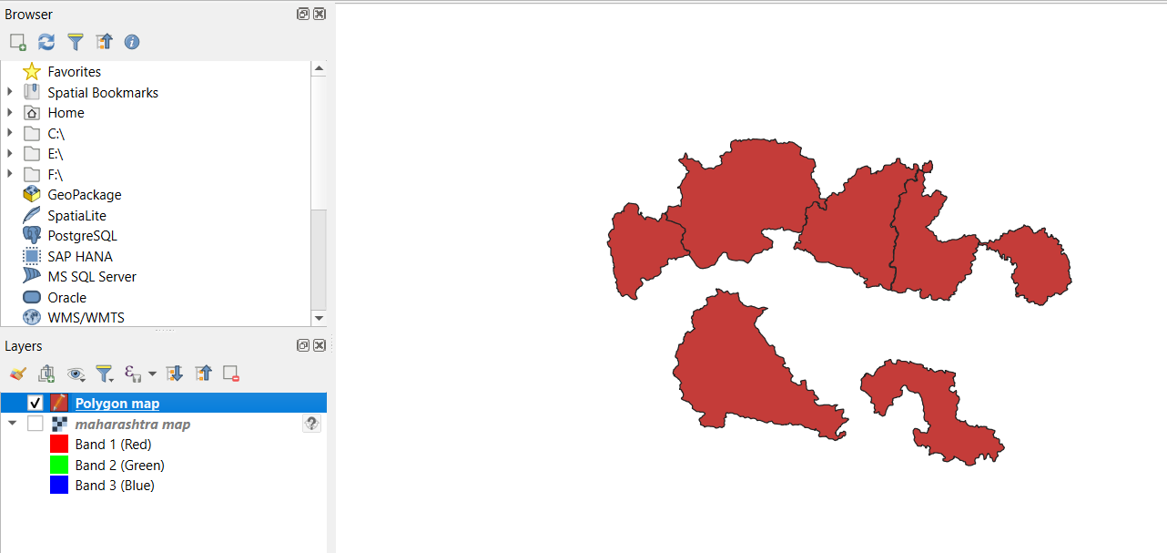

Step 17: Right click on Polygon map then click on open Attribute table.

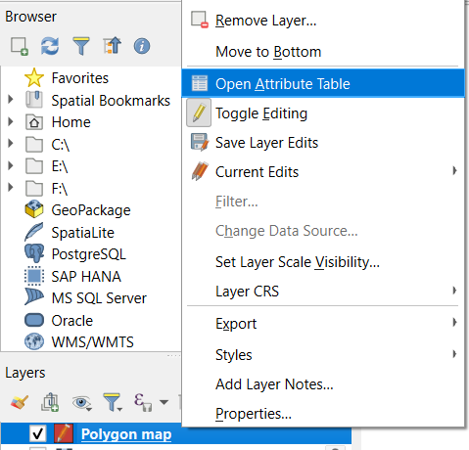

Step 18: This is map Attribute table .

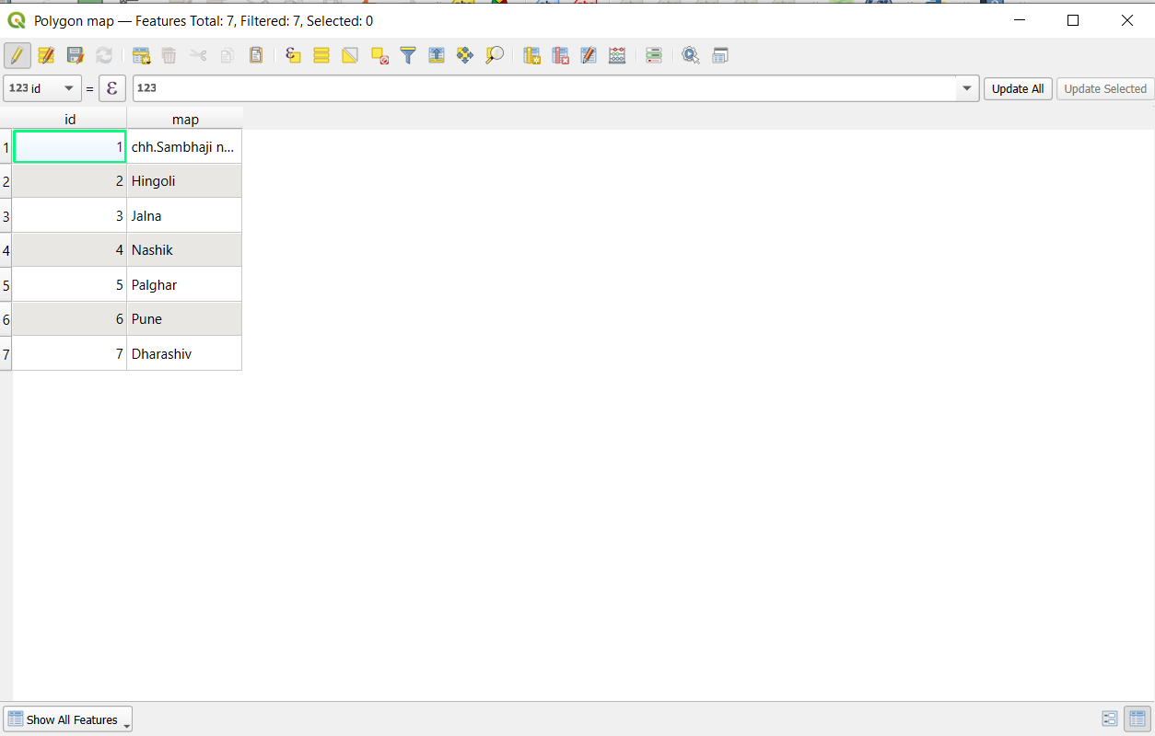

Step 19: Right click on Polygon map then go to Properties .

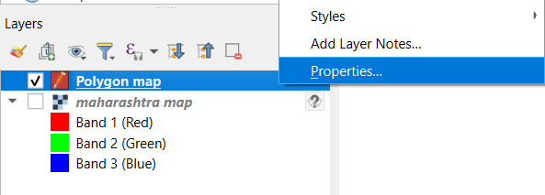

Step 20 : Go to Symbology then select categorized the give value then give different color for all map then click on Classify then click on Apply button.

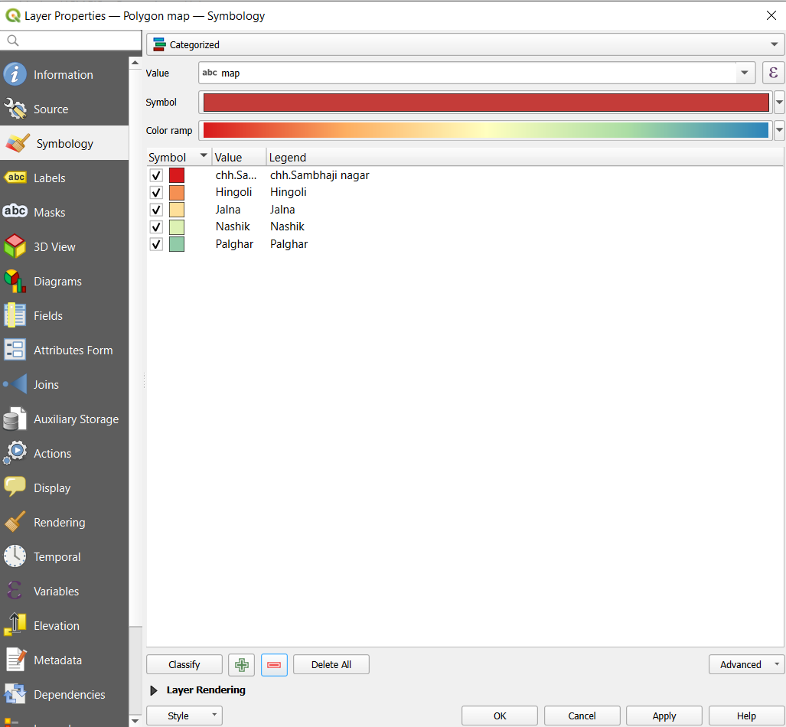

Step 21: Give lables .

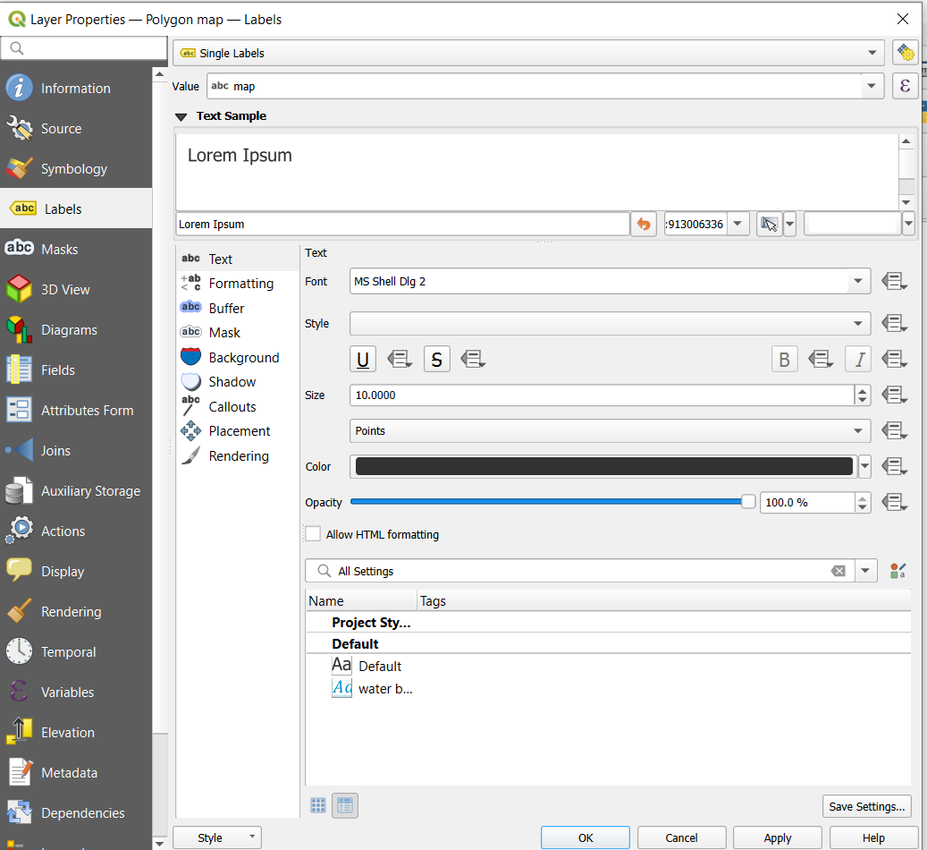

Step 22 : Digitize map .

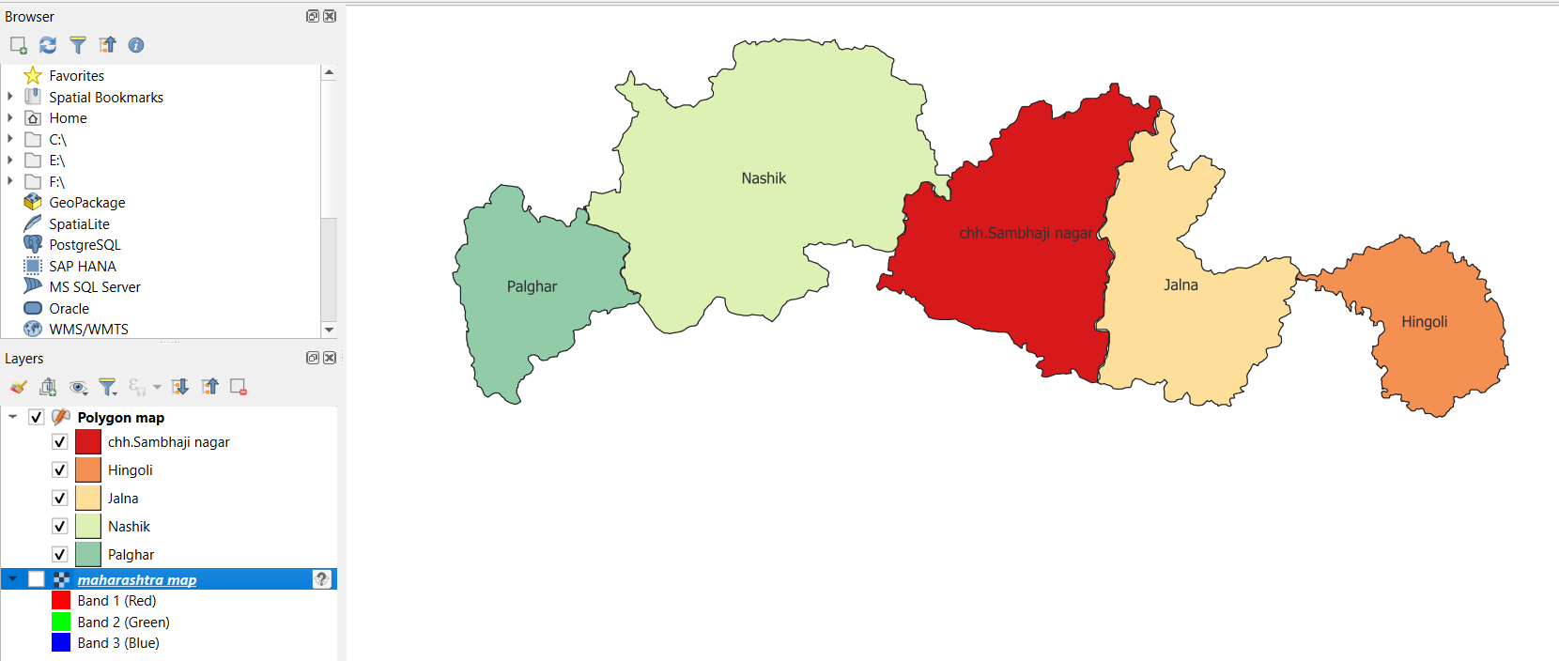

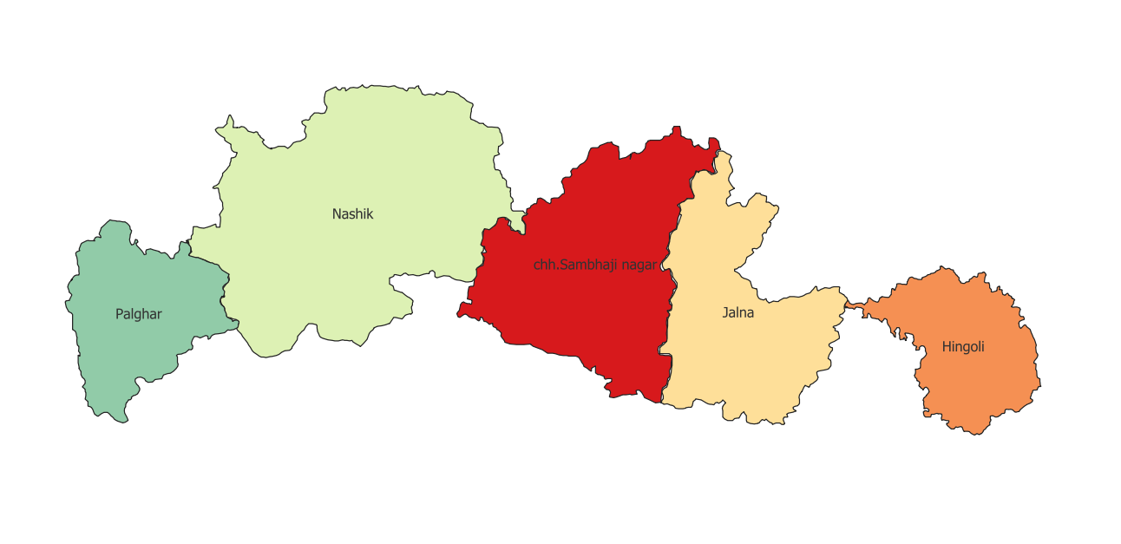

**Assignment 10**

**Aim :** To perform Vector Analysis using QGIS.

Types of Raster Analysis:

* Buffer
* Clip
* Intersect
* Union
* Merge
* Dissolve

**Theory :**

**1. Buffer in Vector and Raster Analysis**

* **Vector Analysis**:
  + **Buffer** creates a zone around a vector feature (point, line, or polygon) at a specified distance. This tool is typically used for proximity analysis.
  + Example: If you want to create a buffer zone around roads to determine areas within a certain distance from roads, you can use the **Buffer** tool in vector analysis.

**2. Clip in Vector and Raster Analysis**

* **Vector Analysis**:
  + **Clip** extracts portions of one vector layer based on the boundaries of another layer. It helps extract specific features of interest.
  + Example: Clip a **roads layer** to the area defined by a **city boundary** to extract only roads inside that city.

**3. Intersect in Vector and Raster Analysis**

* **Vector Analysis**:
  + **Intersect** returns the overlapping area between two vector layers. The output layer contains only the features where both layers overlap.
  + Example: Find areas of intersection between **land use zones** and **protected areas**.

**4. Union in Vector and Raster Analysis**

* **Vector Analysis**:
  + **Union** combines two layers and keeps all features from both layers. Overlapping areas are merged and preserved.
  + Example: Combine different administrative boundaries (e.g., district and city boundaries) to analyze how they intersect or overlap.

**5. Merge in Vector Vector Analysis**:

* + **Merge** combines multiple vector layers (with the same geometry type) into a single layer.
  + Example: If you have multiple shapefiles for different regions (like different counties), you can merge them into one.
  + **How to use**:
    - Go to **Vector > Data Management Tools > Merge Vector Layers**.
    - Select all the layers you want to merge.

**6. Dissolve in Vector and Raster Analysis**

* **Vector Analysis**:
  + **Dissolve** combines adjacent polygons with the same attribute value into a single feature. It simplifies the dataset by removing boundaries between features with identical values.
  + Example: Dissolve the **municipal boundaries** based on **land use** to create a new layer of generalized land use areas.

**Result :**

**Step 1:** Open QGIS.

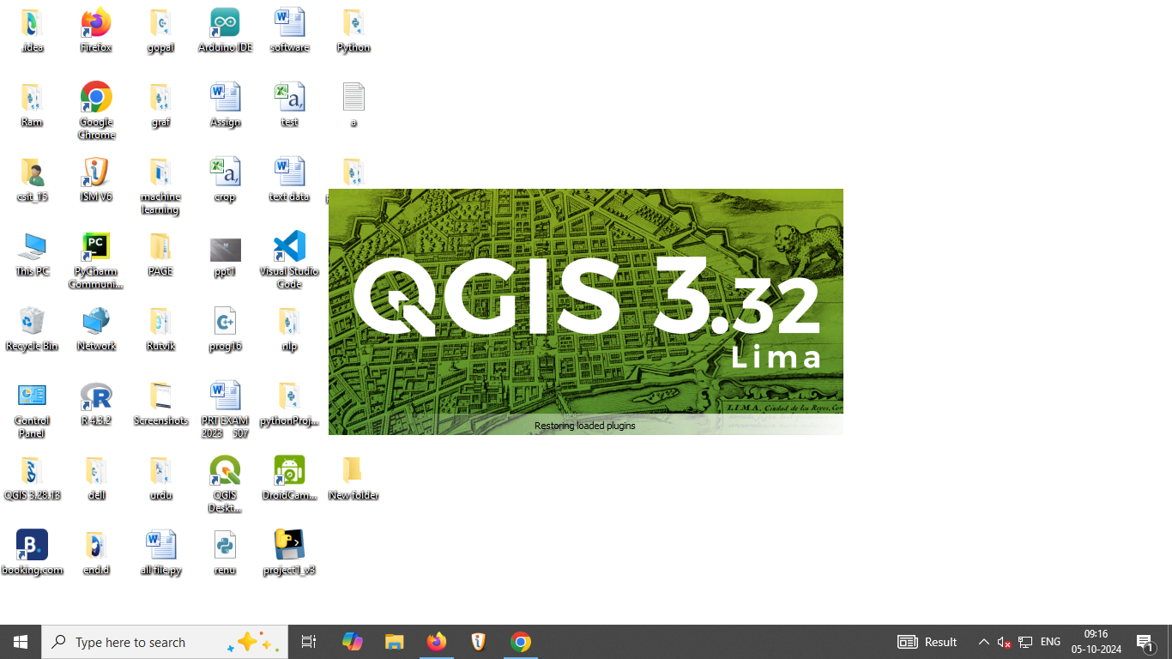

**Step 2:** Open New File

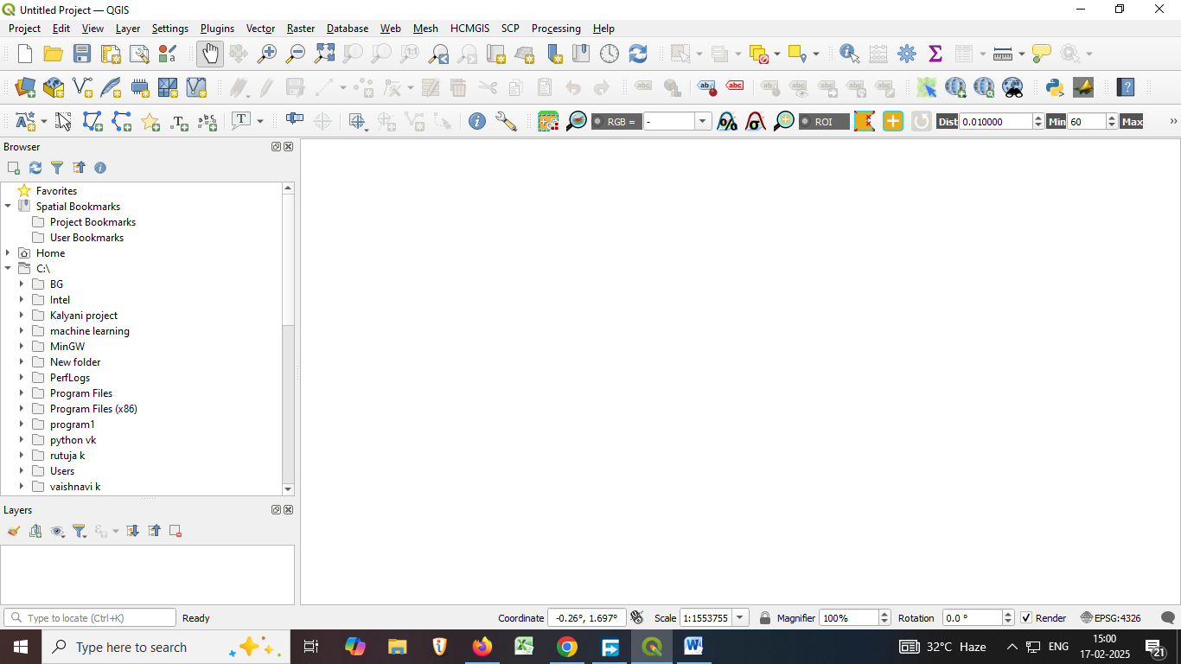

**Step 3:** Click on Layer then Add Layer and Add vector layer.

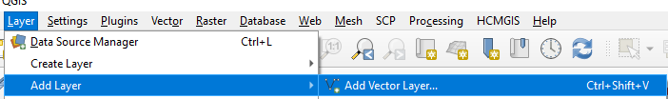

**Step 4:** Open this Data Source Manager vector and add vector dataset.

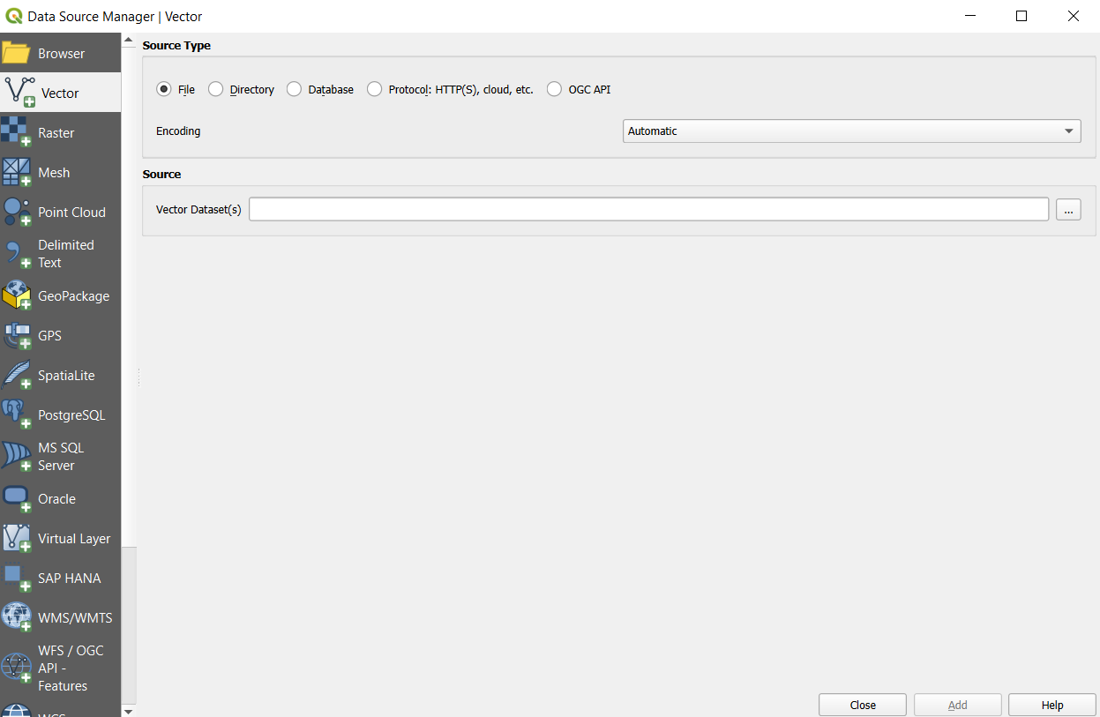

**Step 5 :** click on Map.shp and click on open .

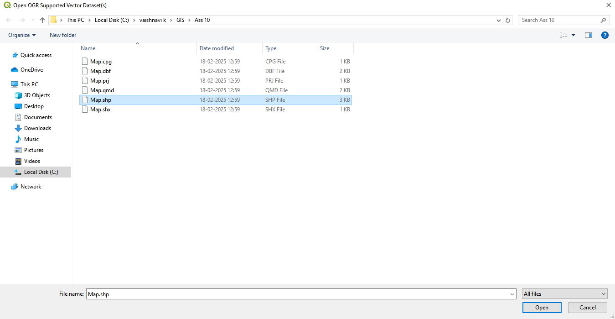

**Step 6:** Click on Add button.

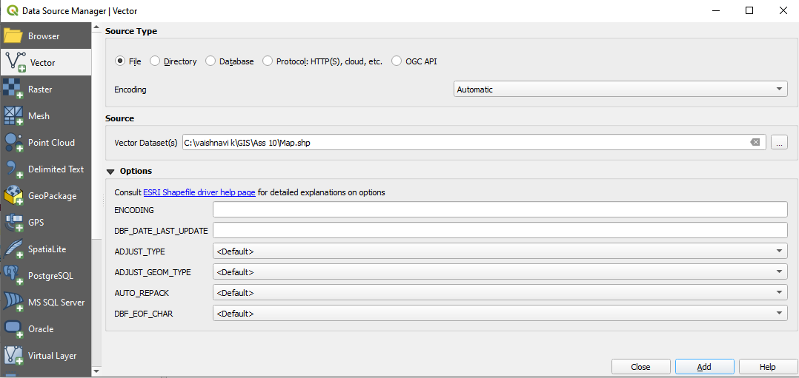

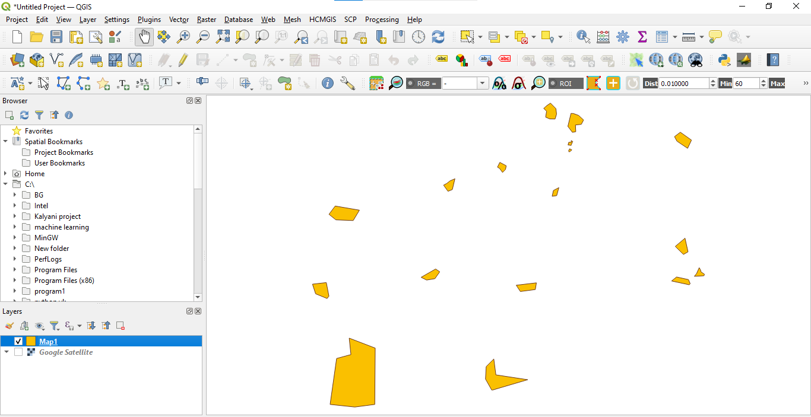

**Step 7:** Click on HCMGIS then click on BaaseMaps the Add google satellite.

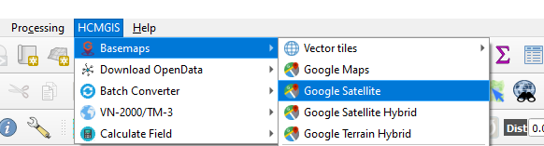

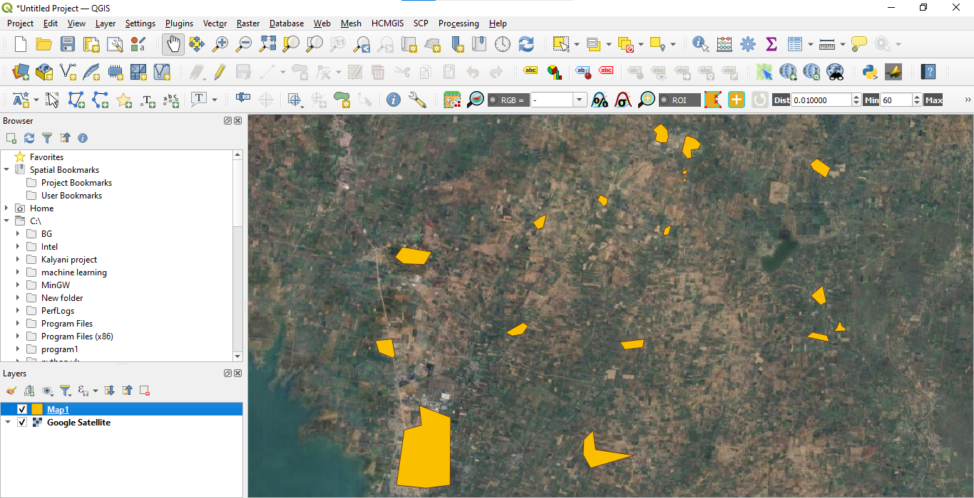

**Step 8:** **FOR BUFFER.**

Click on vector layer then Geoprocessing Tools then click Buffer

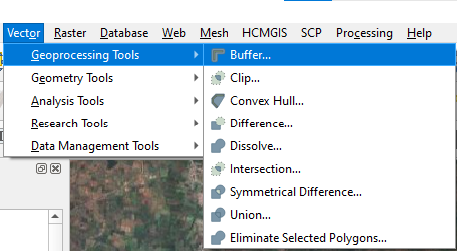

**Step 9:** give Input layer and distance then click on Run button.

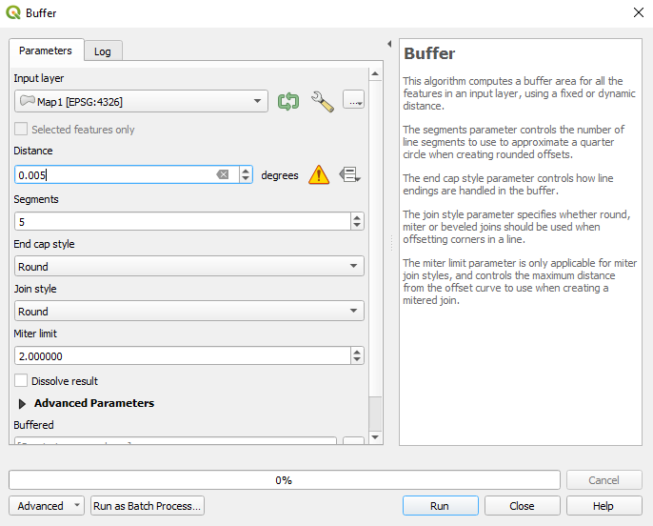

**Step 10 :** After buffer process map look like this.

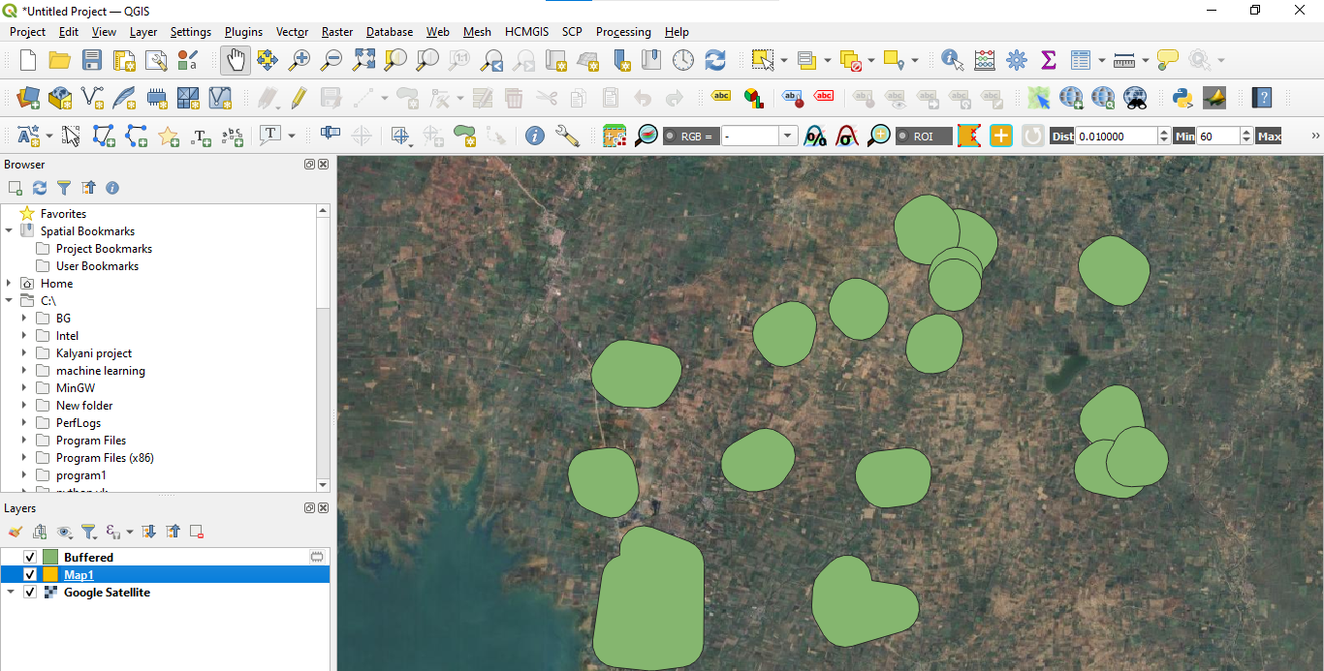

**Step 11:** Right click on Buffered then click on Properties.

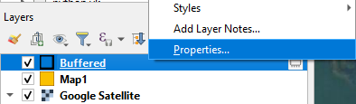

**Step 12:** Give symbology.

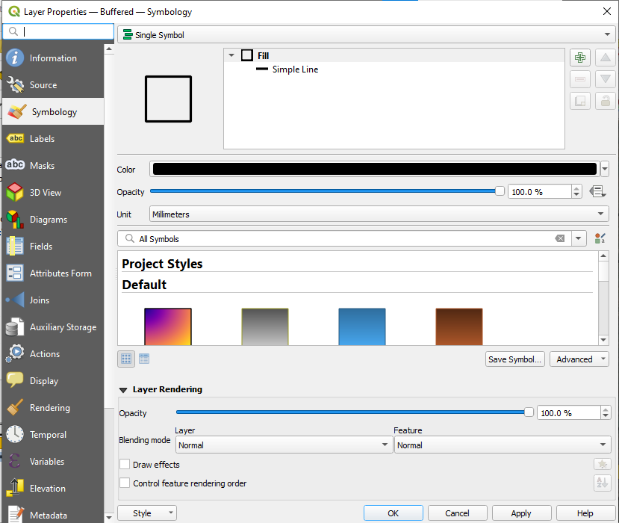

**Step 13:** Buffer map

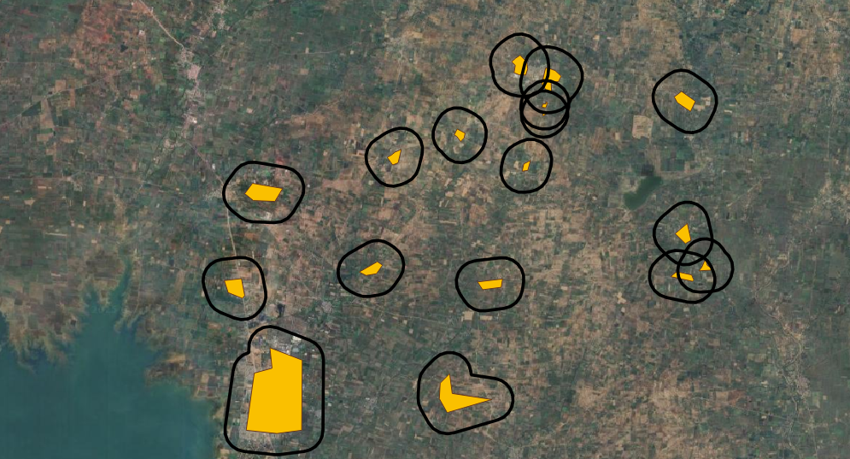

**Step 14 :** **FOR CLIPPING**

Click on Layer the click on Create Layer then Add New Shapefile layer

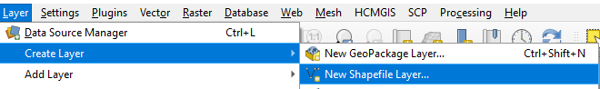

**Step 15:** Give file name and Geometry type then click on OK button.

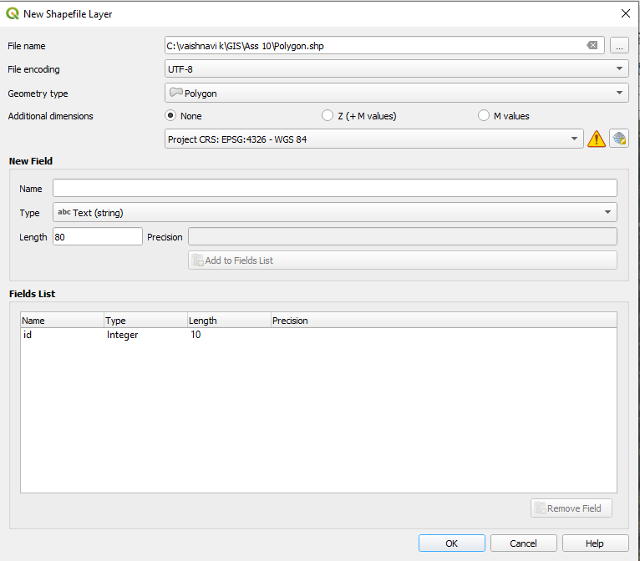

**Step 16:** Click on Toggle Editing and click on Add Polygon Feature.

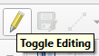

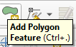

**Step 17:** Create new Polygon.

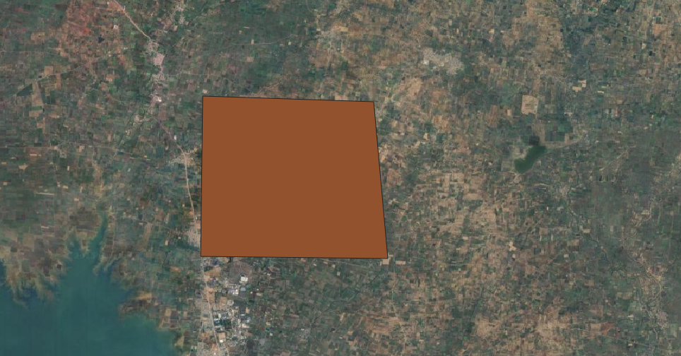

**Step 18:** Click on Layer the Create Layer and add New Temporary Scratch Layer for Polygon.

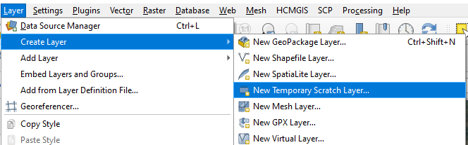

**Step 19:** Give layer name , Geometry type and New Field Name then click on OK button.

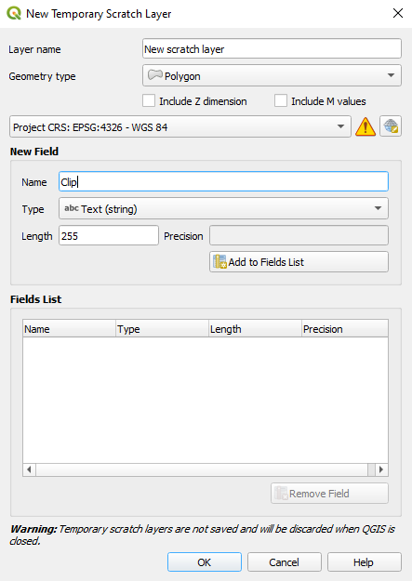

**Step 20 :** Create new Polygon

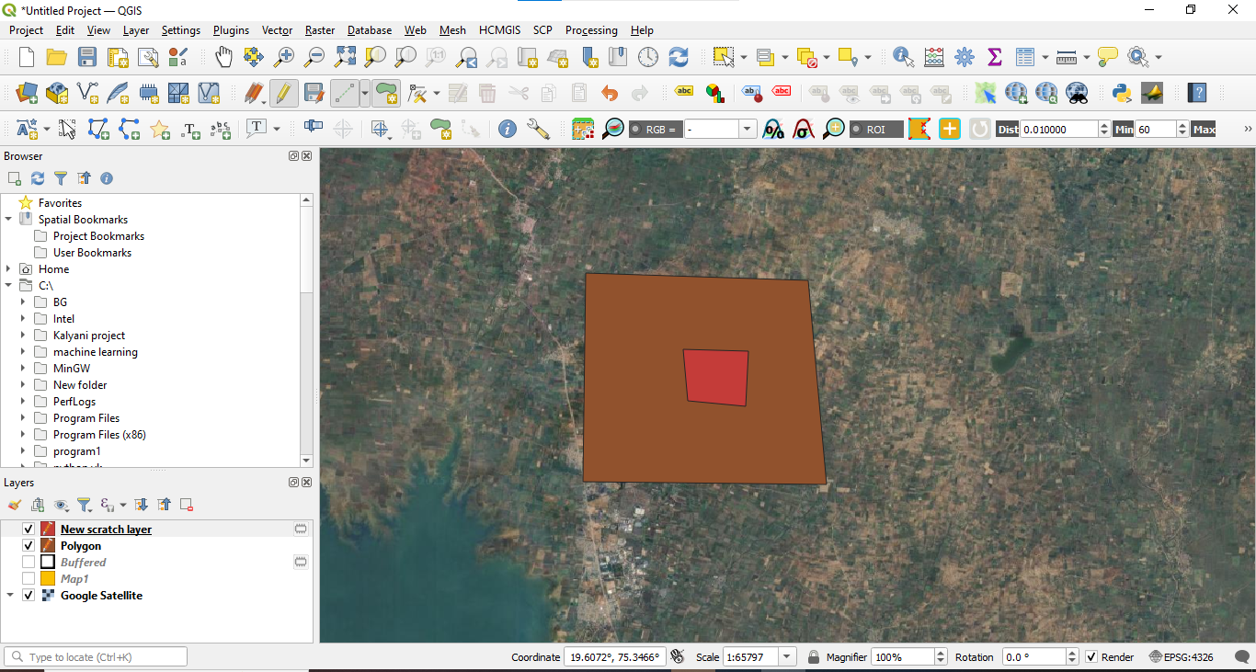

**Step 21:** Click on vector then Geoprocessing then click on Clip.

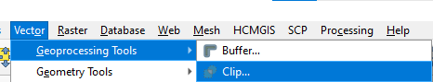

**Step 22:** Give Input layer , Overlay layer and then click on Run button.

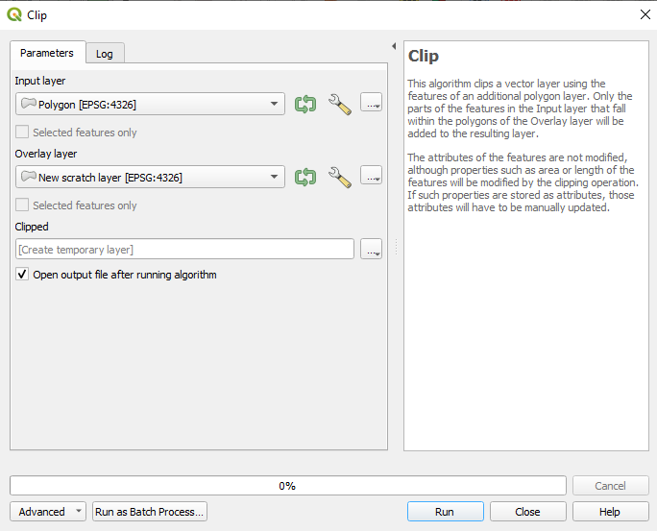

**Step 23:** After clipping look like this.

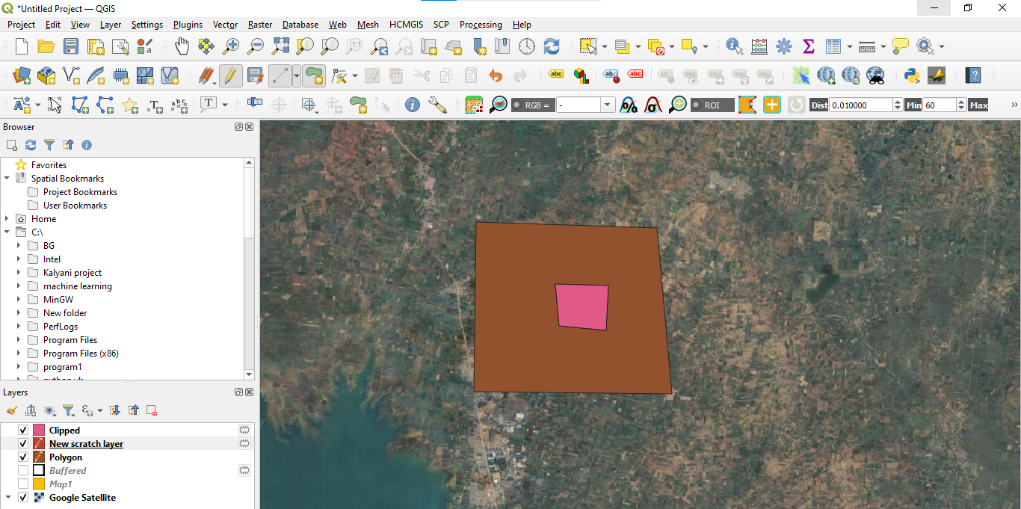

**Step 24:** Clip map.

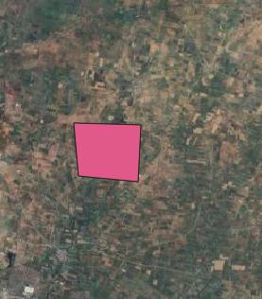

**Step 25:** **FOR INTERSECTION**

Open Polygon layer and new scratch layer

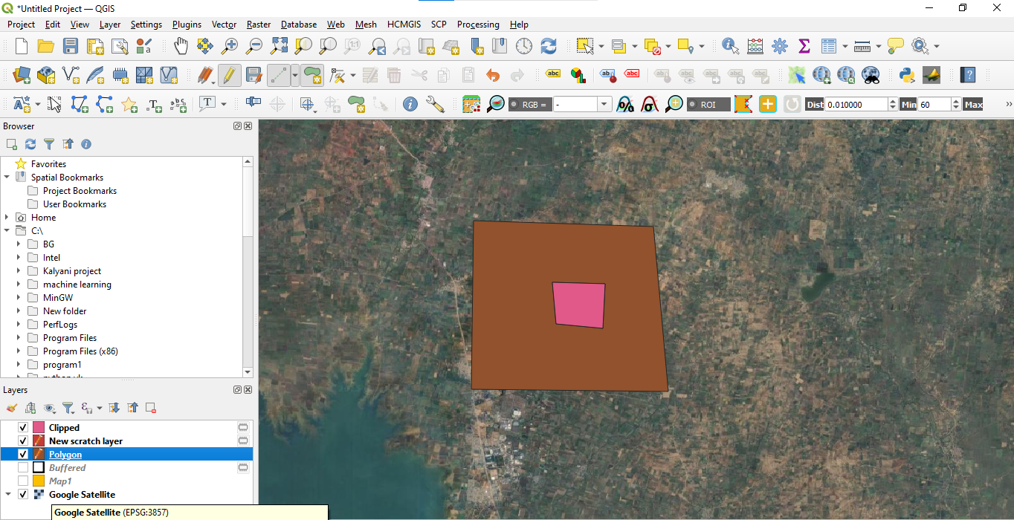

**Step 26:** Click on vector then click on Geoprocessing Tools, and click on Intersection.

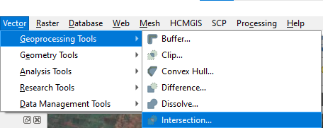

**Step 27 :** Give Input layer , Overlay layer and click on Run button.

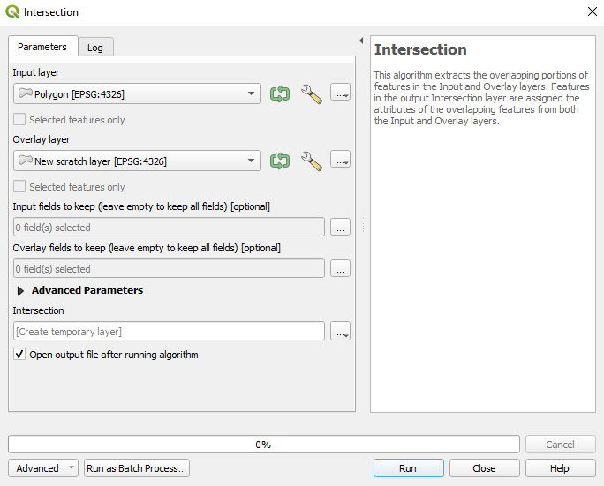

**Step 28:** After Intersection Process look like this.

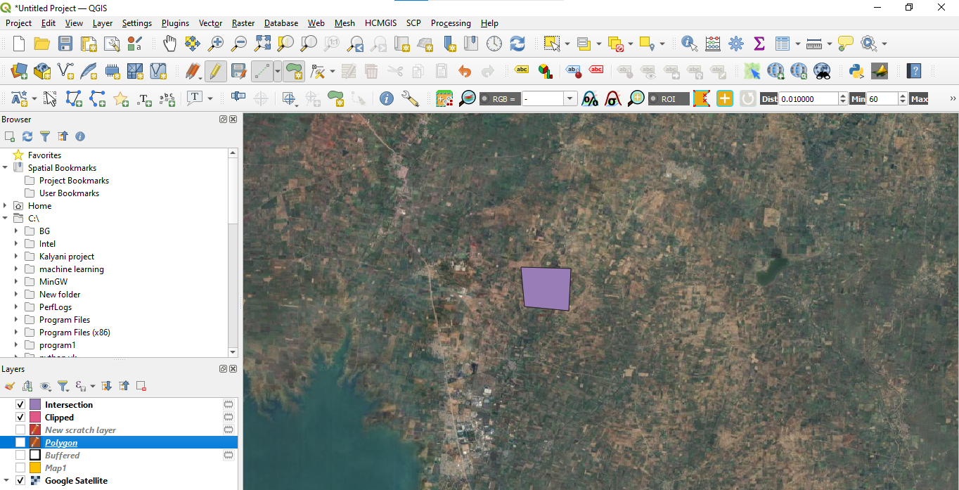

**Step 29:** **FOR UNION**

Open Polygon layer.

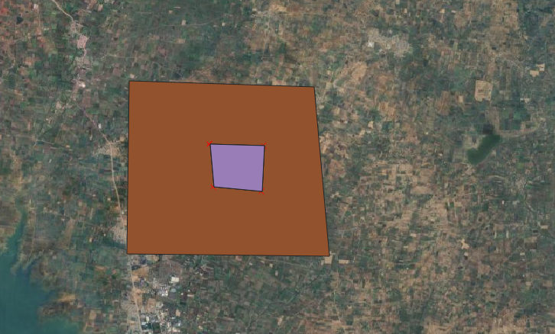

**Step 30:** Click select features by area or single click for delete Polygon.

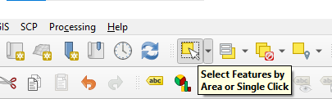

**Step 31:** Delete this Polygon.

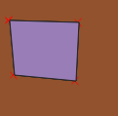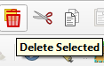

**Step 32:** After delete.

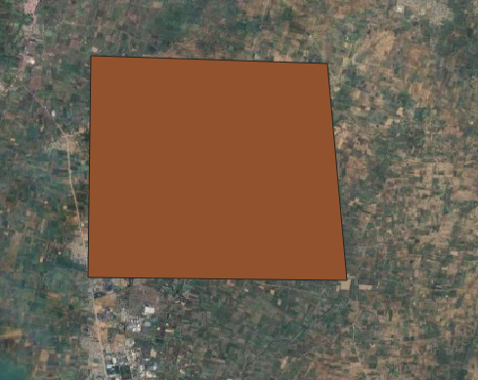

**Step 33 :** Then Add new Polygon.

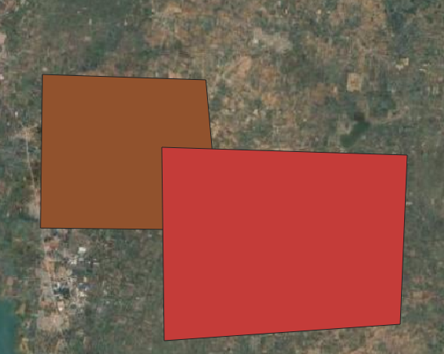

**Step 34:** Click vector then click Geoprocessing Tools then click Union.

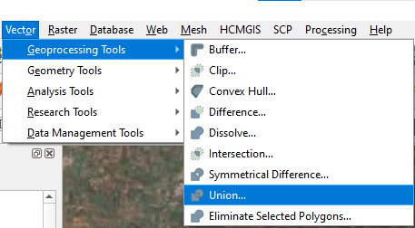

**Step 35 :** Give Input Layer , Overlay layer then click on Run button.

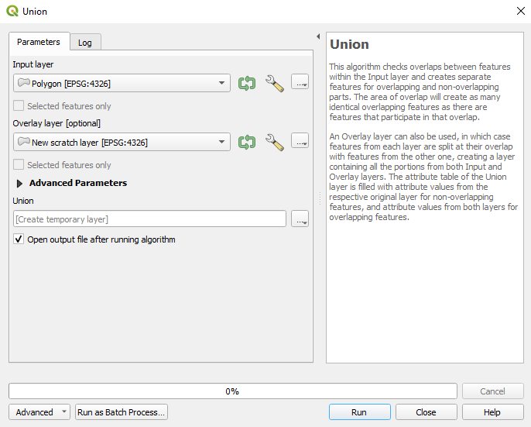

**Step 36:** Afte Union process map look like this.

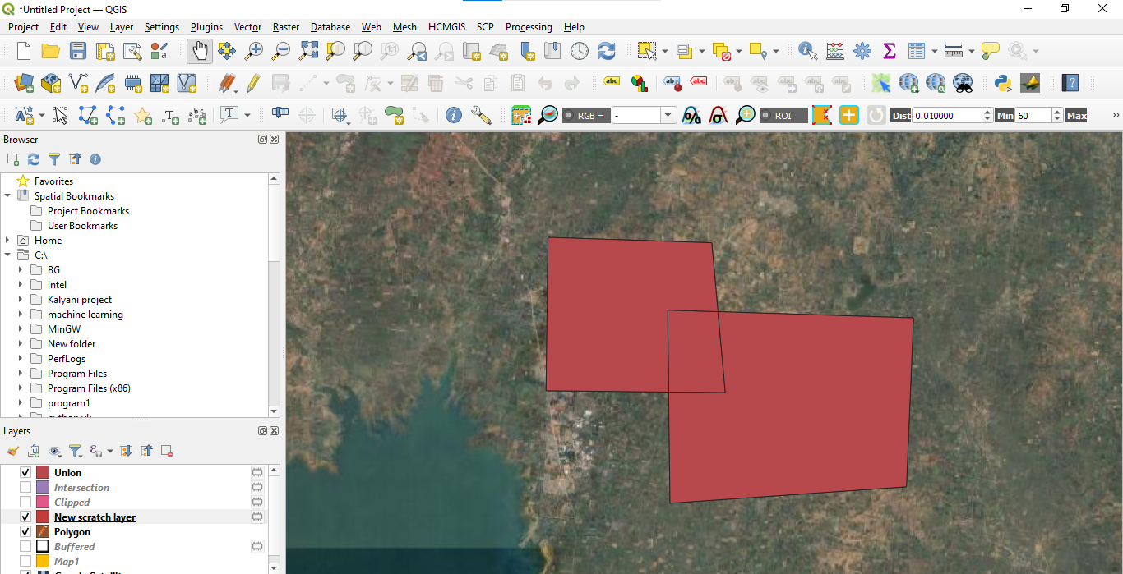

**Step 37:** Union Map.

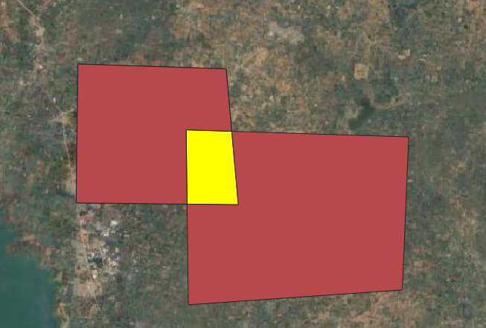

**Step 38:** **FOR MERGE** .

Click vector then click Data Management Tools then click on Merge vector Layers.

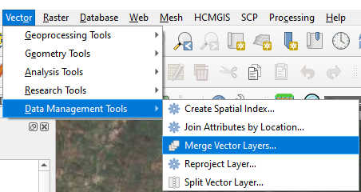

**Step 39 :** give Input layer , destination CRS, Merged.

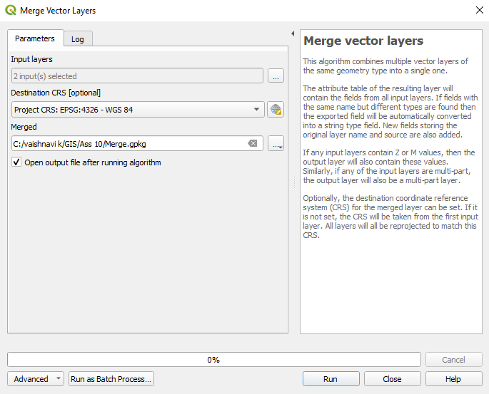

**Step 40 :** After Merge process look like this.

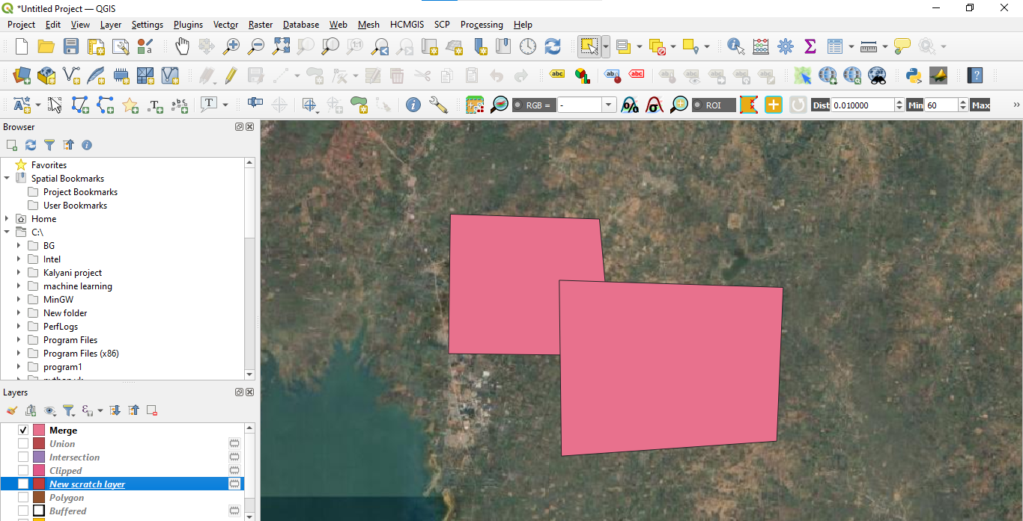

**Step 41:** **FOR DISOLVE**

Open Map1 layer, Google Satellite.

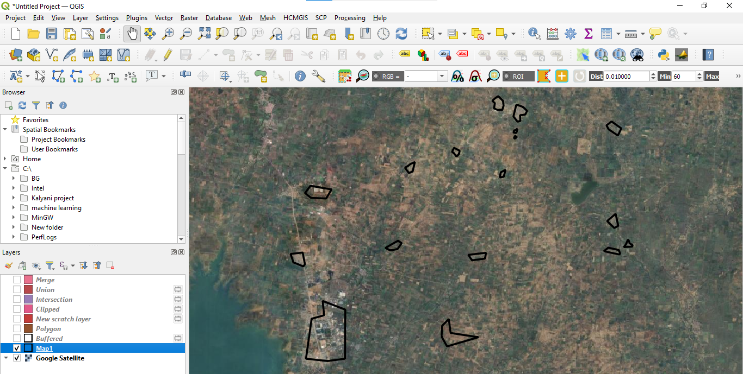

**Step 42:** click vector then click Geoprocessing Tool then click on Dissolve.

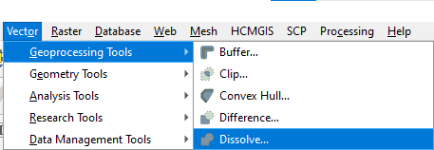

**Step 43:** Give Input layer .

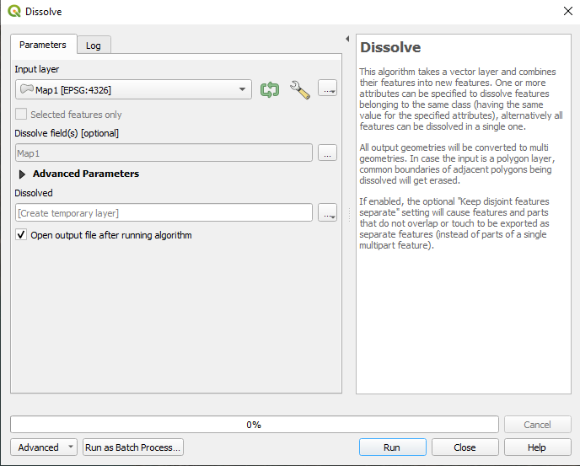

**Step 44 :** After Dissolve process map look like this.

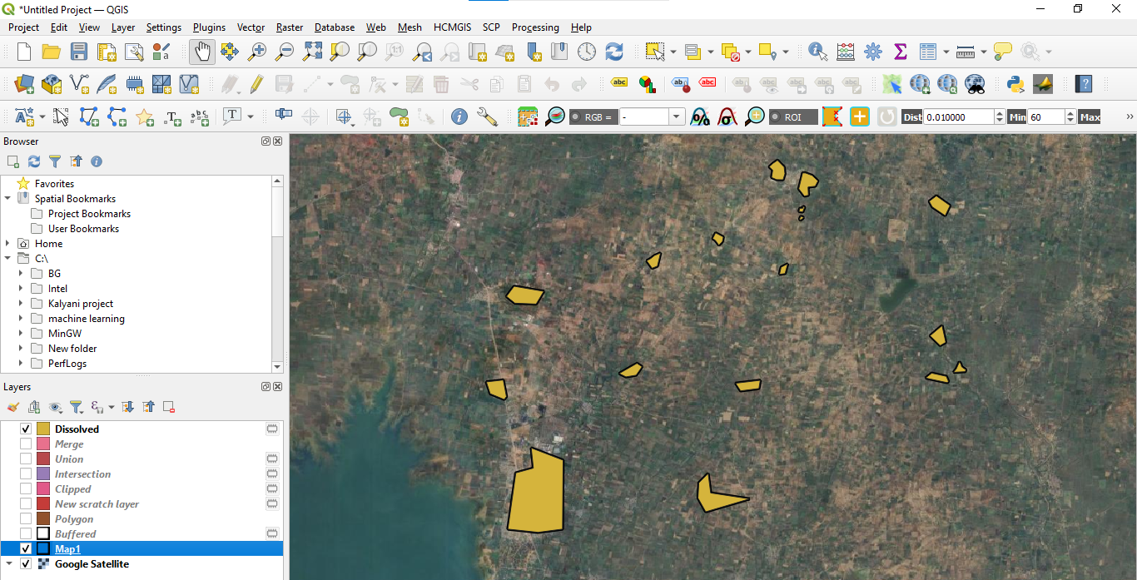

**Step 45 :** Dissolve Map .

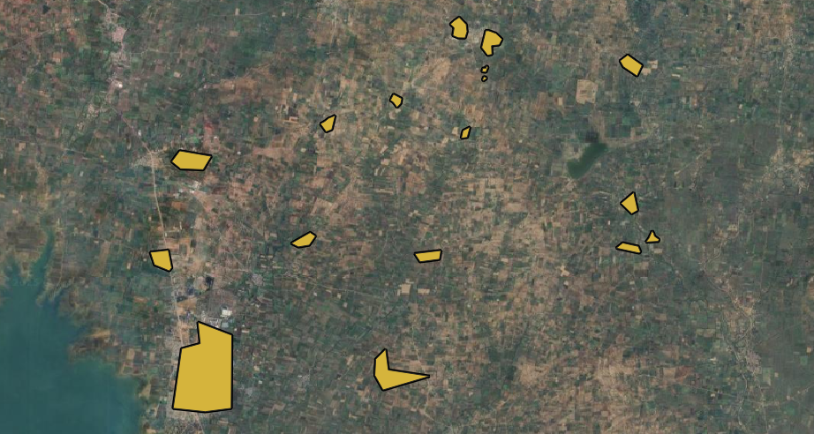

**Practical assignment 11**

**AIM:** To perform Raster Analysis using QGIS

## ****Theory:****

Raster Analysis in QGIS involves performing spatial operations on raster data to extract meaningful insights. QGIS provides various tools under the **Raster** menu and **Processing Toolbox** for raster-based analysis. These tools are essential for applications like environmental modeling, terrain analysis, land cover classification, and hydrological studies.

Raster data represents spatial information in a grid format, where each cell contains a value representing information such as elevation, temperature, or land cover. Common raster analysis techniques include mathematical operations, distance calculations, surface modeling, statistical analysis, and raster classification. These techniques help in understanding and manipulating spatial data to derive important geographic and environmental information.

**Steps:**

Step 1: Open QGIS.

Step 2: load raster image.

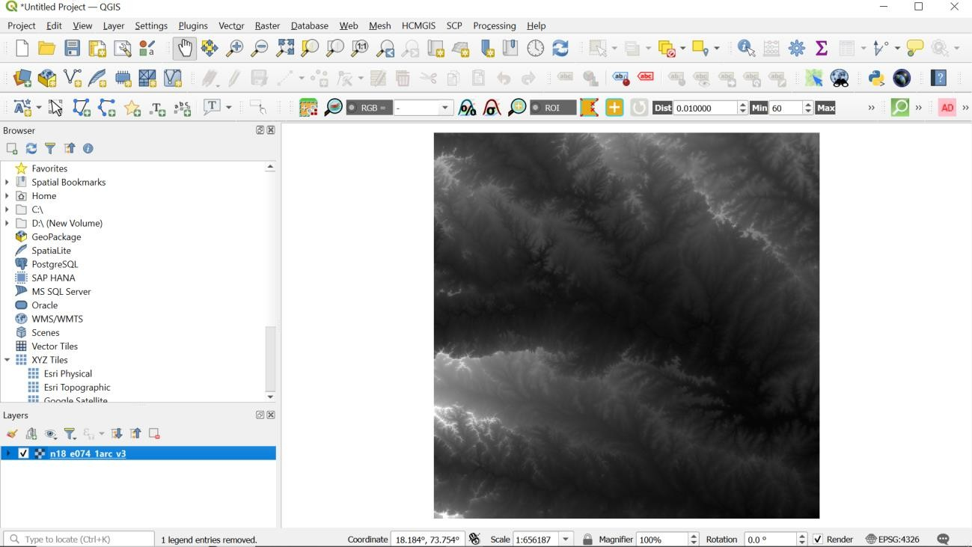

Step 3: Go to Raster analysis and Hillshade

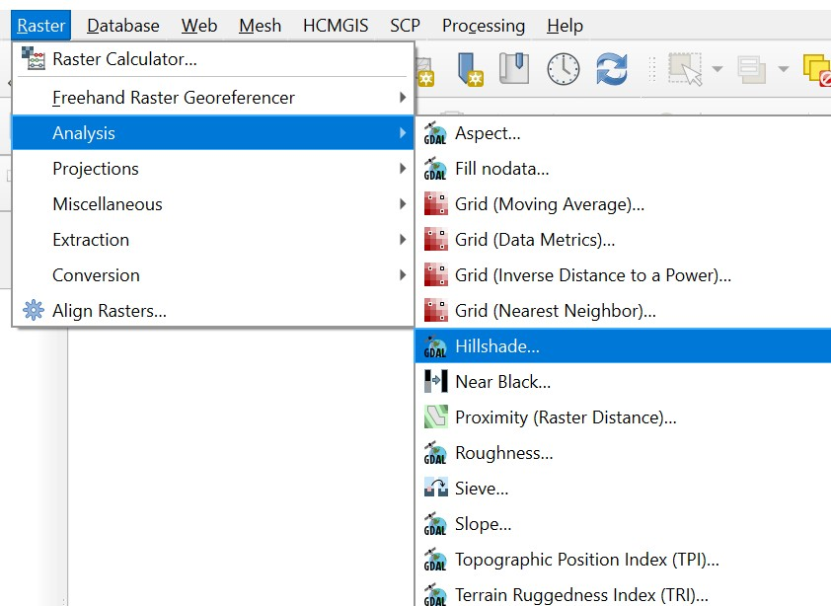

Step 4:

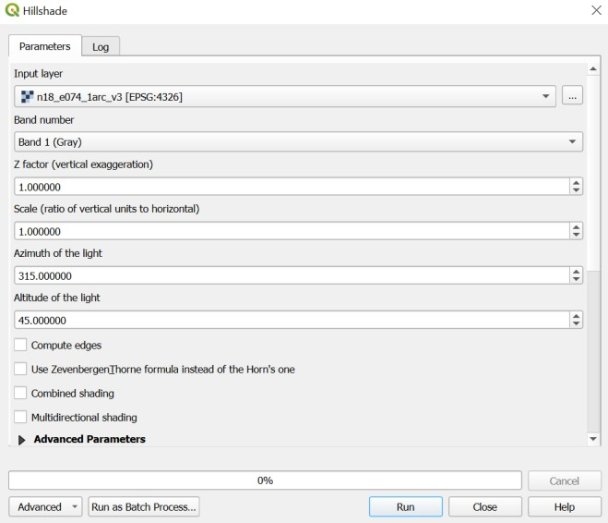

Step 5:

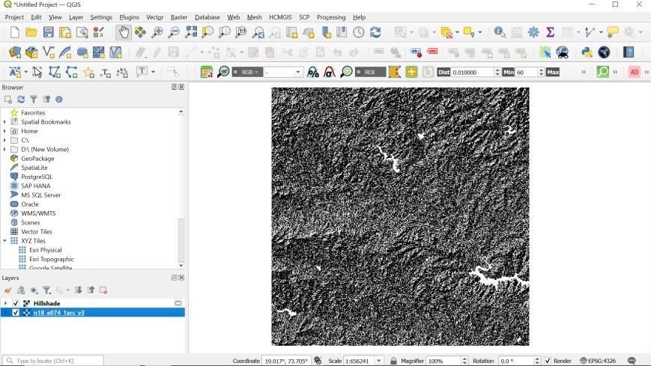

Step 6: Apply some symbology

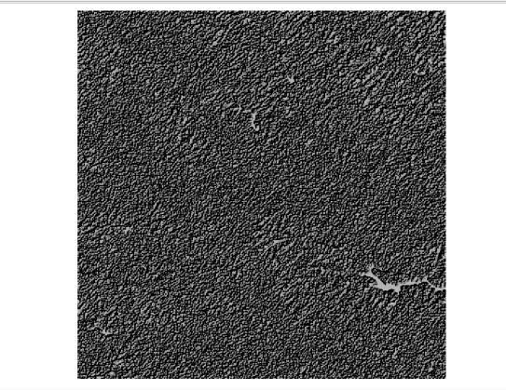

Step 7: Similarly do slop mapping

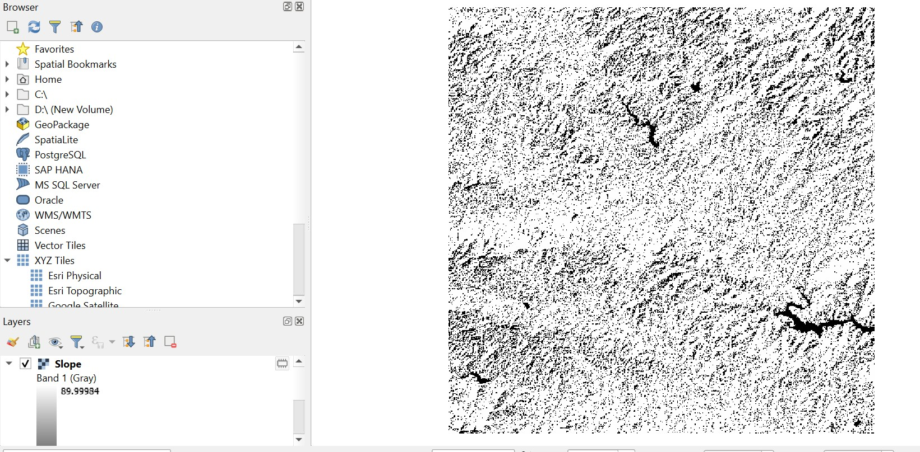

Step 8: Apply some symbology.

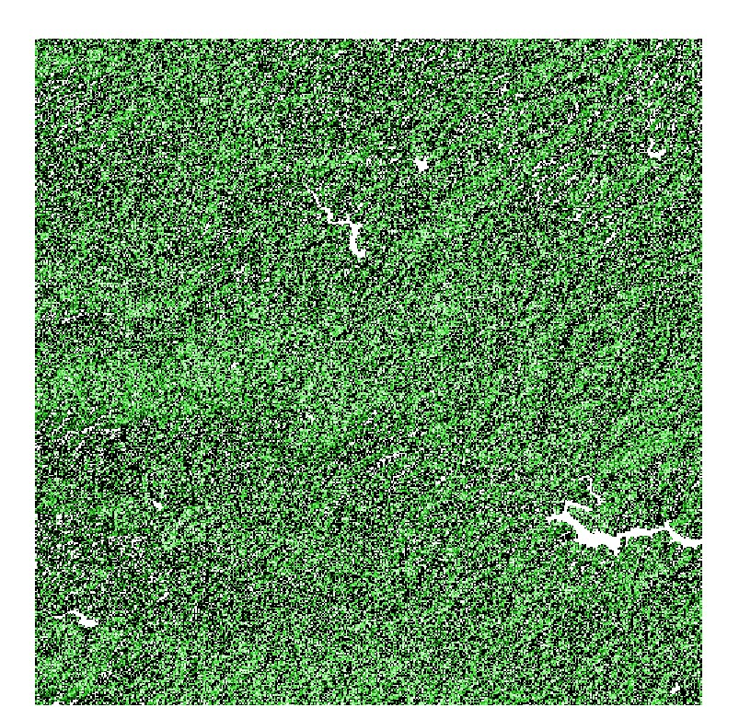

Step 9: Similarly do Aspect.

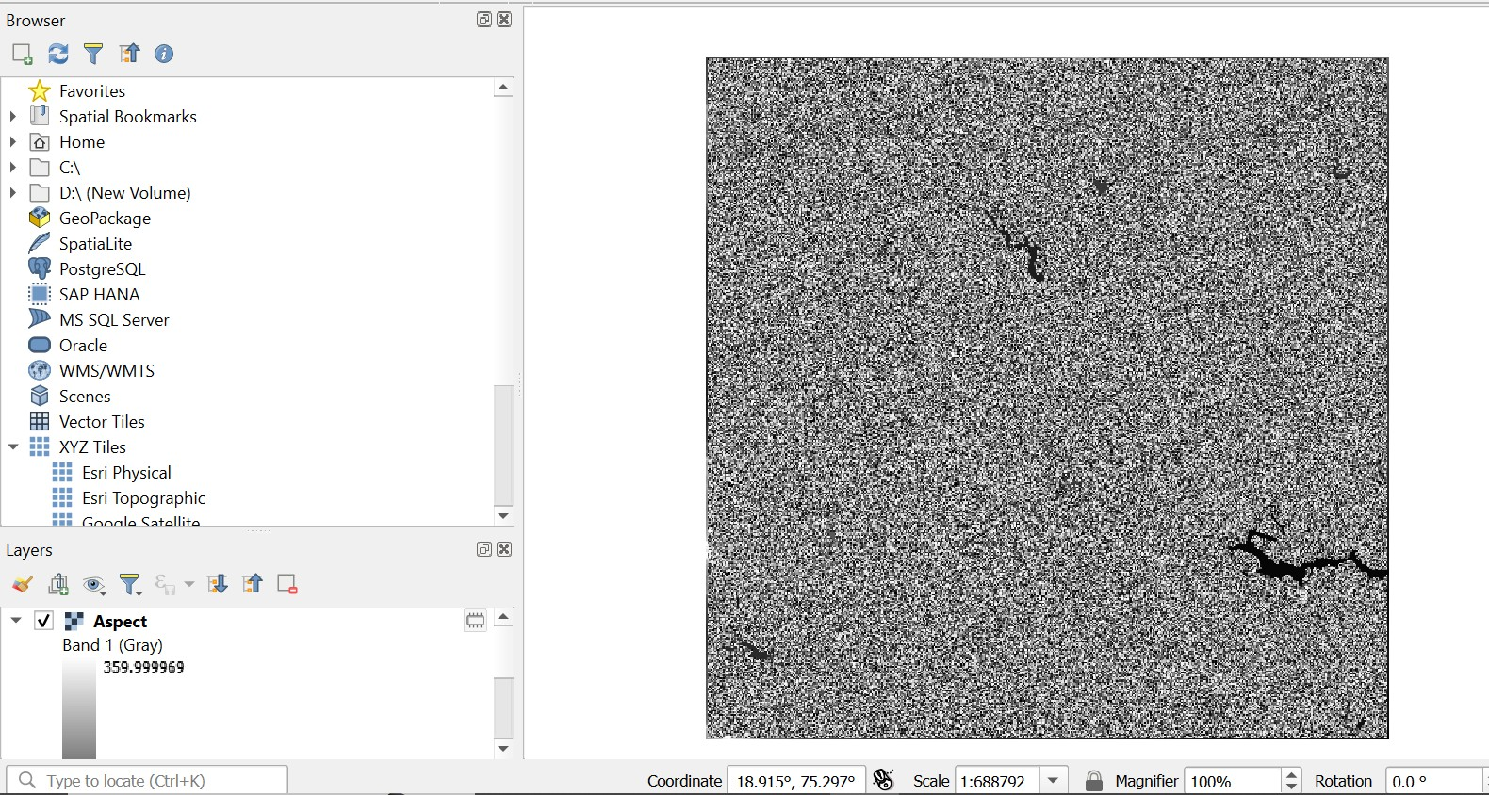

Step 10: Show the histogram

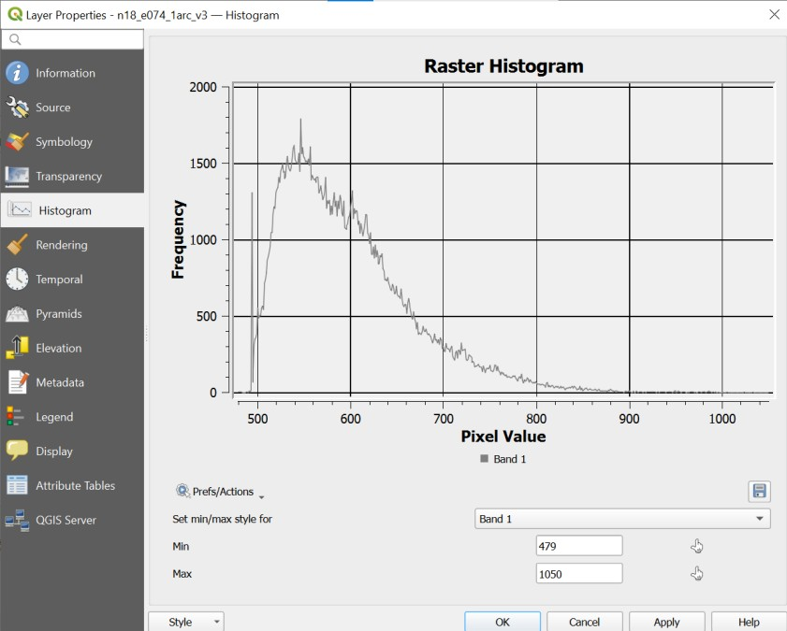

Step 11: Clipping raster

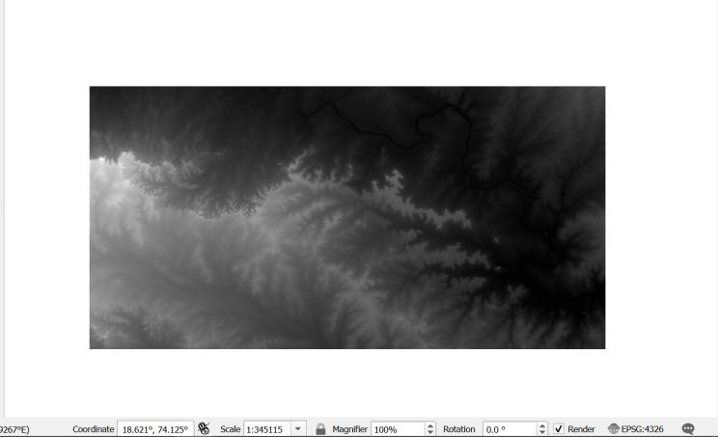

Step 12: Raster styling

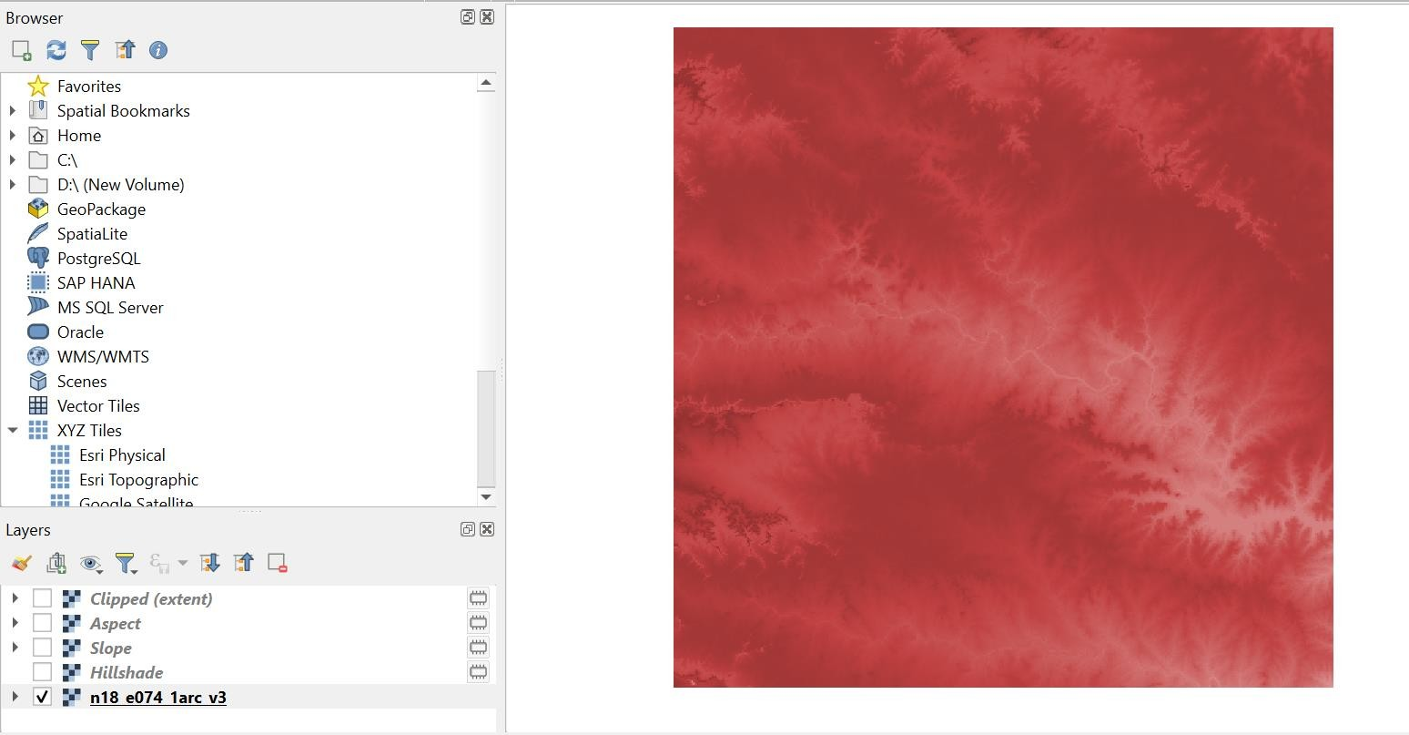

**Assignement number 12**

1. **Download District Maps**

* Visit [IIT Bombay GIS website](https://www.cse.iitb.ac.in/).

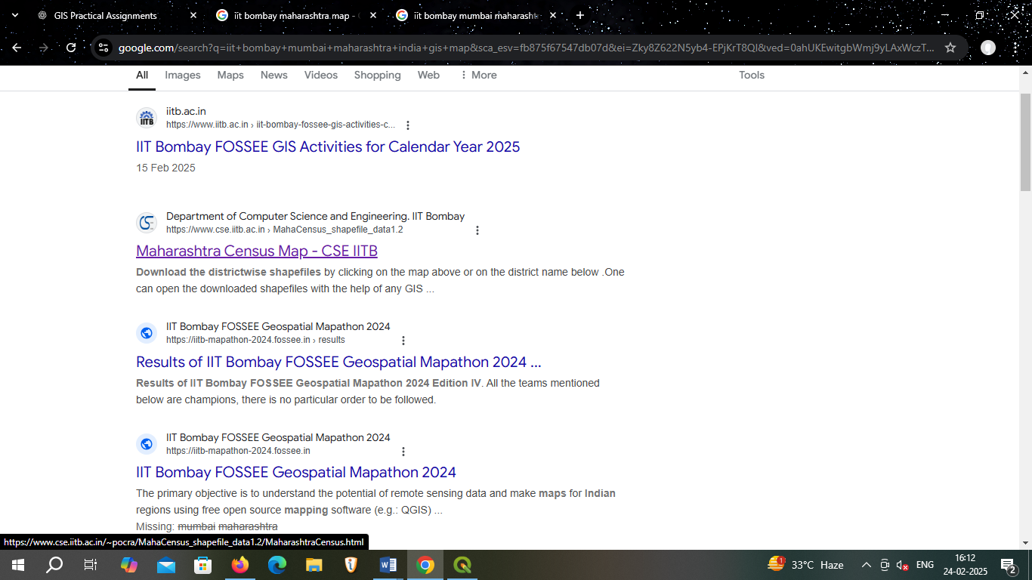

* Download maps for **five districts** (Ahmednagar, Aurangabad, Beed, Pune, Nashik).

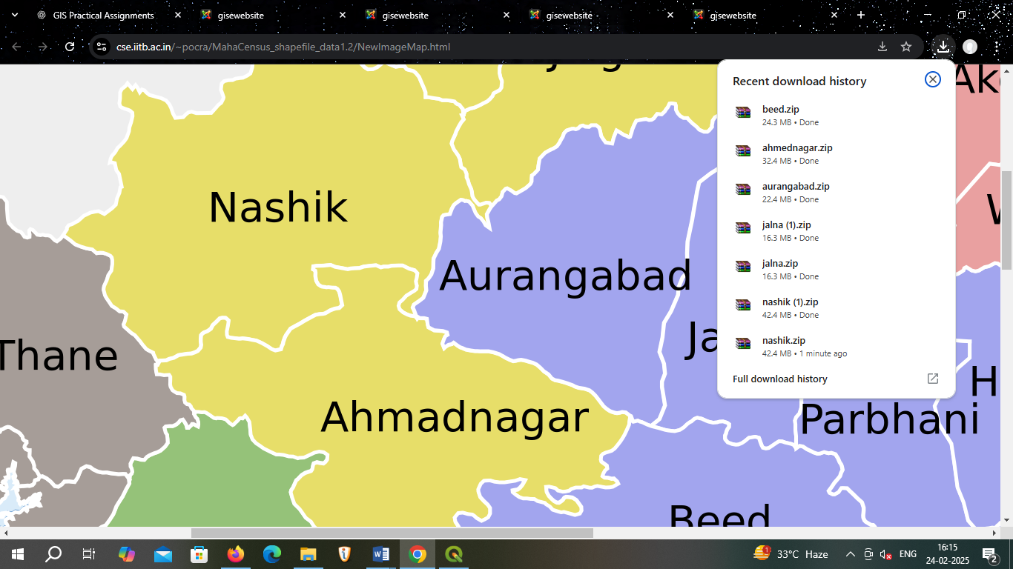

1. **Extract the Downloaded Maps**

* Unzip or extract the files if they are in a compressed format (e.g., .zip).
* Ensure that all maps are accessible in a folder.

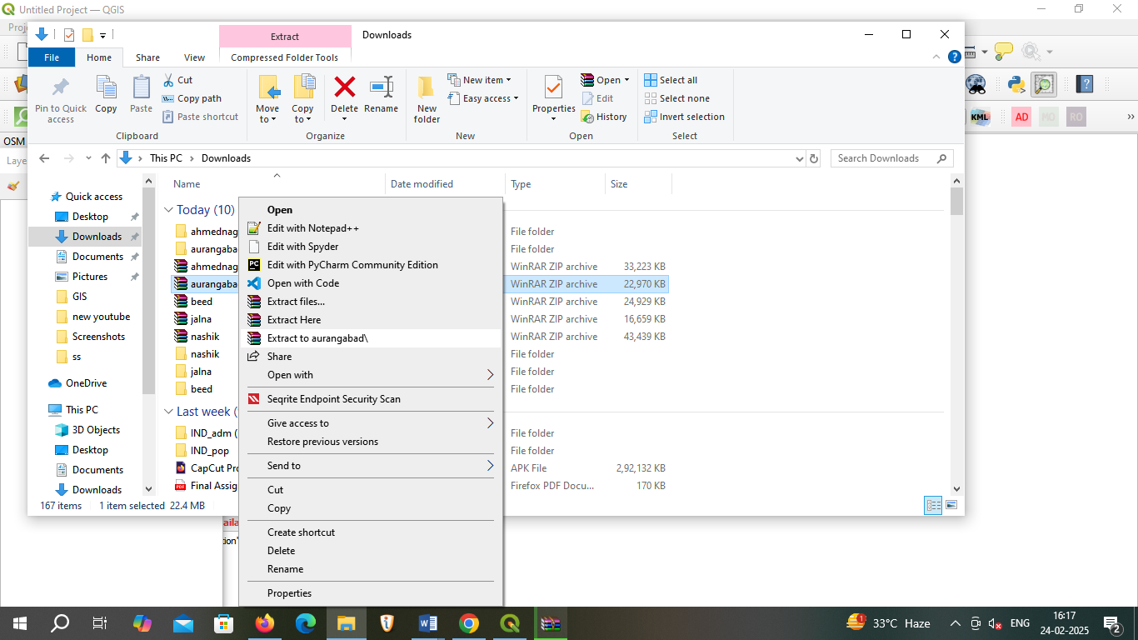

1. **Add Vector Layers**

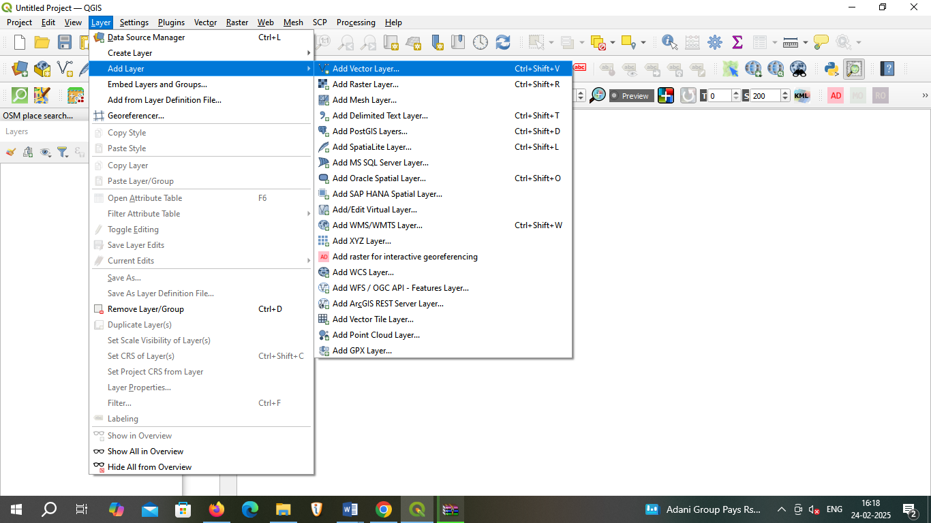

1. **Browser open extract file**

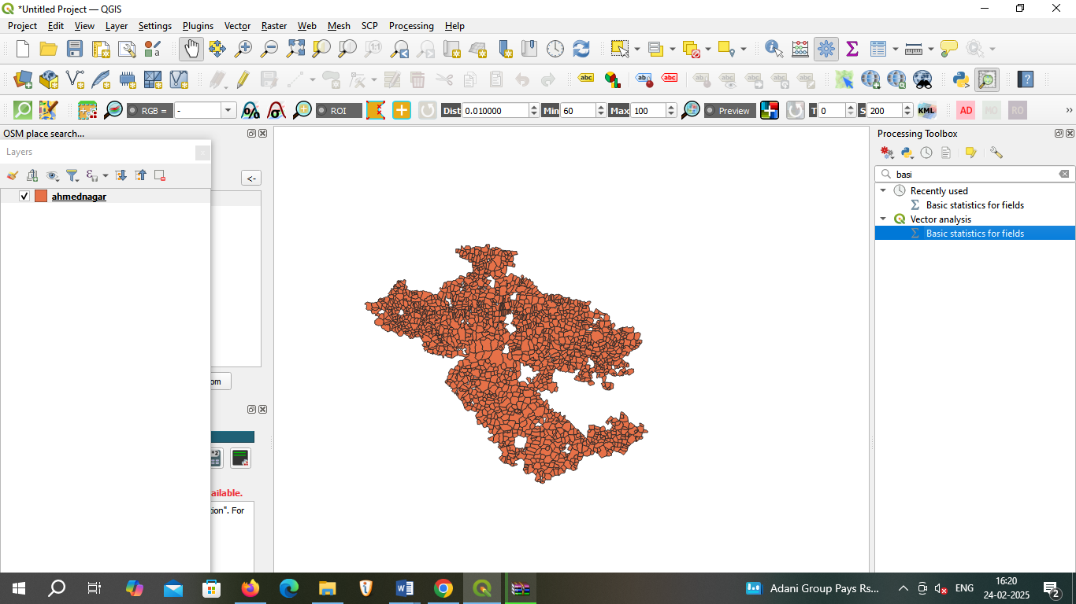

1. 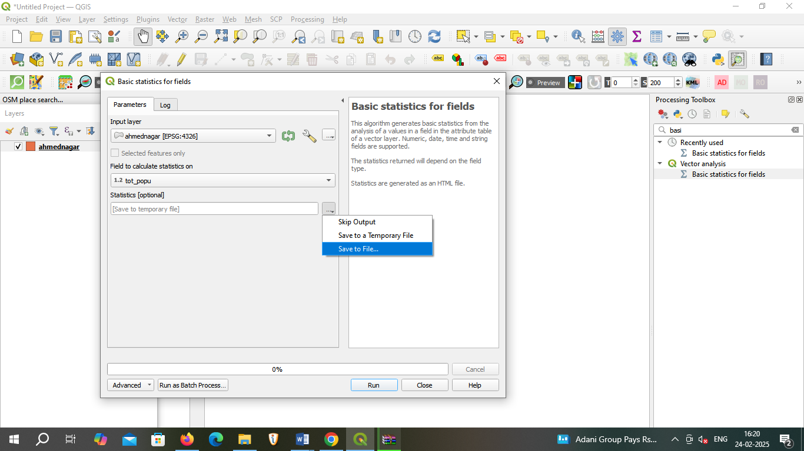**Search Basic statistics for fields input layer field and save file :**
2. **Run** 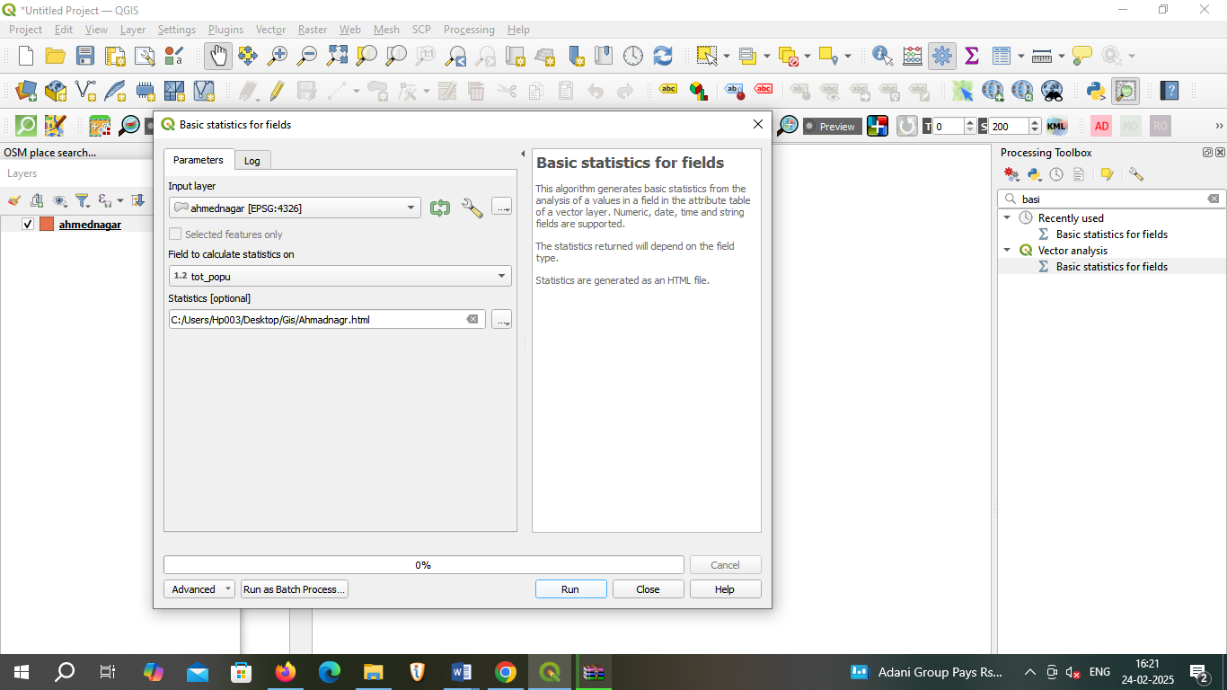
3. 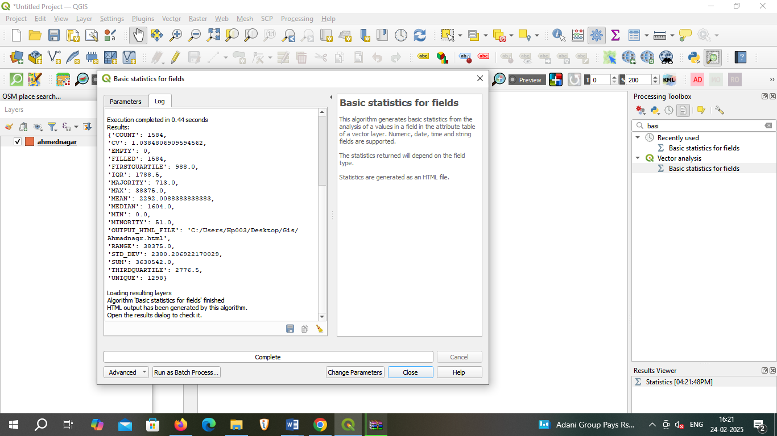 **Open toolbox Search vector layer histogram open this :**

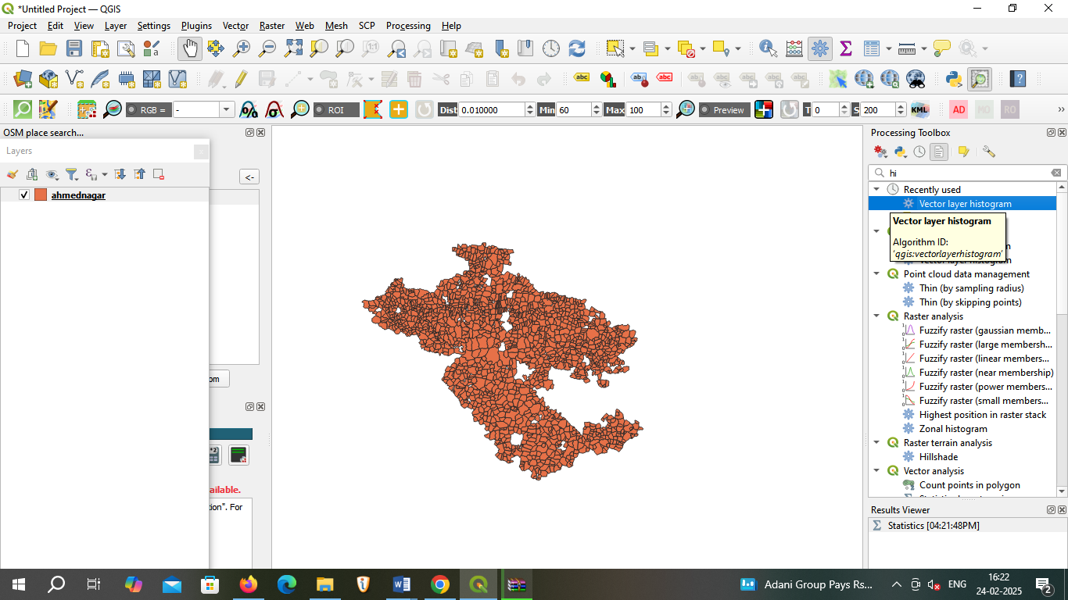

1. **Save this file**

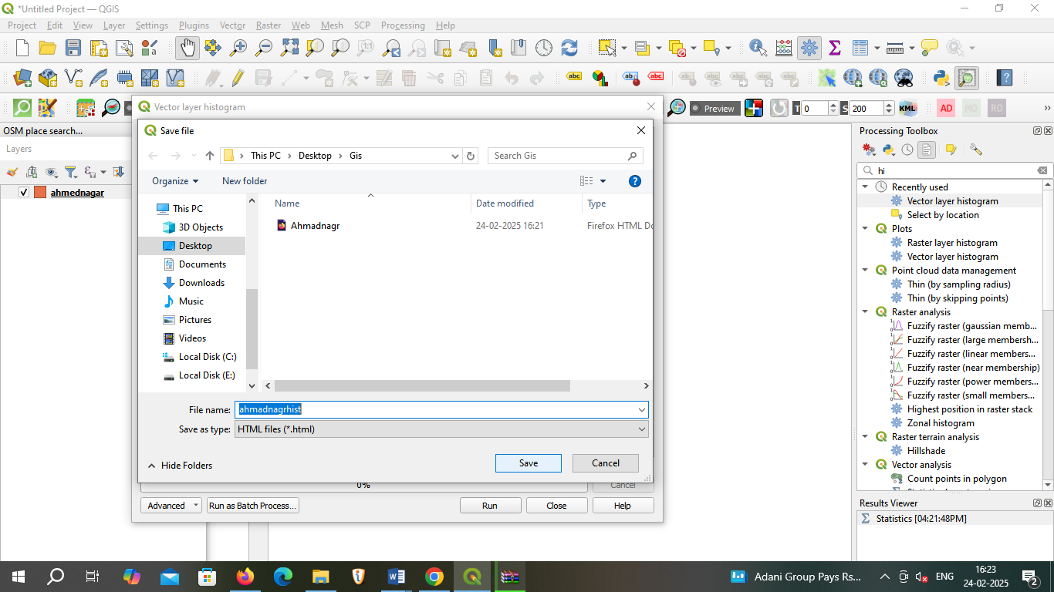

1. 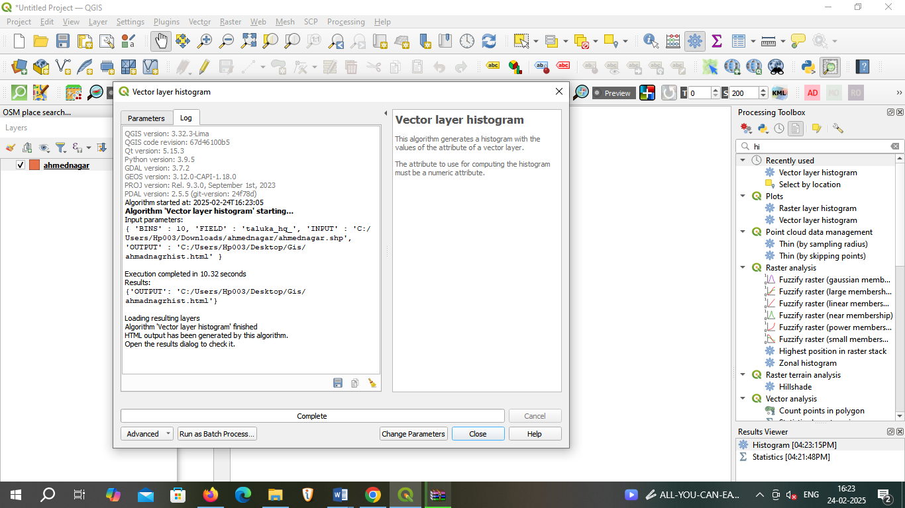**Output overview**
2. **Open this save file**

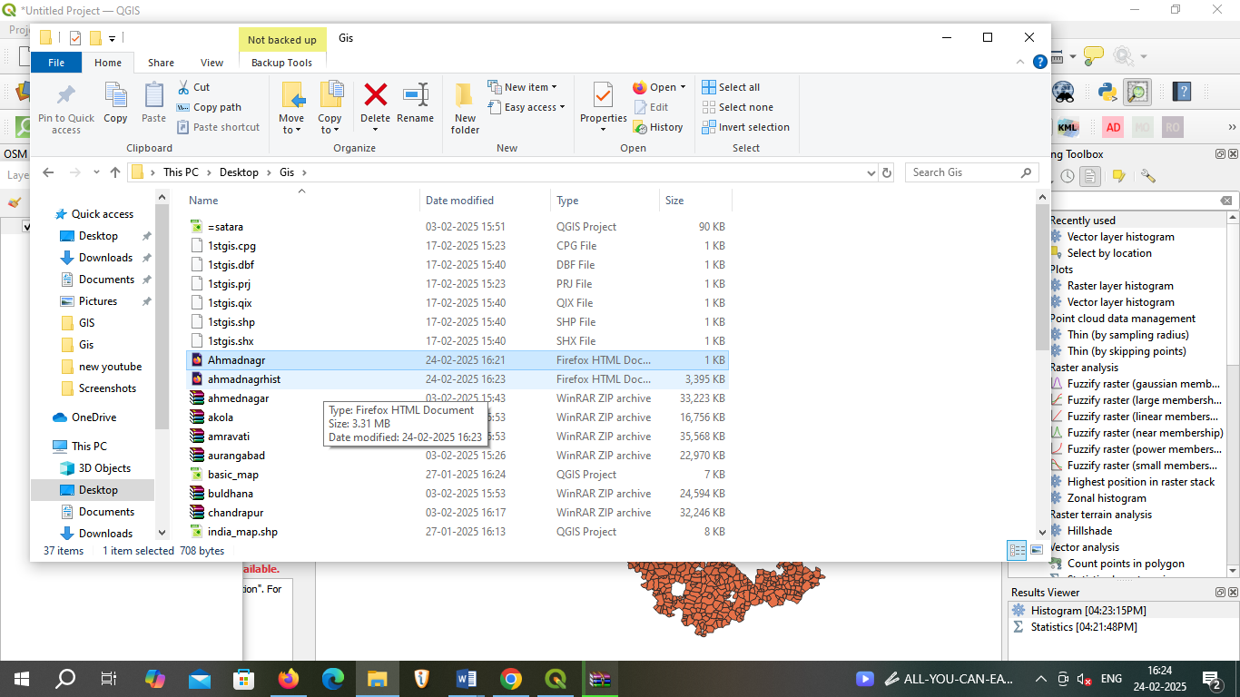

**Ahmednagar Basic statistics for fields output :** 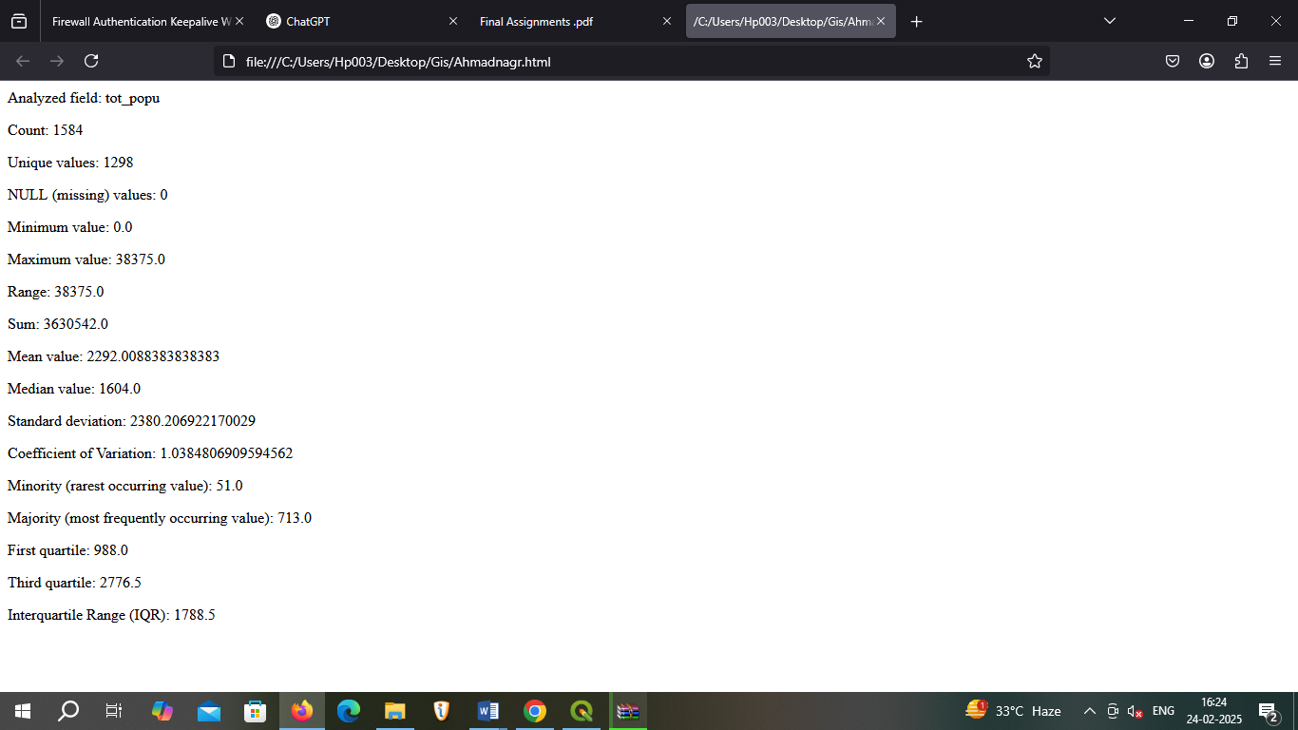

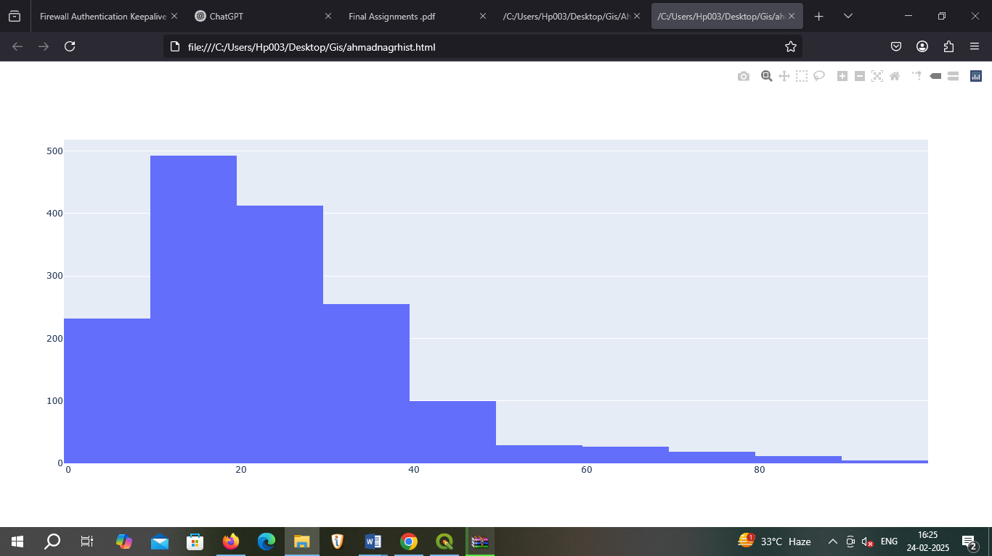**Ahmednagar vector layer histogram**

**2) Aurangabad**

**Basic statistics for fields output :**

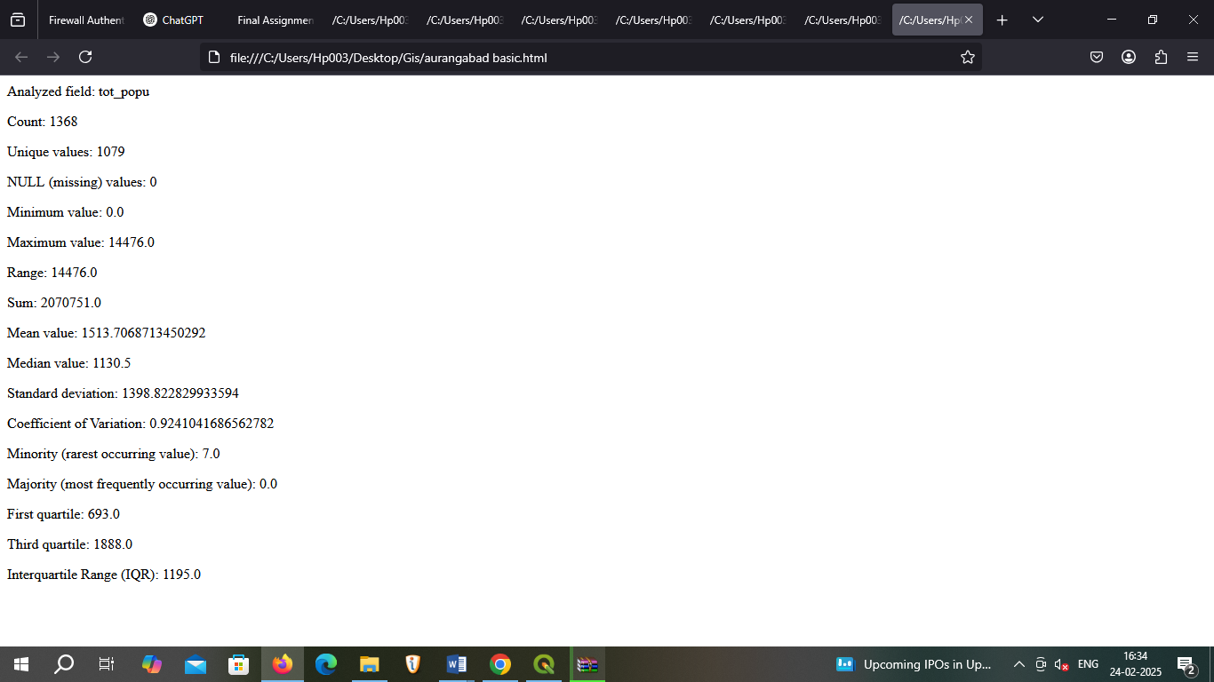

**vector layer histogram**

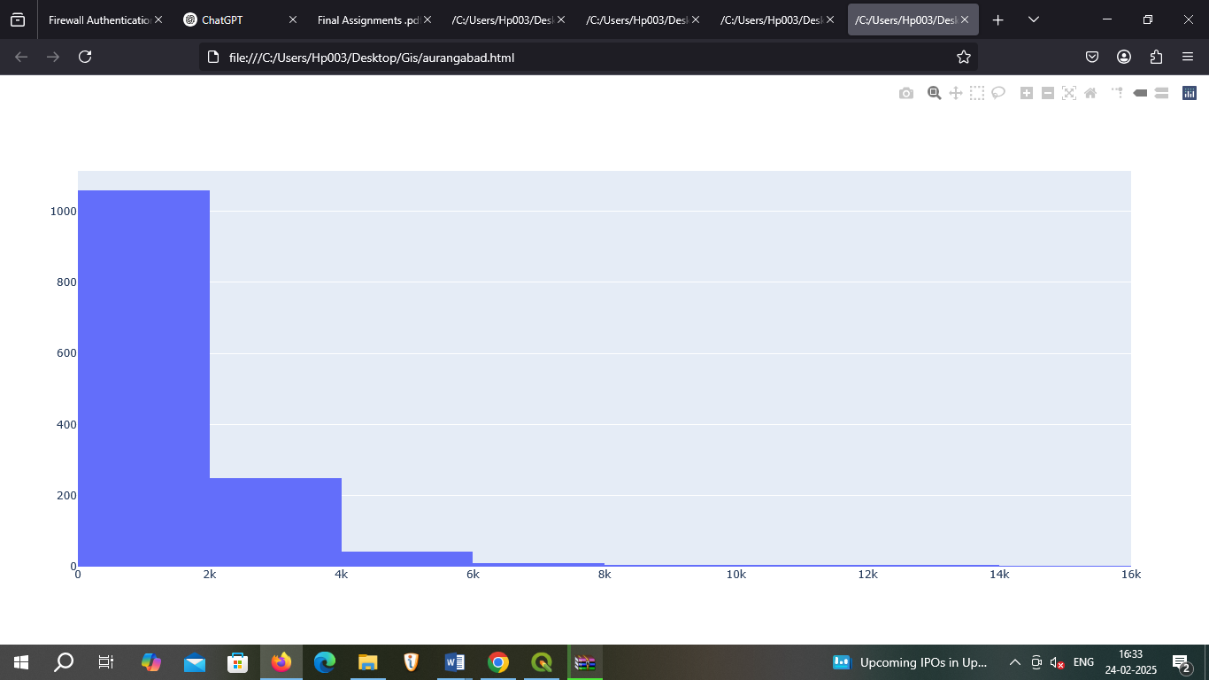

**3) Beed**

**Basic statistics for fields output :**

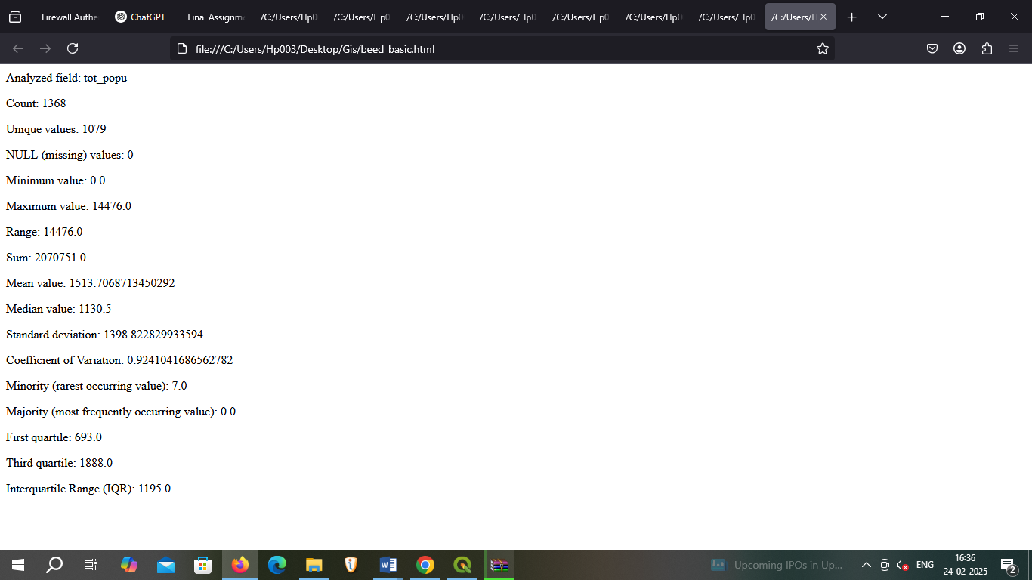

**vector layer histogram**

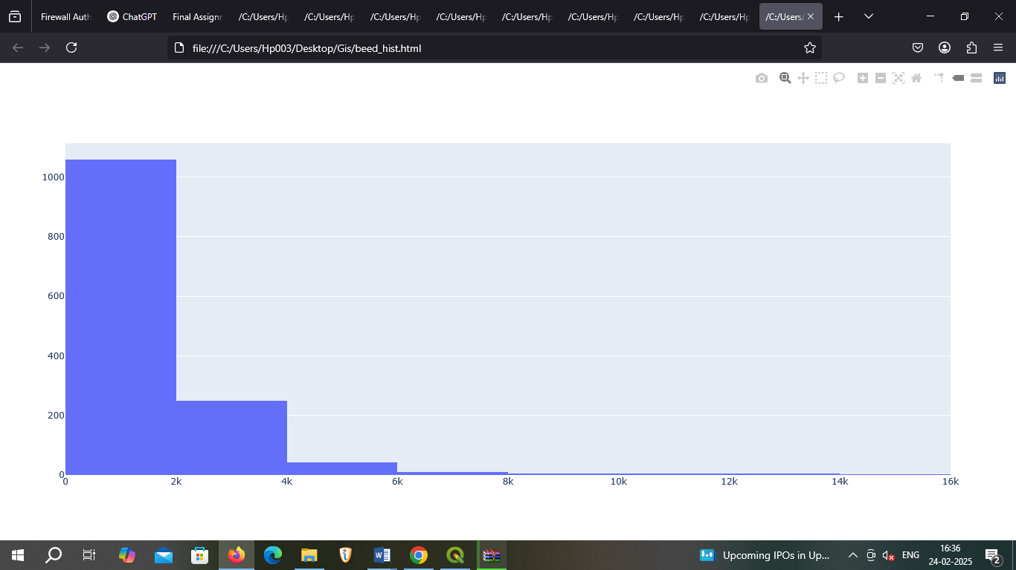

**4) pune**

**Basic statistics for fields output :**

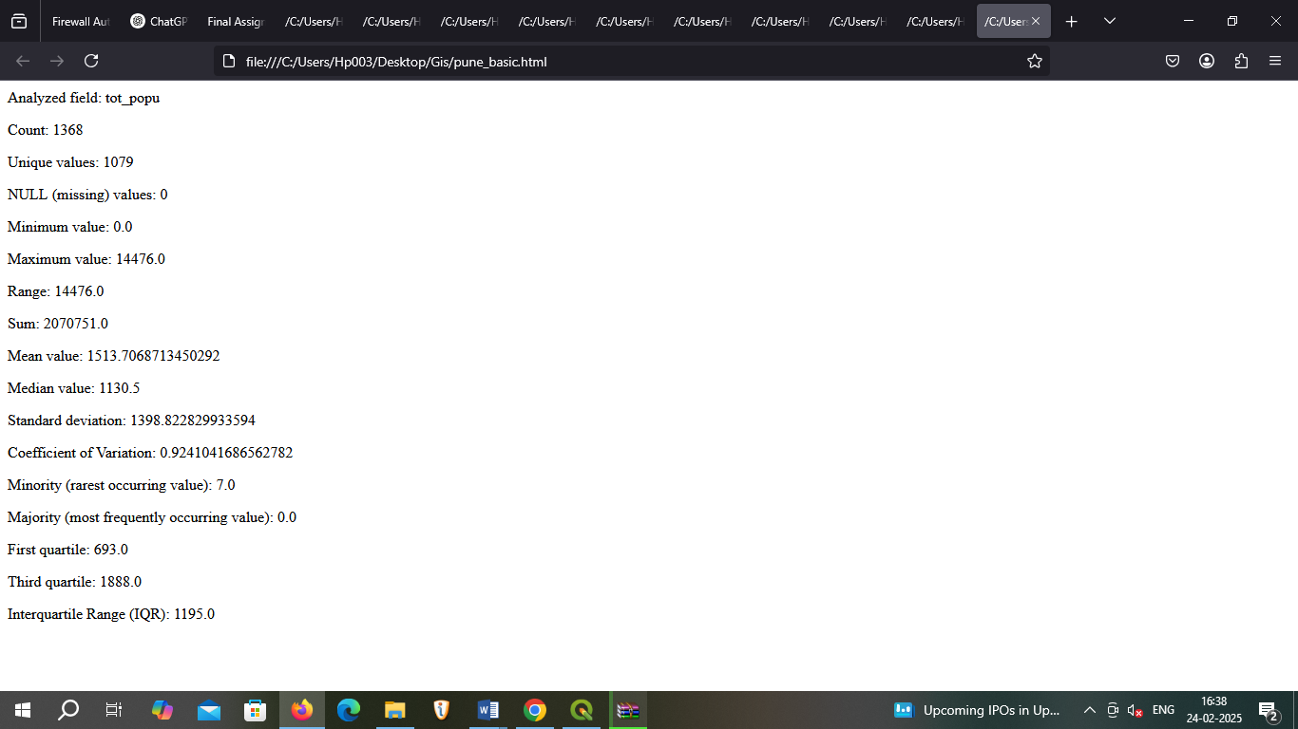

**vector layer histogram**

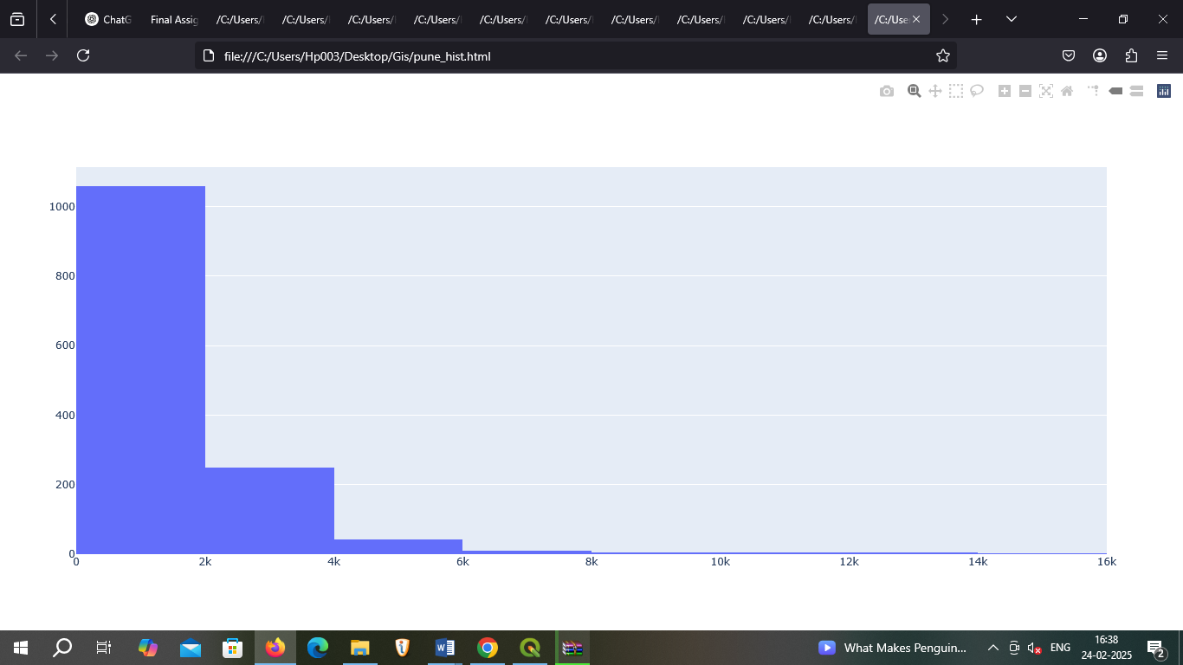

**5) Nashik**

**Basic statistics for fields output :**

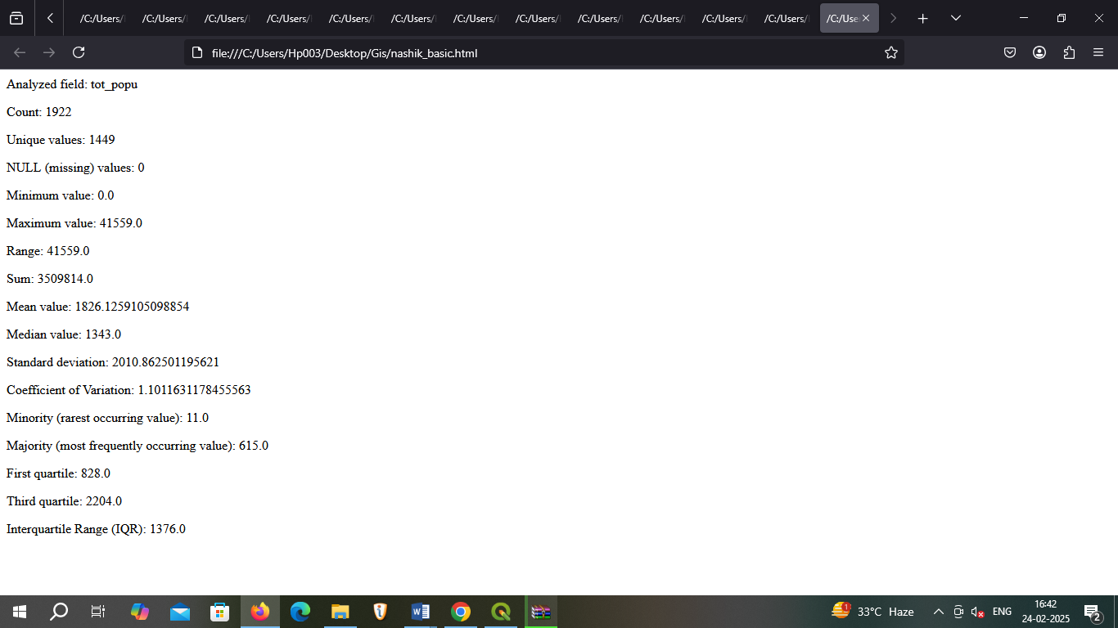

**vector layer histogram**

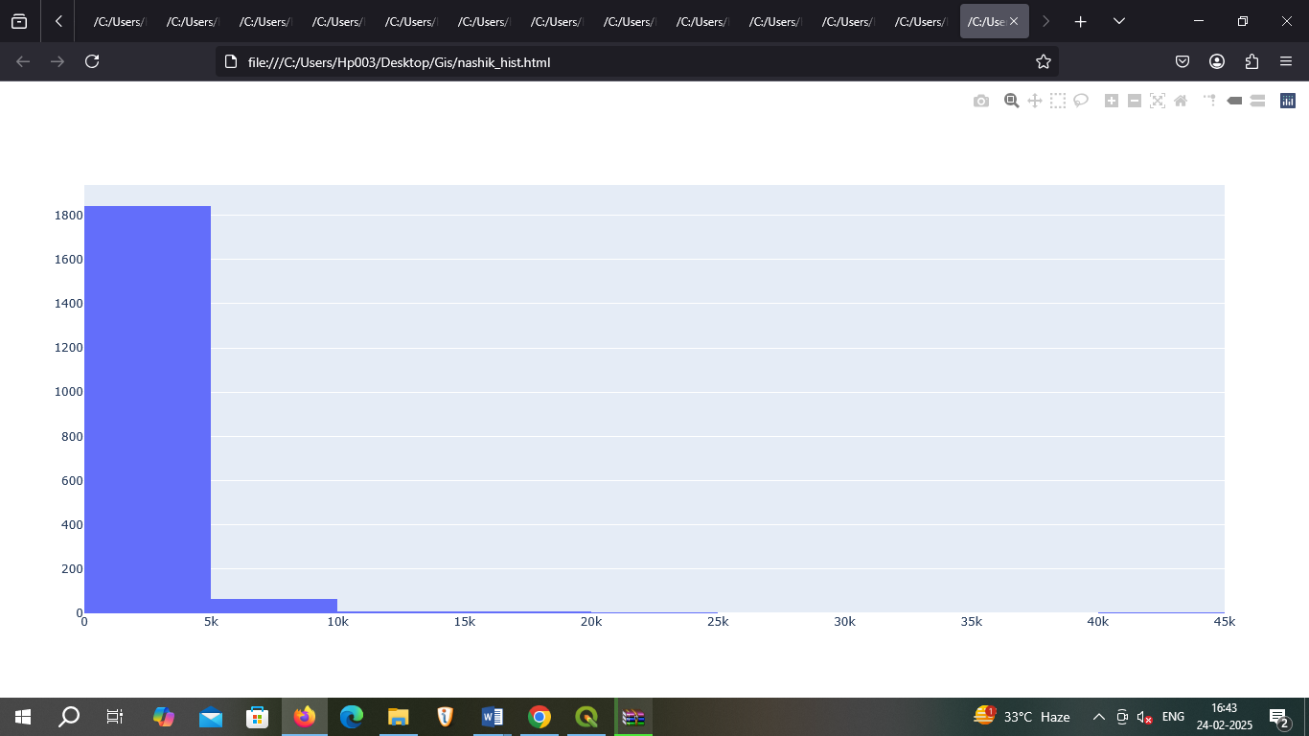

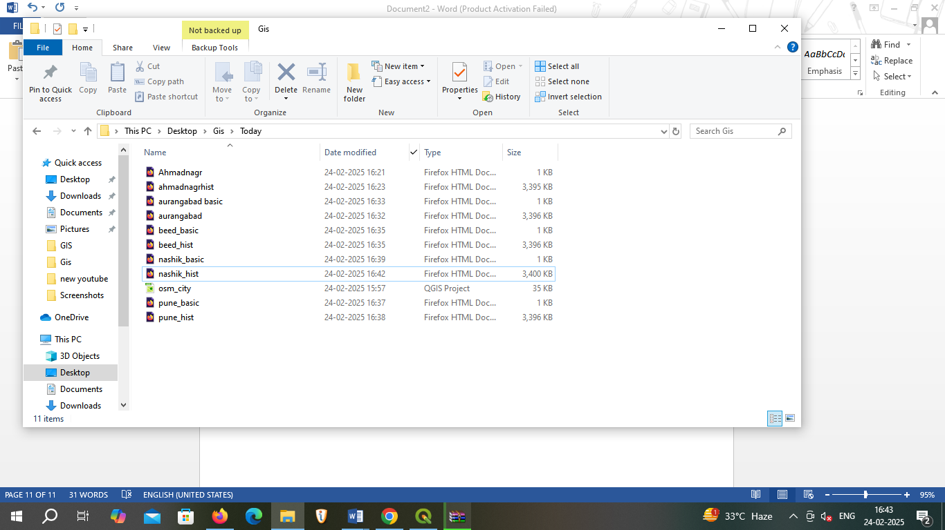

**Practical Assignment : 13**

**Aim: Create ARFF file of given elements .**

**1.First elements is rose flower.**

**Step 1. Open notepad++**

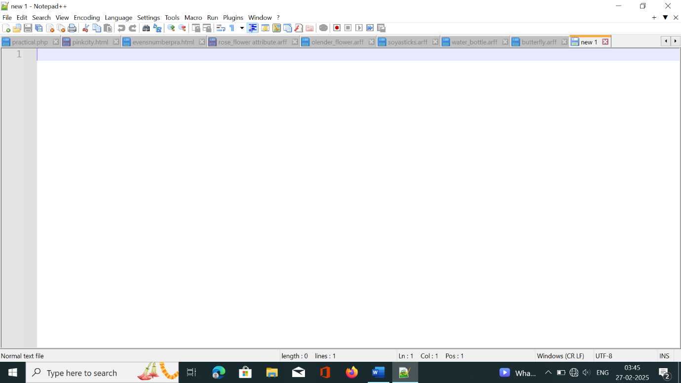

**Step 2. Add a ARFF code of rose flower.**

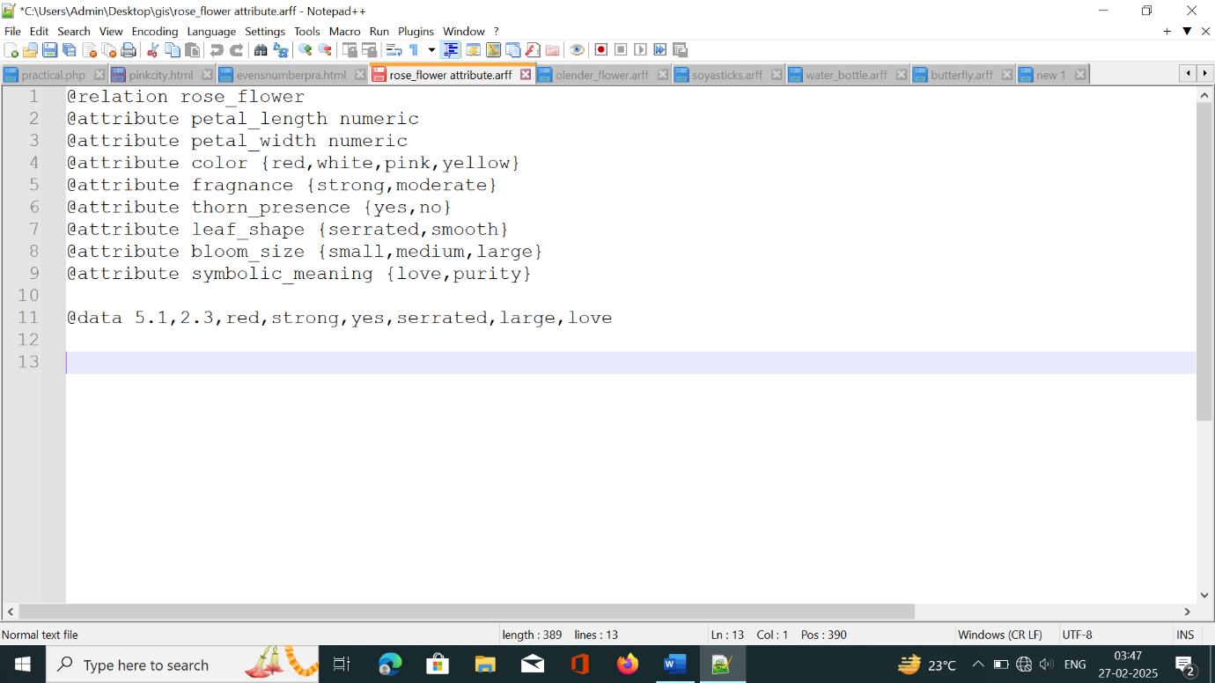

**Step 3. Save code in desktop with extension .arff**

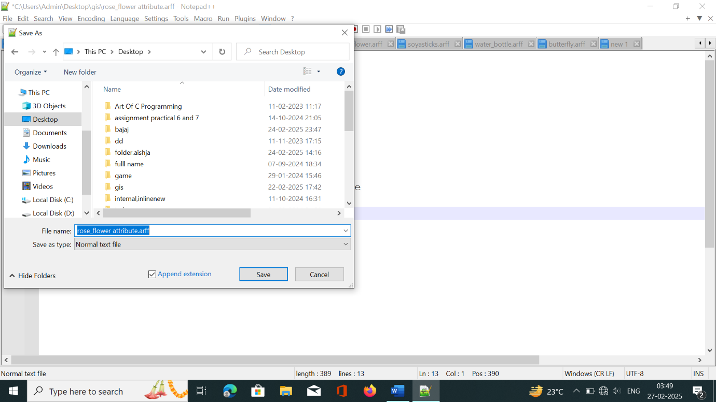

**Step 4. Open the WEKA tool and click explorer.**

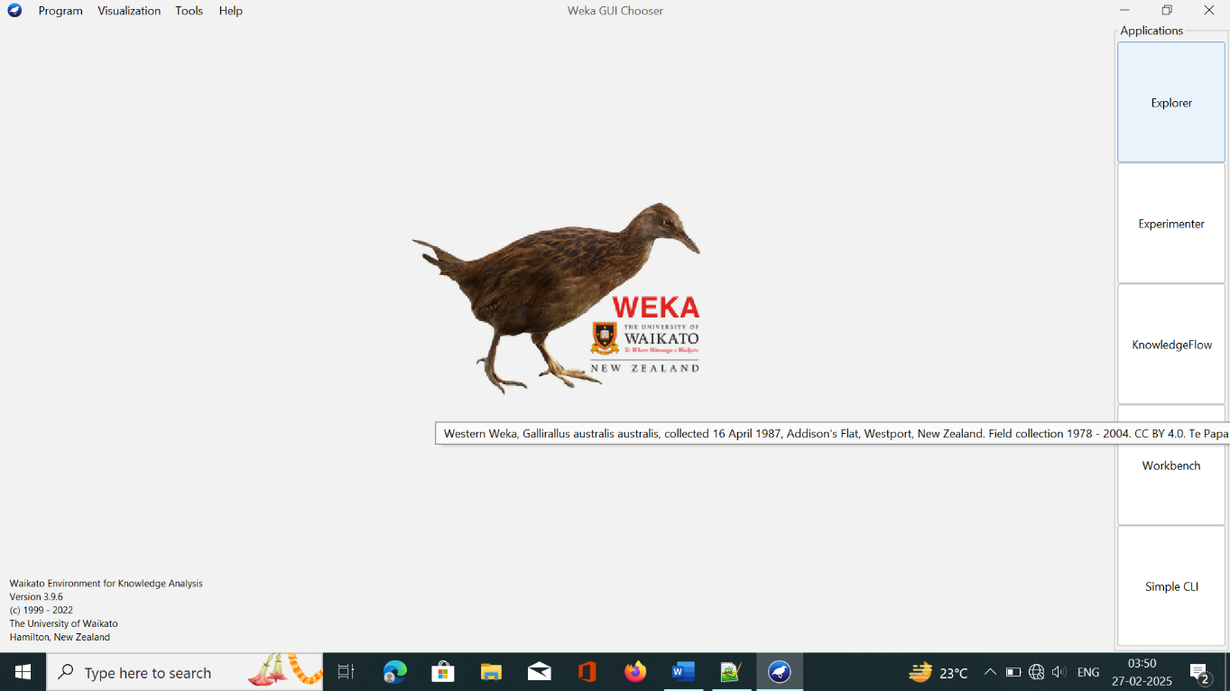

**Step 5. Click open file.**

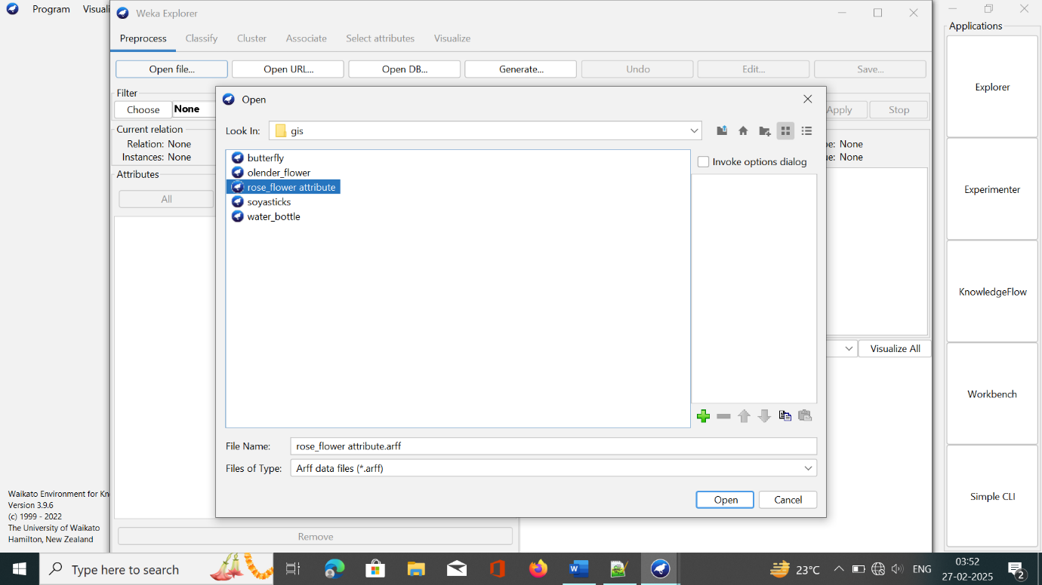

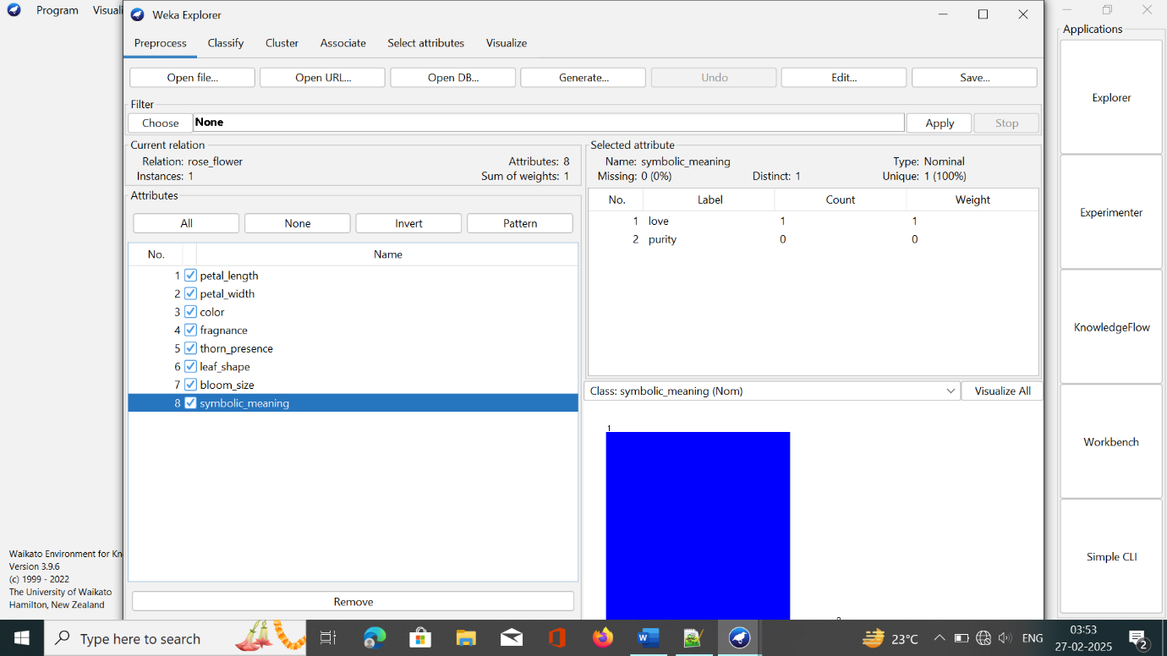

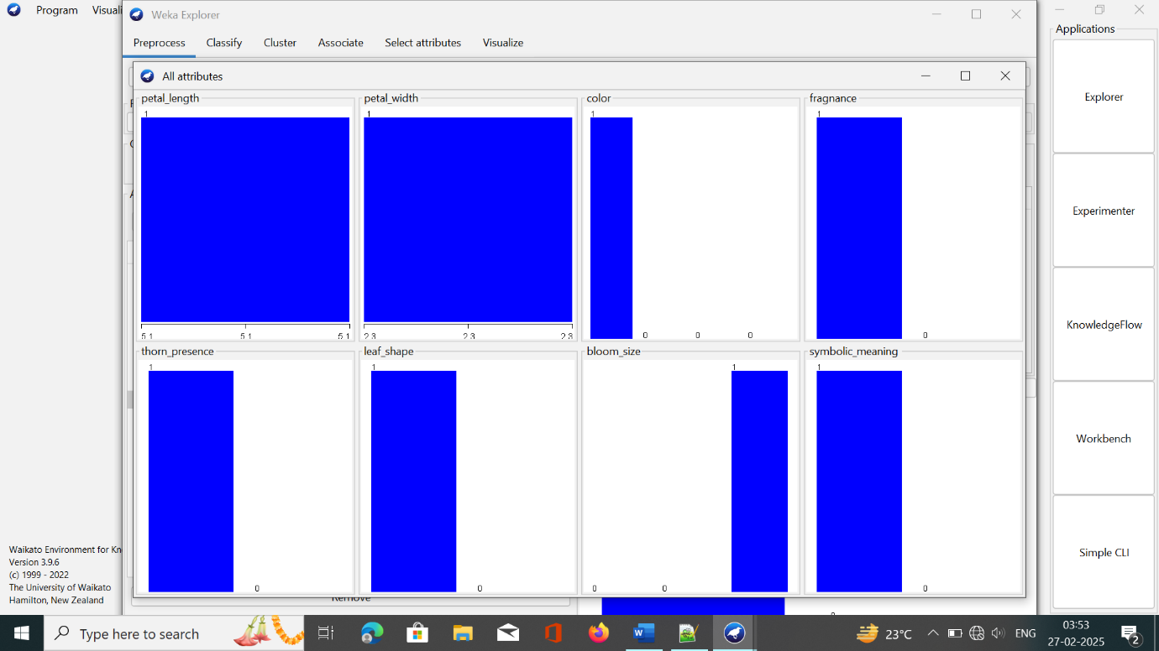

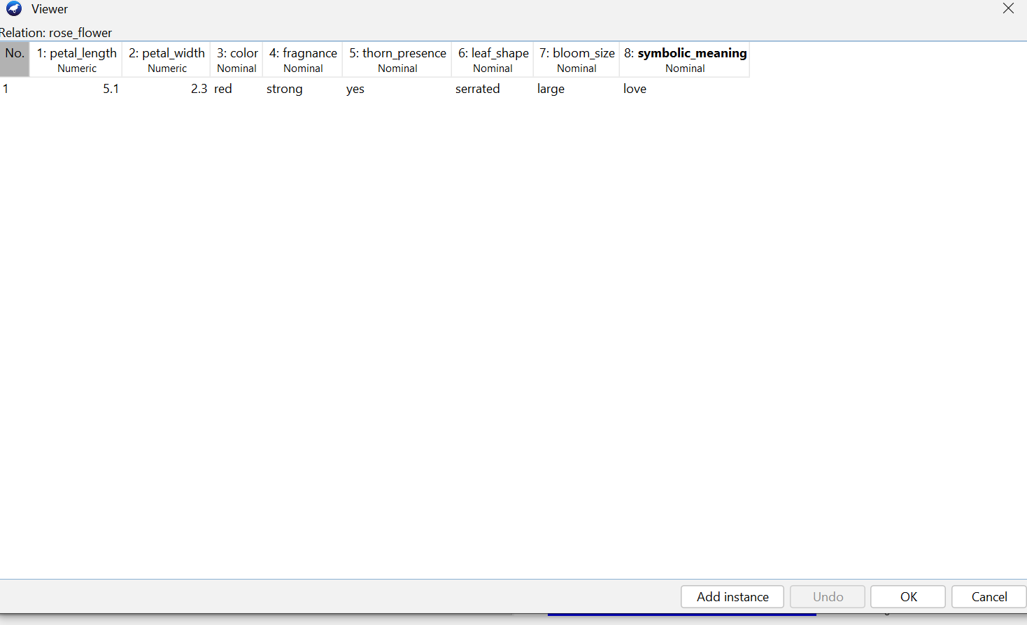

**PRACTICAL ASSIGNMENT: 13**

**2. Second element is Olender Flower.**

**Attribute ARFF code:**

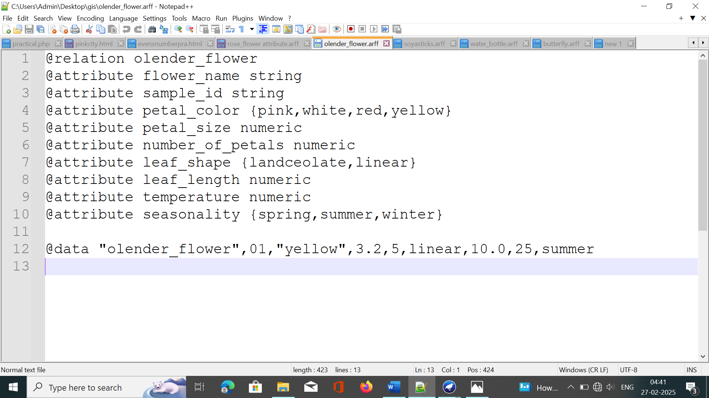

**Output:**

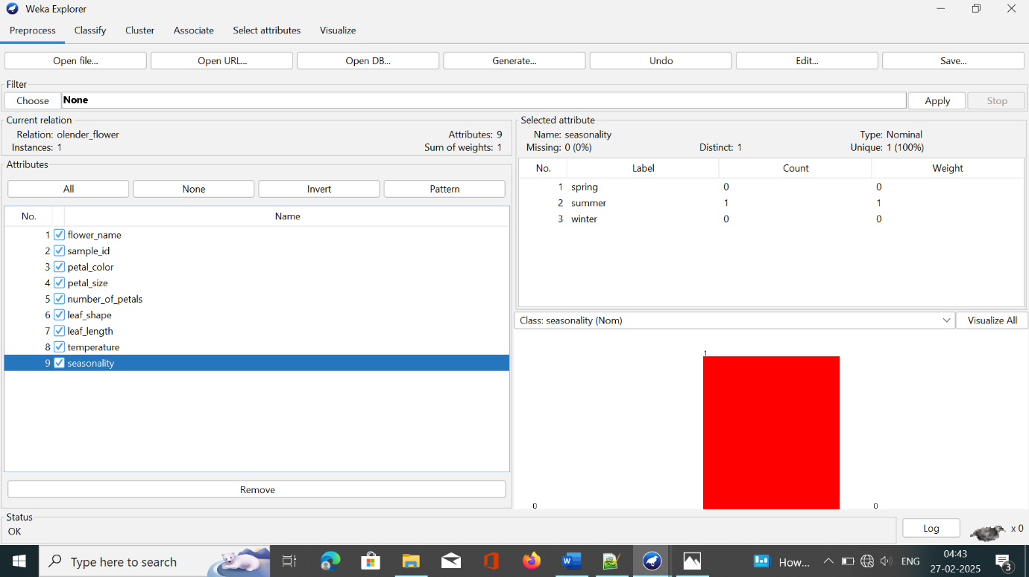

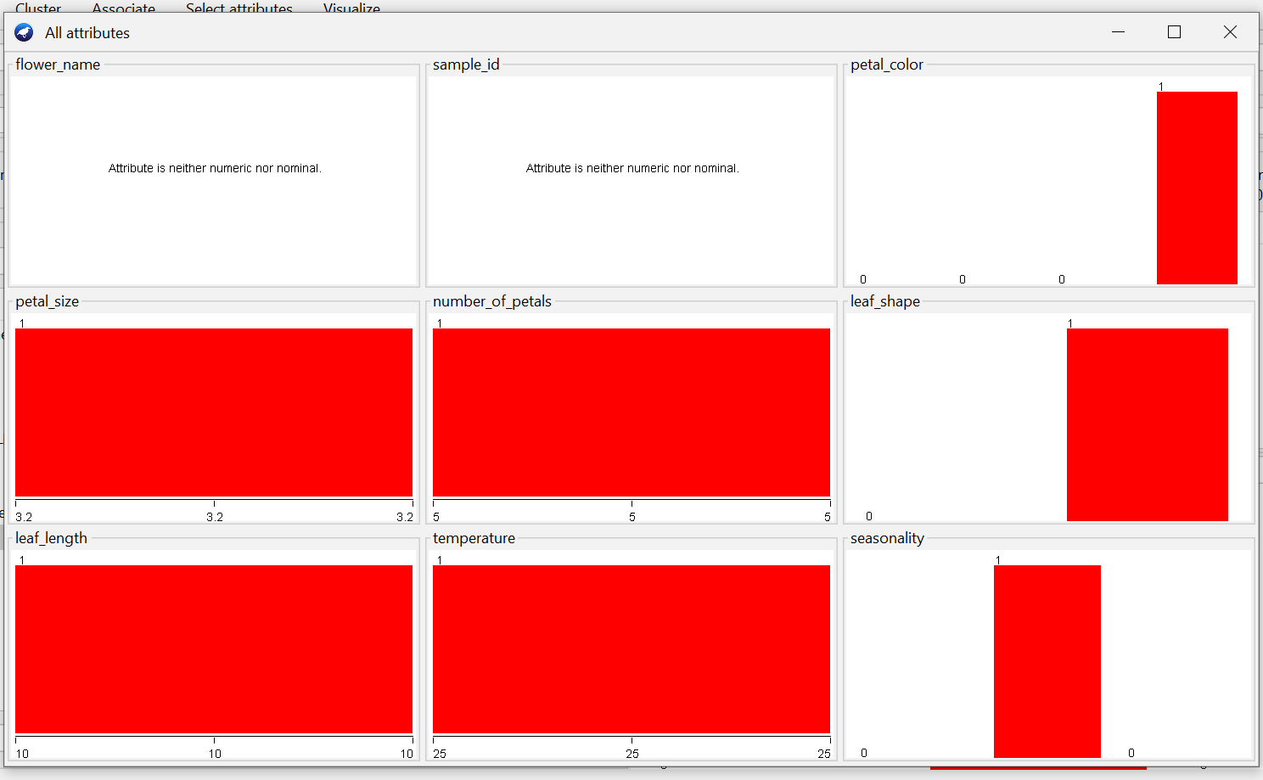

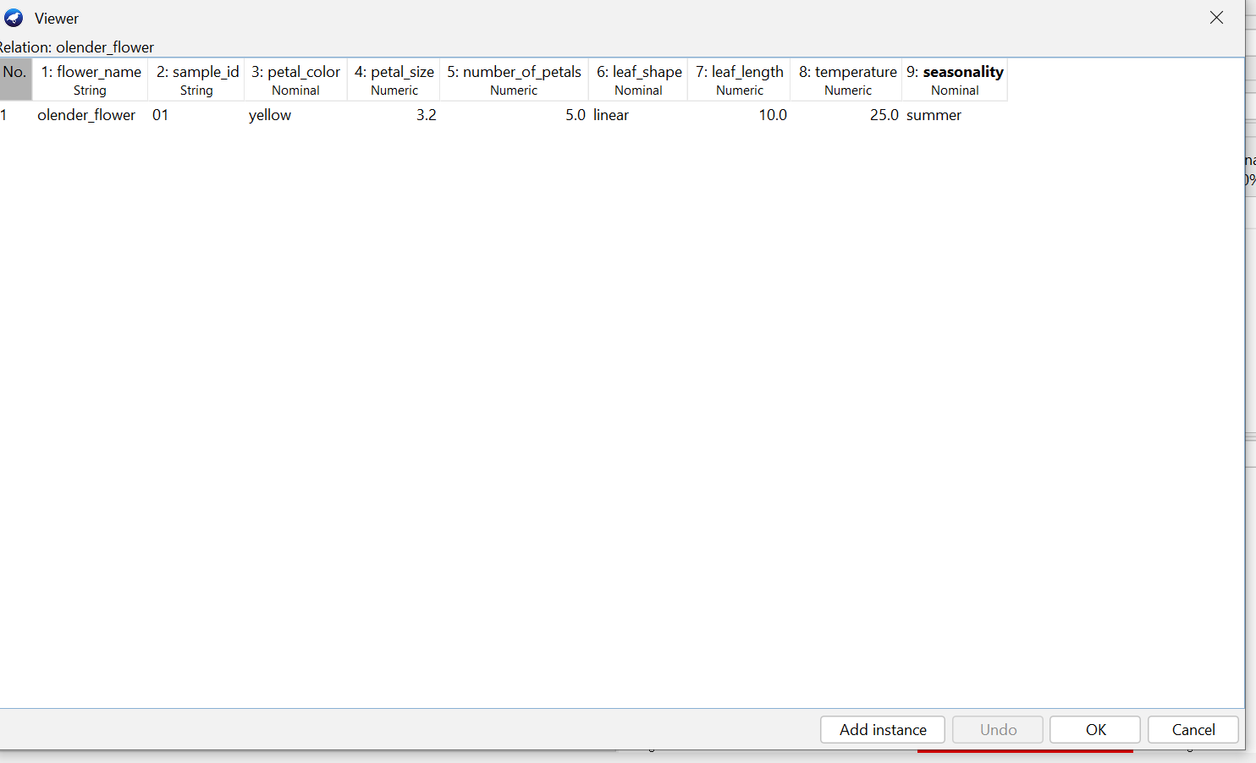

**PRACTICAL ASSIGNMENT : 14**

**3.Third element is soya sticks.**

**Attributes ARFF code:**

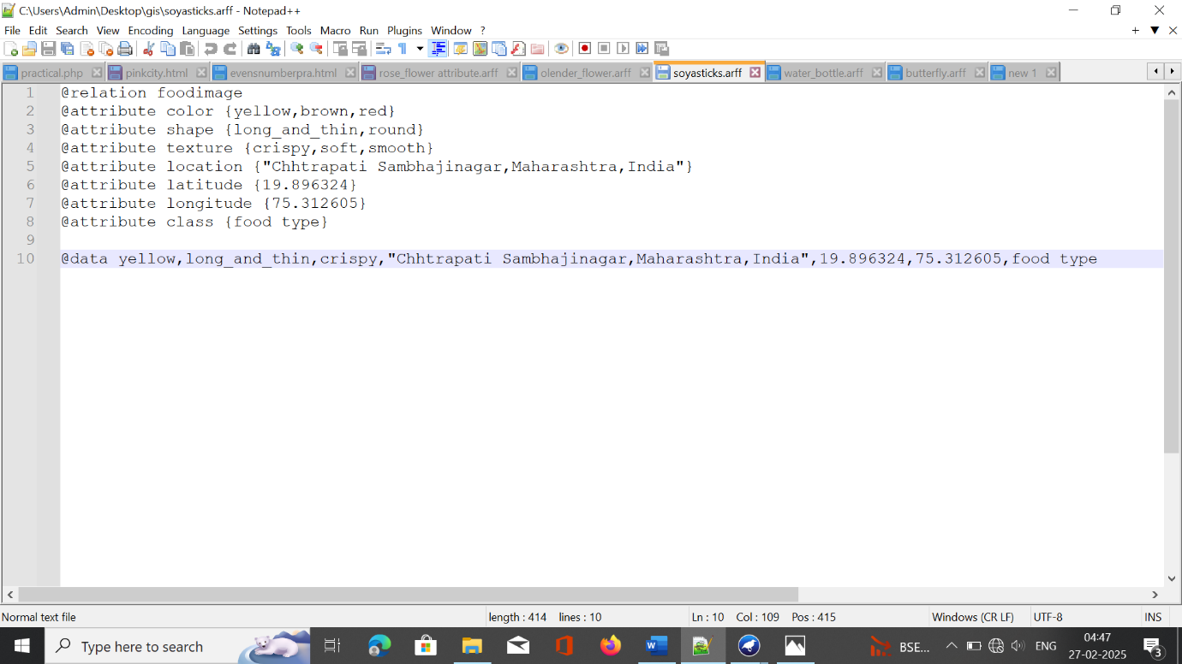

**Output:**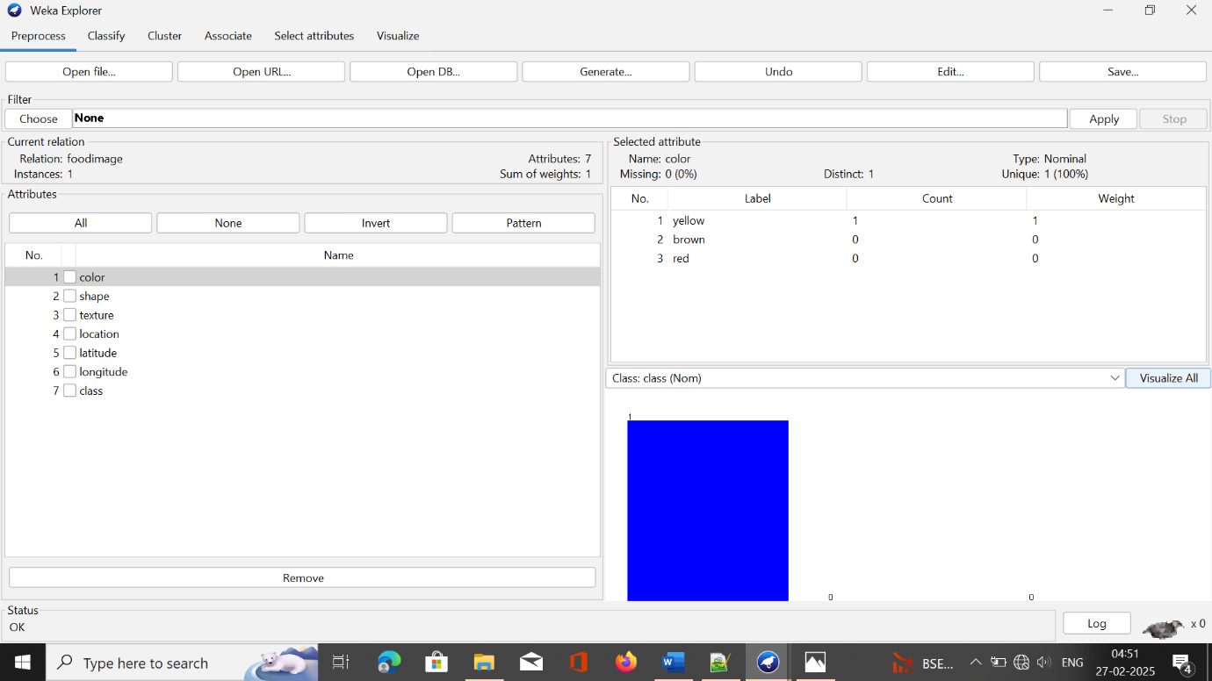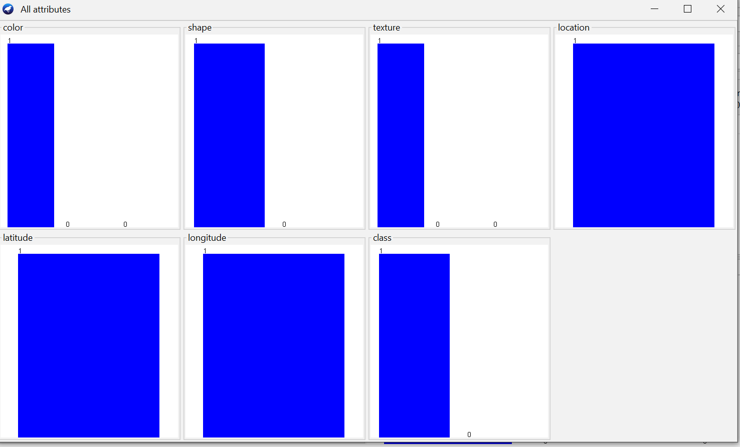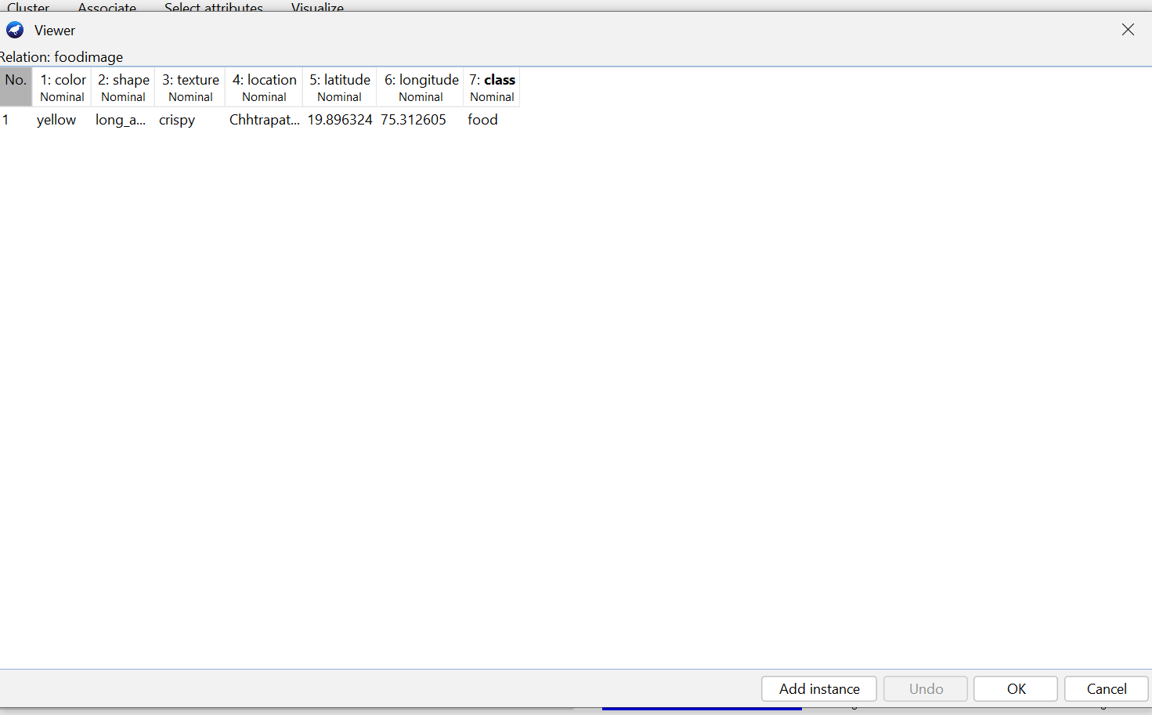

**PRACTICAL ASSIGNMENT : 15**

**4. Fourth element is water bottle.**

**Attribute ARFF code.**

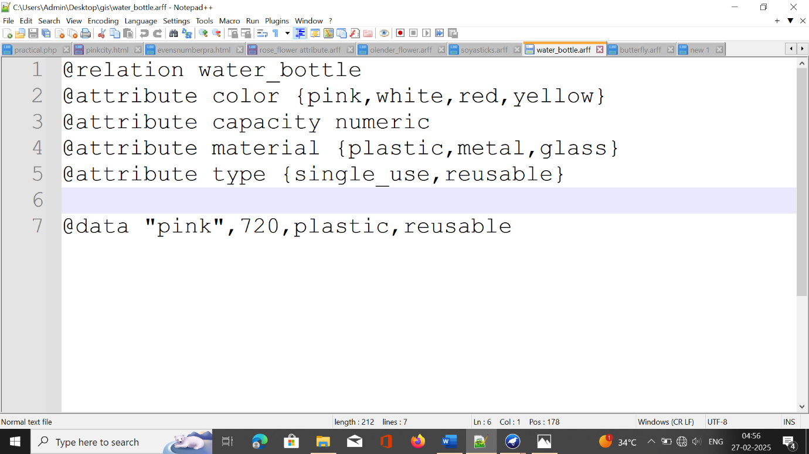

**Output:**

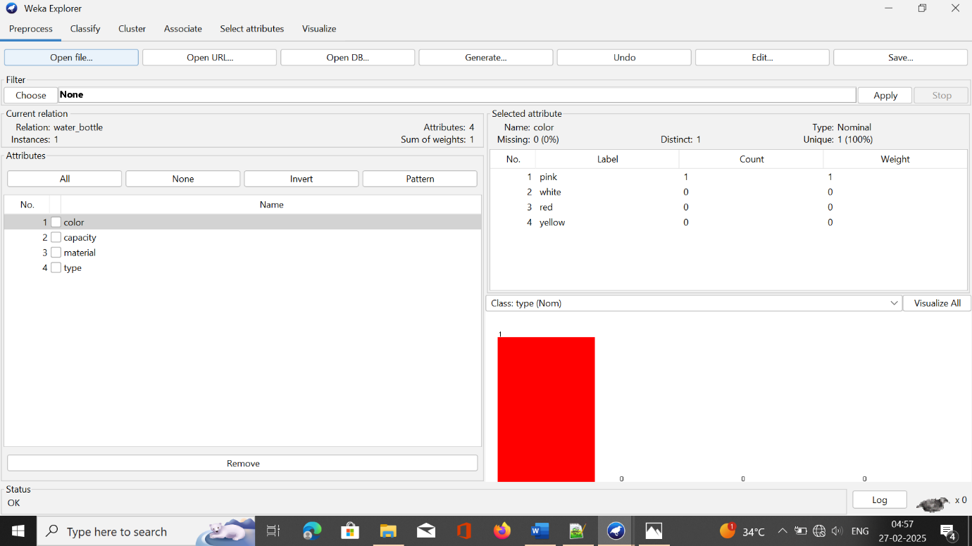

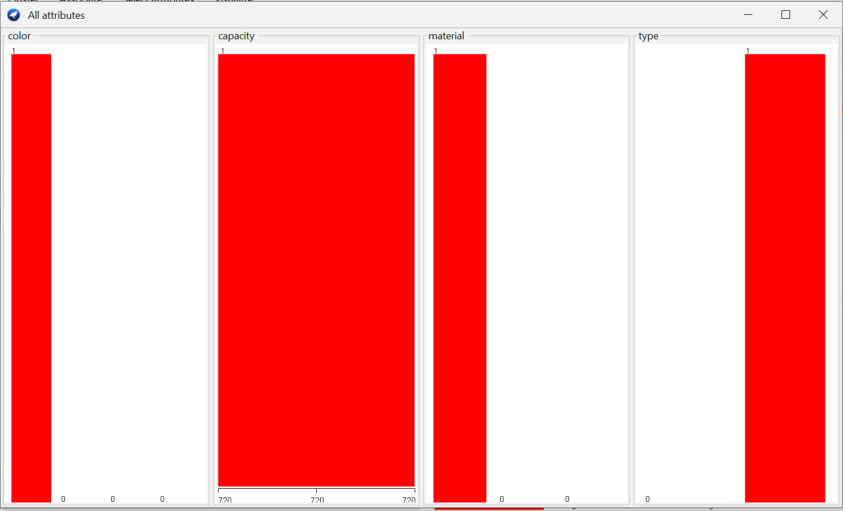

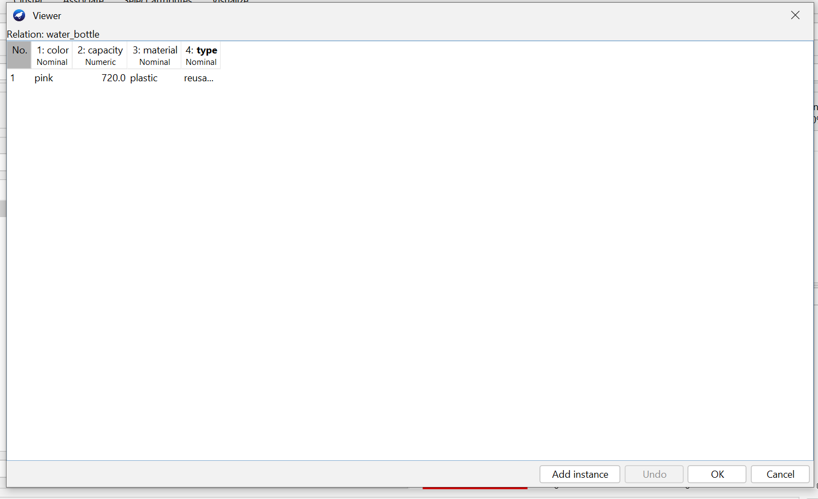

**PRACTICAL ASSIGNMENT : 16**

**5.Fifth element is butterfly.**

**Attribute ARFF code.**

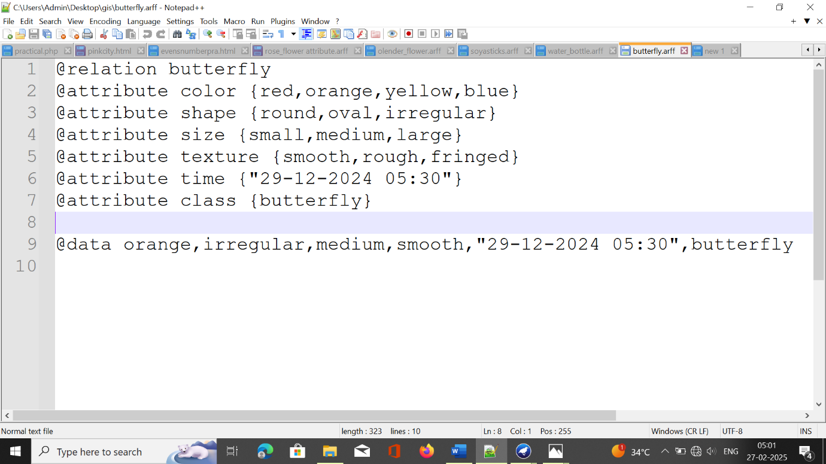

**Output:**